)FFIClAL INTERNATIONAL PUBLICATION OF THE ASSOCIATED LOCKSMITHS OF AMERICA, INC

|  |  |  |
| --- | --- | --- |
| 1 ►>€ 11 1 •Im II |  | , Tnl |
|  | A Xi |  |

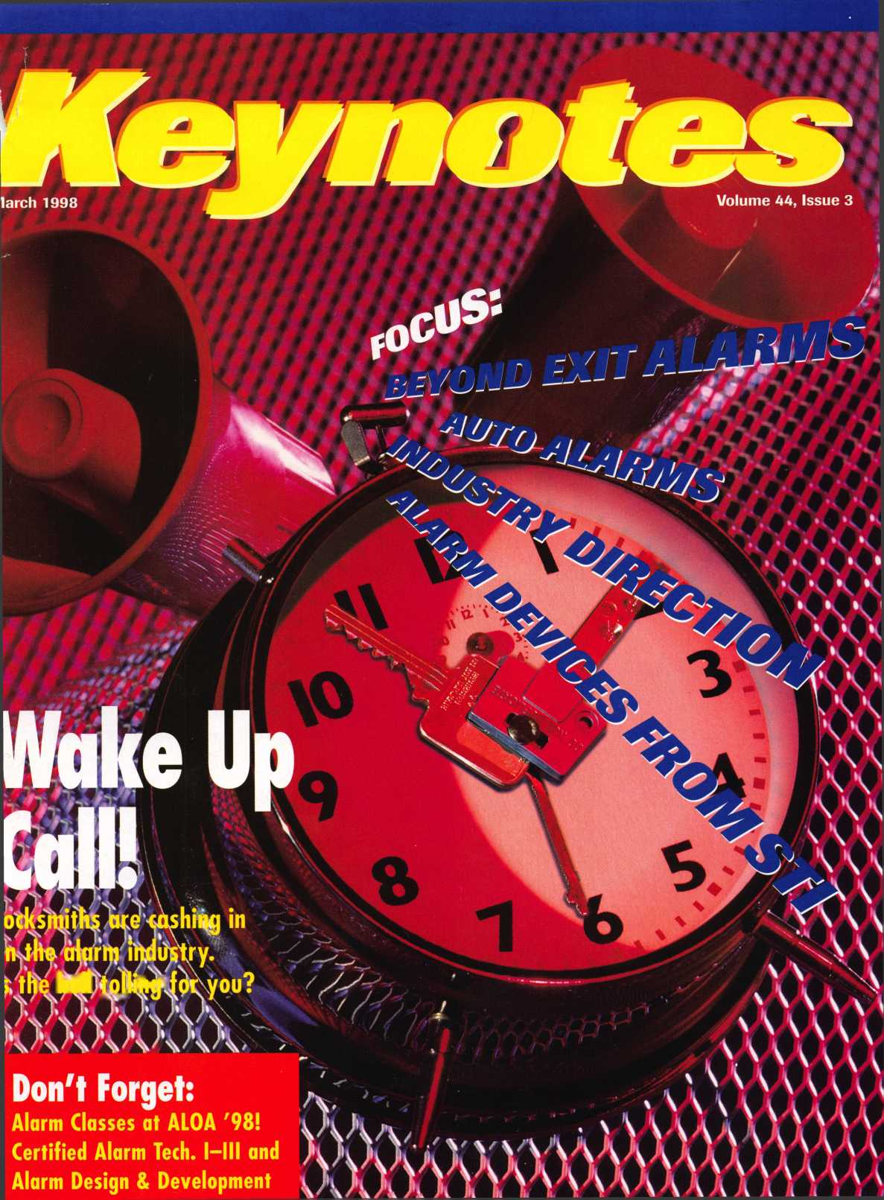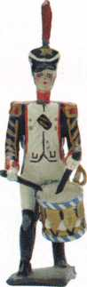

S A F E T E C H ’98

SAFETECH '38 CONVENTION UNO TRADE SNOW • VALLEY FORGE, PENNSYLVANIA • MAT 18-

Die Hard Manipulation Time Lock Servicing Advanced Servicing and D$&SSrtethods Red Label GSA Containers

Safe Opening Extravaganza Electric Locks and Safe Retrofitting Safe Moving and Installation



SAFE AND VAULT TECHNICIANS ASSOCIATION  
3 0 03 LIVE OAK STREET  
DALLAS, TEXAS 75Z04  
31 4.0 27.7233  
21 4.0 27.1 01 0 (FAX)

E MAIL: CONVTION@ANET DFW.COM

ALOA ’98 International Convention & Security Expo

*‘No one succeeds alone*. *The*

*input, tolerance and sharing*

*of knowledge from others in*

*this industry account for most*

*of my success. My part was to*

*learn—a lifetime process-*

*and to work hard.*

**Nashville Convention Center**

Dan Graffeo, CRL, CMS  
ALOA Member #8188  
1996 recipient, ALOA Lifetime  
of Outstanding Achievement

**Nashville, Tennessee**

*Associated Locksmiths of America 3003 Live Oak Street Dallas, Texas 75204*

*e-mail [convtion@anet-dfw.com](mailto:convtion@anet-dfw.com)*

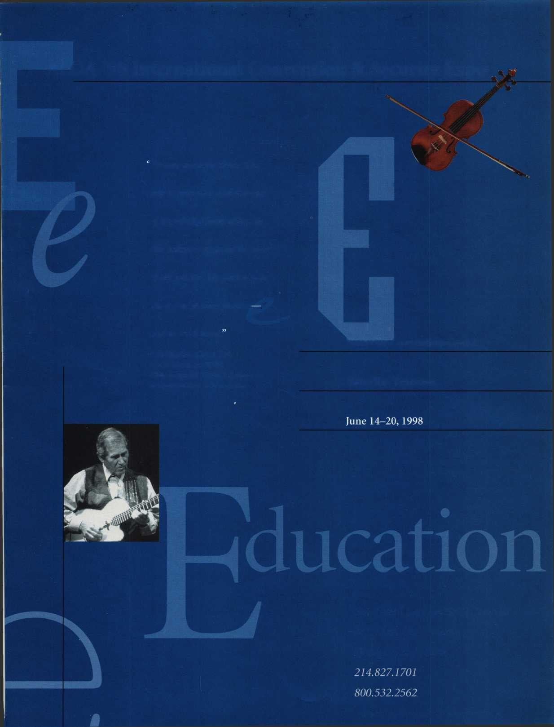

Con ten i

March

19

New Rule Book

**Features** |The ALOA Board is presenting a new set of bylaws and a

revised certificate of incorporation to membership at the June annual meeting. Take a look and give feedback ASAP.

22

Evolution of the Security Industry, Part 2

Review the five “Ds” of security and bmsh up on your locksmithing history.

By Steven Spiwak

The Reves Collection

**1** The rare antiques on permanent display at the Dallas

Museum of Art are a “must see” for serious lock collectors.

By Mike Emery

Auto Alarms

Don’t miss out on this lucrative service, custom tailored

to the automotive locksmith.

By Steven Spiwak

Beyond Exit Alarms

High quality delayed egress systems protect property  
and human life. Isn’t it time?

By Paul Chandler, CPL

The Cover In 1996, Americans spent an estimated $13.2 billion on professionally installed electronic security products. Do we have your attention?

Cover photograph ©Steve Hinds Art direction/design Valerie Rowe

Alarm Devices from STI

A security device can’t do its job if it’s broken or stolen. Sometimes even protective devices need protection.

By Sal Dulcamara, CML

38

Master Keying By the Letter, Part 2

Bound and determined to use last month’s handy chart? Here are some tips.

By Greg Perry, CML

43

Telephone Customer Service

Too many locksmiths underestimate the value of first impressions. That can be a costly mistake.

By Claire Cohen, CML

44

Inside the Alarm Industry

Here are some facts and figures about the folks next door, and where they think they’re headed. Same direction as you?

March 1998

President’s Journey Sound the alarm.

PPMm

**Advertising**

46

Associate Members

50

Classifieds

53

Buyers’ Guide

58

Ad Index

Q&A

New column for technical questions.

Focus on Education Learning about alarms.

12

Legislative Comment Feedback from NBFAA meeting.

54

PRP Report

Frequently asked question.

55

Trade Tips

The ’97 Malibu ignition.

56

Chapter News News from the board.

6

Mail Box

New member asks about ALOA politics.

8

Upcoming Events Mark June 14-20, Nashville.

10

Applicants for Membership Scheduled for clearance April 1.

14

Industry News

Industries join forces at ISC.

16

Security Marketplace

58

ALOA Extra

60

Back Page

2| Keynotes

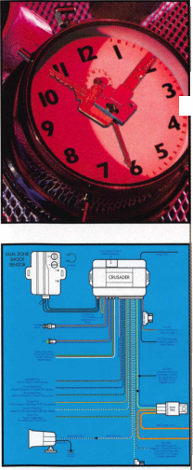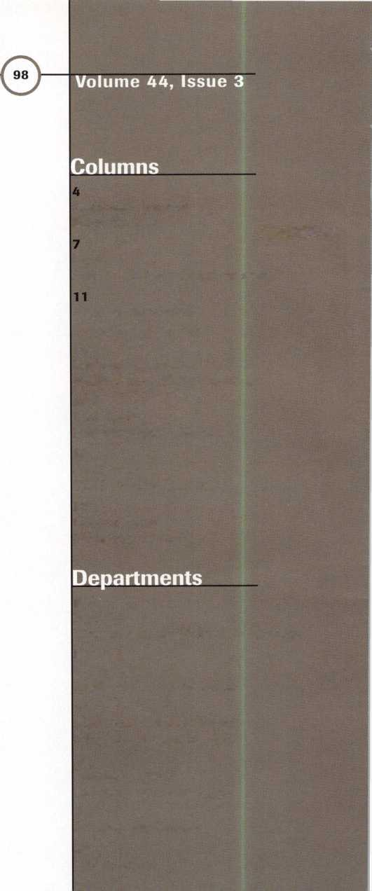

|  |  |  |
| --- | --- | --- |
| Advertising Sales Manager | Anelia M. Banda |  |
| Sales Assistant | D’Anna Weber |  |
| Contributing Authors | Jerome V. Andrews, CML  Kim Bowers,CML  Paul Chandler, CRL  Claire Cohen, CML  Brian Costley, CML, CMS  Bob De Weese, CPL  Ray D’Adamo, CML  Sal Dulcamaro, CML  James Glazier, CML  Wayne Gurnee, CRL  A.J. Hoffman, CML  Ken Holmlund, CRL  Ray Lusk, CML  Mark Ohno |  |
|  | David Parrott | Complete address and |
|  | Randy Simpson, CML  Steven Spiwak  Robert Stafford, CPL | phone number listings for the ALOA Board and most |
|  | Dave Thielen | Keynotes authors are |
| Editorial Advisors | John D. Cannon, CML, Technical Content | available through “Locksmith |
|  | Jerome Andrews, CML | Search" on the ALOA |
|  | A.J. Hoffman, CML | website-www. aloa. org or by |
|  | Leonard J. Passarello, CPL | contacting the ALOA office at |
|  | Randy Simpson, CML | 3003 Live Oak Street; Dallas, |
|  | Robert Stafford, CPL | TX 75204; [2 J4J827-1701; |
| ALOA Professional Staff |  | FAX (214) 827-1810; e-mail |
| Executive Director | Charles W. Gibson, Jr. | publ@anet-dfw. com. |
| Office Manager | Mary May |  |
| Receptionist | Margo E. Vela |  |
| Comptroller | Kathy J. Romo |  |
| Financial Assistant | Debra Bradshaw |  |
| Meetings Manager | Jessica Vasquez |  |
| Meetings Assistant | Janelle Vergara |  |
| Legislative Manager | Tim McMullen |  |
| PRP/Education Manager | David Lowell, CML, CMS |  |
| Education Assistant | Ashley Spenser |  |
| Membership Coordinator | Brandon Durrett |  |
| Membership Assistant | Jackie Arnett |  |



Mission Statement: The Associated Locksmiths of America, Inc. is dedicated to enhancing the professionalism, education and ethics among locksmiths and those in related sectors of the physical security industry. With approximately 10,000 members in the United States, Canada and the freeworld, ALOA is poised to help members obtain the knowledge, the strength, and the confidence to perform their role in the physical security field with pride and dignity. But it is only through active involvement and participation that ALOA can fully achieve its potential-and can help members to achieve theirs.

Policies: Keynoted is the official publication of the Associated Locksmiths of America, Inc. (ALOA). Keynoted acts as a moderator without approving, disapproving, or guaranteeing the validity or accuracy of any data, claim, or opinion appearing under a byline or obtained or quoted from an acknowledged source. The opinions expressed by the authors do not necessarily reflect the official views of ALOA. Also, appearance of advertisements and new products or service information does not constitute an endorsement of products or services featured by the Association. The Association does not accept responsibility for the inaccuracy of any data, claim, or opinion appearing in this publication, due to typographical errors on the part of the authors, Association staff or its agents. Editor’s Note: This publication is designed to provide accurate and authoritative information in regard to the subject matter covered. It is provided and disseminated with the understanding that the publisher is not engaged in rendering legal or other professional services. If legal advice and other expert assistance is required, the services of a competent professional should be sought.

Authors’ Payment: Payment for eligible submissions to Keynotes will be based on the following criteria: topic, time spent and past contributions. Authors who regularly submit to Keynotes are generally paid a higher rate. The latter is especially true of authors who write to fit specific editorial needs and submit said copy by Keynotes deadlines. As a general guideline: Average payment for a 750 word, business or ‘light’ technical article would be $200. Payment for a 1500 word article involving significantly higher time and research efforts would be $400.

Payment will not be offered for articles submitted by ALOA employees or members of the ALOA Board of Directors (unless material is of a technical nature), nor for articles submitted by a company that promote that company’s products or services. ALOA reserves the right not to pay for articles submitted by an individual(s) that promote a particular company’s products or services.

Disclaimer: The Associated Locksmiths of America, Inc., (ALOA), reserves the right to refuse any article for any reason. Additionally, ALOA reserves the right to edit, amend or modify any article submitted for publication in order to preserve technical accuracy, clarity, fairness or grammatical correctness. ALOA will make the best efforts to notify the author of any changes. The extent of ALOA’s liability for any article or information contained therein will be a notice of correction or retraction in the next possible issue.

Keynoted (ISSN 0277 0792) is published monthly except for the combined June/July issue by The Associated Locksmiths of America, Inc., 3003 Live Oak St., Dallas, TX 75204-6186. Telephone: (214) 827-1701; FAX (214) 827-1810; e-mail [aloa@anet-dfw.com](mailto:aloa@anet-dfw.com). Subscription rates for members-$ 15.00 per year. Second class postage paid at Dallas, Texas. POSTMASTER: Send address changes to: Keynotes, 3003 Live Oak St., Dallas, TX 75204-6186. © Copyright 1998, All rights reserved. No part of the contents may be reproduced or reprinted in any form without prior written permission of the publisher.

President

Dallas C. Brooks (334) 826-8990

Regional Vice Presidents Southeast

‘Jeffrey S. Nunberg, CML, CMS (305) 324-8800

North Central

‘John J. Greenan, CML, CPS (773) 486-2030

South Central

‘Randy L. Simpson, CML (713) 780-7026

Southwest

John I. Shandy, CML (303) 776-7898

Northeast

James H. Glazier, CML ’

(301) 831-5454

Northwest

Raymond C. Lusk, CML (509) 624-3152

Secretary

John D. Cannon, CML (703) 960-6413

Trustees:

David M. Lowell, CML, CMS (214) 827-1701 Breck H. Camp, CML (770) 455-6244 Henry H. Printz, CML (201) 538-2737 Leonard J. Passarello, CPL (416) 752-7210 Edwin Toepfer, RL (416) 225-5589 Directors

*These officers also serve as directors.

Dana L. Barnum, CML (610) 565-9900 Mark E. Blum, CML. CPS (517) 482-5809 AJ. Hoffman, CML (714)572-6008 Barry K. Leas, CRL (610) 272-9292 Clyde Roberson, CML, CPS (540) 380-5000 Donald E. Rule, CML (601) 324-2658

Anthony J. Ramunno, CML, CPS

(330) 782-6204

Robert H. Stafford, CPL

(860) 768-7917

Bruce J. Tarbet, CML

(601) 924-4184

Chairmen of International Affairs

Laurence P. Mills/Australia (129) 958-0445 Hans Mejlshede, CML/Europe FAX (453) 139-1004 Members-at-Large Jerome V. Andrews, CML (860) 621-3601 Steven G. Engel, CML, CPP (414) 731-5400

Past Presidents

1995-1997 David Lowell, CML, CMS 1993-1995 Breck Camp, CML 1991-1993 Henry Printz, CML 1989-1991 Evelyn WersonicK CML 1987-1989 Leonard Passarello, CPL 1985-1987 Joe Jackman, CML 1983-1985 Stanley Haney, CPL 1981-1983 Louis LaGreco, CPL 1979-1981 John Kerr, RL 1977-1979 Clifford Cox, CML 1974-1977 Charles Hetherington 1972-1974 Gene Laughridge 1970-1972 William Dutcher, RL 1968-1970 Constant Maffrey, RL 1966-1968 Harold Edelstein, RL 1964-1966 William Meacham 1962-1964 Robert Rackliffe, CPL 1960-1962 Edwin Toepfer, RL 1956-1960 Ernest Johannesen

March 1998

Keynotes 3

President’s Journey

■

SOUND THE ALARM

The editorial focus of this issue (alarms) is pretty appropriate right now for  
several reasons. First of all, alarm work is a relatively new and quite profitable  
addition to many of our members’ businesses. It’s a logical fit for the oldest  
group of security professionals in existence.

But too many of our fellow locksmiths are still limiting their horizons.  
Remember—it’s one thing to specialize in an area that you’ve found to be a  
lucrative niche for your particular abilities or situation. But it’s a bad habit to  
pigeonhole yourself into cutting keys or opening automobiles because it’s easy  
and you’re comfortable doing it.

Time to wake up! I want to see ALOA members learning, growing, making  
money, expanding services, reaching the commercial and public markets in  
high-profile, comprehensive ways. For most of us, that means learning basic safe  
servicing or adding alarm installation to our agenda or computerizing our shops  
or taking the leap into access control—or all of the above. Every day, another  
member of our industry hangs up the towel because he or she wouldn’t face facts  
about competing in today’s marketplace. Don’t let it be you. Need training?  
Three words. ALOA Continuing Education.

Alarm-wise, I also just finished meeting with representatives of the National  
Burglar and Fire Alarm Association. Along with our new legislative manager,  
Tim McMullen, I tried to make it very clear to this group that ALOA stands  
ready to see that fair licensing legislation comes into existence that does not  
require locksmiths who do electronic security installation and repair to be  
subjected to unnecessary training and testing requirements (ask Alabama or  
Texas locksmiths). The NBFAA reps at least seemed receptive, and I hope we  
will be able to peaceably agree on some standard industry definitions and skill  
sets. To this end, we are going to be part of an Electronic and Physical Security  
Industry Coalition. Tim will keep you informed on how we’re doing with this.

And if alarm work is a brave new world for some of you, take a look at  
pp. 19-22. ALOA is re-inventing itself. In the past seven months, we’ve begun  
to do a lot of things you’ve been asking for, but there’s more. We need every  
member to stay informed and to make your voice heard. This is a time of change  
and change frightens some people. A famous playwright once wrote, “Progress  
is impossible without change, and those who cannot change their minds cannot  
change anything.” ALOA must change, locksmithing must change. With  
your help, we won’t be turning back.



|  |  |
| --- | --- |
| Kwok-kei Leung | 160 |
| Henry Raymond | 93 |
| Toshihiro Asano | 68 |
| Stewart Levine, CML | 67 |
| Mary Ohmit, CPL | 63 |
| Allen Konrath | 49 |
| Charles Robertson, CML | 48 j |
| Jack Hobin, CPL | 47 |
| Yuriko Yanai | 43 |
| William Neff, CML | 36 |
| Myeong-Rae Cho | 36 |
| Salvatore Dulcamaro. CML | 35 |
| Thomas Freehling, CML | 32 - |
| Jeanne Lodge, CML | 25 |
| Roy Renderer, CML | 23 |
| Danny Rudd, CPL | 23 |
| John Heckman, CML | 23 |
| Robert Carroll, CPL | 23 |
| Barbara Watt | 23 |
| David M A Federico | 23 |
| John Elliott, CML | 22 |
| James Watt CML | 22 |
| Diana Barnum, CRL | 22 |
| J Thomas Hood, CML | 22 |
| Robert DeWeese, CPL | 22 |
| Larry Warnick, CML | 21 |
| Jerome Cohen, CML | 21 |
| Eugene Altobella | 21 |
| Jim Williams | 21 |
| D Michael Lee, CPL | 18 |
| James Fowler, CML | 18 |
| David Harris, CML | 18 |
| FI vis Hammerschmidt, CPL | 18 |
| John Kerr. RL | 17 |
| Marian Swann, CRL | 17 |
| John Dorsey, CPL | 17 |
| Charles Cole, CML | 17 |
| Ronald Heidzig | 17 |
| Joseph Ferrero, CML | 16 |
| William Grant, CRL | 16 |
| Brian Reetz | 16 |
| Walter Lascar, RL | 15 |
| James Cawby, CML | 15 |
| William McElheney, CML | 15 |
| Michael Robinson, CRL1 | 15 |
| Rex Parmelee, RL | 14 |
| Lawrence Smith, CML | 14 |
| Thomas Vandersteen, CML | 13 |
| Edwin W Scott | 13 |
| James Gruber | 13 |
| Peter Gauthier, CPL | 13 |
| Gary Teams, CPL | 13 |
| Philip Rovenolt, CPL | 13 |
| Russell Fuller, CRL | 13 |
| Robert Rodocker, CRL | 12 |
| Frank Hartung, CML | 12 |
| RoLando Bouza | 12 |
| Lonnie McKinney, CML | 12 |
| James Brickler, CRL | 12 |
| Richard Sievers | 12 |
| Herbert Dusenberry, CML | 11 |
| Robert Duman, CML | 11 |
| Jon Griswold, CML | 11 |
| Robin Horsley | 11 |
| John Engel. CRL | 11 |
| Daniel Landry | 11 |
| Eric Veal | 11 |
| Ernest Wright | 10 |
| William Wickward, CML | 10 |
| Lester Brodsky | 10 |
| Joseph Whitaker. CPL | 10 |
| Dale Knowles. CPL | 10 |
| Paul Souber | 10 |

The Brightest

And The Best.

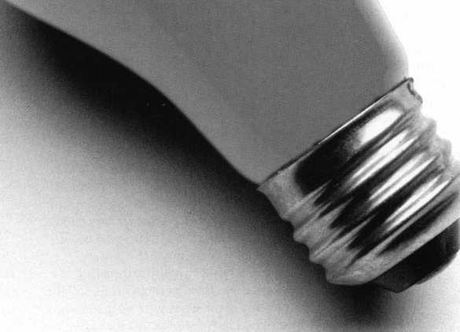

**How can I join the President's Club?**

You can earn membership in this prestigious dub by recruiting just  
10 new members for ALOA.

*Any ALOA member may participate.

**What do I get?**

When you recruit 10 members, you receive a handsome blue blazer  
with a President's Club crest. For each additional five members you  
recruit you receive a lapel pin with gold-filled numbers, indicating  
your recruiting successes.

You also get the satisfaction of knowing that you are helping your  
association, helping your industry grow, and you are helping fellow  
locksmiths achieve success.

**How do I get started?**

Contact the ALOA office for a supply of applications (214) 827-1701  
or FAX (214) 827-1810. One President's Club credit is awarded for  
each new applicant. Credit is awarded only after the membership  
application is approved. Flowever, the credit will apply for the period  
in which the application is received. Failure to identify yourself as  
the sponsor on the application form at the time it is submitted to  
ALOA for processing will forfeit any credit.

*AL0A Board of Directors not eligible for membership in the President's Club.

**Keynotes**

Mail Box



If you have an opinion to offer on the letter(s) printed in **Keynotes** each month, let us know! Submissions to the “Keynotes Mail Box” department are printed on a space-available basis. Write to: Keynotes Mail Box; Associated Locksmiths of

lerica, Inc.; 3003 Live Oak Street; Dallas TX 75204; or FAX (214) 827-1810.

To be or not to be?

Obviously, I have your attention and now that I have it you may find the following to be of interest, and to some readers of great concern.

For more than two years, I have taken a good hard look at our association from the outside in. That look has prompted me to ask this all important question that I feel we should ask ourselves: Are associations becoming extinct? And most importantly, is yours one of them? I personally feel our association, The Association of Ontario Locksmiths (TAOL), was one of those on the Endangered Species List. After 24 years it doesn’t seem possible. We must take a look at our numbers. Our membership is approxi­mately 390, yet a new member joining up will receive a membership ID card with a number somewhere in the 1200 range. Oh my gosh! We must have lost over 800 members. Did they all pass away? Or did we kill them? I know we killed them. Yes, we drove them away. We did not give them reason to belong. We gave them a magazine five or six times a year. We held a convention every year, but we made them pay to come on the show floor so they could spend their money if they didn’t pre-register. Membership in any association should benefit the member, not the association. The cost of dues is irrelevant if the benefits outweigh the dues. All associations must provide benefits to the members or we won’t have them as members (i.e. look at your numbers). Something is wrong. Most associ­ations lose members at a rate far greater than they get new ones. Those numbers do not lie. Once again, take a good long look at yours.

It is evident that conventions are not doing as well as they should be. Our industry is changing its views on a lot of things. One of those things is the manufacturers selling direct to the locksmith. This seems to be a new trend, or is it? Not so long ago we used to buy from many manufacturers then it stopped. Recently some of the manufacturers are once again selling direct to the locksmiths. Another bone of contention in our areas, of course, in-house trade shows. This again leads me to ask: Are associations doing something wrong? In talking to many manufacturers and their representatives, I find they are not in favor of these shows and the feeling is there are far too many Perhaps our association should go after their support

on a larger scale. Just imagine the turnout you could have. “United we stand”— something of that magnitude would most certainly benefit all locksmiths in Ontario as well as distributors, manufacturers and suppliers. The Association of Ontario Locksmiths is openly asking all suppliers, distributors, manufacturers and their repre­sentatives to forgo their in-house shows for 1998 and support The Association of Ontario Locksmiths in celebrating our 25 th Anniversary, 11-13, 1998. Things could be great in ’98. We work hard for our members. We are the association that cares.

On a recent trip to another convention in Reno, Nev., I met many interesting and wonderful people, I learned many things.

The one thing I so vividly recall was that I was attending my first annual meeting as a proud new member of ALOA. The frightening thing was I just looked into a mirror and saw TAOL last November at our annual meeting. The only difference was this mirror showed me a picture far larger and more frightening than I believe we could ever be or could become. The power struggles, the petty politics, the anger, the backstabbing, the choosing of sides and the separation of members were all in evidence, just like us in November. All the nasty little things that ruin any association. Please keep in mind I was attending my first ever meeting as a new member. Not a pretty sight, even for an old warrior like myself. I had heard so much about this great association and was looking forward to that meeting hoping to learn many things to bring back to our meetings. Something to benefit our association. Unfortunately I have seen what our past members must have seen and obviously the reason for their leaving. To those members who have left us for any or all of the above reasons, please come back. We need you. I am so pleased that I have listened to our locksmiths prior to returning as president and more pleased that, along with the board of directors and trustees, we have made an honest effort to avoid this kind of thing in/and for the future of our great association. I am fully convinced this kind of thing will kill any association’s membership. I love my association and I work hard for our members, as I am sure most leaders do.

Please don’t lose sight of what we are there for. That’s to serve our members, not to put them on the Endangered Species List.

1. am sure that there is not an association

anywhere, whether it be The Corn Huskers of Iowa or The Lobster Fishermen of Nova Scotia, that some part of this article would or does not pertain to you. It happens to us all. Associations are necessary. To survive is one thing; to prosper is another.

To be or not to be. Is there any question? DJ. Nelson,

Chevrolet Customer Service Center

ALOA says “to be”

Your point is well taken, D.J., and I’m sorry you saw the political nonsense that was all too apparent at the 1997 ALOA membership meeting. But the good news is that the conflict you witnessed isn’t, in ALOA’s case, the result of an association that has atrophied into pointless in-fighting. The reason for this rocky period we’re going through right now is that the current leadership of ALOA is working to improve our operations and our structure to better serve our members, and the locksmithing industry itself. A funda­mental part of what we’re doing involves opening the association up to all members, not just the few who are accustomed to running the show. One way we’re hoping to accomplish this is by presenting a new set of bylaws at the 1998 meeting that will include the right for each ALOA member to vote by mail. That seems fair, doesn’t it? So why the fighting? Well, unfortunately, some people who are used to being in authority don’t react peacefully when that control is taken away from them. They may have the best of intentions—may honestly believe that they are best suited to decide our industry’s future for everyone. But the future of ALOA and locksmithing isn’t one that will benefit sufficiently from the limited efforts of a few well-intentioned members of the old guard. It’s a tough new world out there, and it’s going to take the latest and best ideas and abilities of every one of us to succeed. So, I’m sorry if you were disillusioned by conflict you witnessed. I hope you’ll take my word that it’s healthy conflict—necessary conflict and,

I hope, very temporary conflict. Change is hard. But I believe we’ll get through it just fine and stand together united in the end, a better association and a better industry. Dallas Brooks ALOA President

Keynotes

March 1998

|  |  |
| --- | --- |
| r\ o a | Questions & Answers |
| Q&A |  |
|  | |^teverH>pTwak |

{Editor’s Note: More than once over years past, readers have told us how much they like the Trade Tips column in Keynotes. “But what do I do when I come up with the problem and not the answer?” Q&A is our solution to that dilemma. Teel free to contact the column editor with your own queries.)

Q. I have heard that the new transponder keys at the Ford Motor Company are going to he replaced by new technology in the near future. If this is true, do you know what that technology will he?

A. There has been much discussion over the past couple of years that the Ford Motor Company will lead the way for the next evolution in automotive security systems. This “feeling” is predicated on the fact that the current auto security systems revolution was spawned by the Ford Motor Company’s research and development of the PATS.

(PATS is a highly sophisticated and successful auto security system based on the use of an electrical component called a transponder, which every major automotive company both here and abroad has adopted in some form or another for use in their own vehicles.)

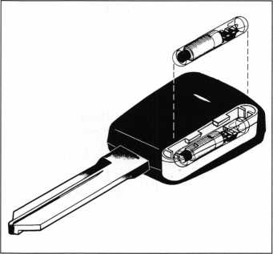

The new technology will be referred to in general as “Smart Technology.” Specifically, Ford Motor Company is developing a “Smart Key” (see Illustration). This new key is rumored to have a memory capacity of storing one million bits of information. This reprogrammable information can and will be used for everything from individual

biometrics, such as seat position and radio station preferences to information about the driving habits of those using the car. All this can then be downloaded to a compatible computer and used as an audit trail for such items as mileage verification.

Be sure to notice that aside from the two contact points and the significant technology present in the bow of the key, the Ford Key remains virtually the same physically. However, the costs have been estimated at up to more than $100 for each key (A “guesstimate” that has not been verified).

Q. When did General Motors first introduce their original side bar disc tumbler lock cylinder?

A. General Motors first introduced the side bar disc tumbler lock cylinder in 1935.

Q. The other day I encountered a tubular deadbolt lock with the name “Homed’ inscribed on the front of the cylinder. What is the proper key blank to use for this deadbolt lock cylinder?

A. Most of the lock cylinders bearing the name Homer can be operated by using an ILCO UNICAN X1054K key blank.

Q. What key blank would I use for an old Segal deadbolt lock cylinder? I know that the cylinder is not the high security Hines Key System. However; the standard ILCO UNICAN 1022 (SEI) key blank will not enter the lock cylinder. If anything, the key way looks as though it may be the reverse of a standard ILCO UN I CAN 1022 (SEI) key way.

A. The old lock cylinder that you are referring to is quite old. Since you say that the keyway seems to be the reverse of the standard Segal key way, the most likely choice is the ILCO UNICAN 01022 key blank. This key blank is in fact the reverse of the standard Segal key blank with which you are already familiar.

Q. Now that the Volkswagen Beetle has been reincarnated as the “darling” of this year’s auto show I have been seeing more VWs than I have seen in years. Therefore, it is no small surprise that I would run into one of the older models that I am not familiar with. What is the proper key blank to use fora 1974 Volkswagen Beetle?

A. Use the ILCO UNICAN VW71, or the Curtis V28.

Q. What is a “Nib”? I have heard this term in reference to a fountain pen point, but until the other day I had never known it was a locksmith term.

A. A nib is the name or term used for the small projection or indexing point on a tubular key that is found between the first and last cuts, and is used to properly align the tubular key in a tubular lock cylinder.

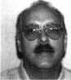

fcl About the column editor: Steven B.

Spiwak is a fourth generation locksmith who specializes in a variety of variety of areas including crime prevention and institutional security. His broad experience in the security field spans 20 years of writing, teaching and consulting. Spiwak’s lengthy client list includes Ford Motor Company, Exxon, The Chicago Tribune, Sears, Westin Hotels, the U.S. Treasury Department and the Federal Bureau of Investigation. Most recently he formed Lockport, Inc.—a security consulting company for industrial, commercial, institutional and governmental clients. Readers with questions for him can contact ALOA at email [publ@anet-dfw.com](mailto:publ@anet-dfw.com) or fax to (214) 827-1810.

March 1998

Keynotes L

**Upcoming**

Events



Dept)

Future

Conventions

1998

ALOA ’98 June 14-20 Nashville, Tenn.

SAFETECH ’98 May 18-23 Valley Forge, Pa.

1999

ALOA ’99 July 25-31 Cincinnati, Ohio

SAFETECH ’99 May 3—8 Las Vegas, Nev.

2000

ALOA 2000 Date TBA Las Vegas, Nev.

SAFETECH 2000 May 5-6

Birmingham, Ala.

2001

ALOA 2001 July 15-21 Baltimore, Md.

2002

ALOA 2002 July 21-27 Rosemont, 111.

For PRP dates, seep. 54. For ACE dates, see p. 11. Send in the dates of your organization's activities today!

IJ

^ **March 1998**

MARCH ’98

6-8

IDN Hardware Sales, Inc.

9th Annual Trade Show and Security Conference Ypsilanti, Mich.

Contact: Fred Strasberger (800) 521-0955 ext. 203 or John Kress ext. 232

7

Hans Johnson Company Dealer Trade Show Dallas, Texas (888) 879-1500

7-9

Lockmasters Automotive Opening/ Automotive Servicing Nicholasville, Ky.

(800) 654-0637

10-11

Lockmasters Signature Series Advanced Picking Course Nicholasville, Ky.

(800) 654-0637

12

Lockmasters Signature Series Push Button Manipulation Course

Nicholasville, Ky.

(800) 654-0637

1. 14

Lockmasters Signature Series Advanced Impressioning Course Nicholasville, Ky.

(800) 654-063

1. 15

Ozark Professional Locksmith Association (OPLA)

Annual Retreat/Free Clinic Eureka Springs, Ark.

(501) 524-3660

14-15

Annual Retreat and Free Clinics Eureka Springs, Ark.

Contact: Betty Gray (501) 524-3660 (501) 427-1066 fax or Janis Reves (501) 631-6406, evenings

21

MBA

Lever Lock Picking Nicholasville, Ky.

(888) 622-5495

1. 23 New Event

ALOA ACE Classes at the International Security Conference and Exposition Master Keying Methods Comprehensive Interchangeable Core Safe Lock Troubleshooting Access Control Aluminum Storefront Doors Commercial Grade Locksets Mas-Hamilton Auditcon System 2100 Certification S&G Electronic Safe Locks Intro to Closed Circuit Television The Complete Door & Door Closers Exit Devices

Investigative Locksmithing Las Vegas, Nev.

Contact: Customer Service (800) 840-5602 (203) 840-5602

1. 25

South Carolina Locksmiths Association Quarterly Meeting Columbia, S.C.

Contact: Jean Griggs (803) 532-9008

1. 26

Clark Security Products

ISC West

Las Vegas, Nev.

(619) 505-1950

26

Louisiana/Mississippi Locksmith Association Contact: Thomas L. Hung (205)833-3333

26

Locksmith Swap Show South Jersey Locksmiths Association

1111 Route 7 3 at NJ Turnpike Exit 4

Mount Laurel, N.J. 08054 (609)939-6373

26-29

MLANJ Annual Security & Lock Show Morristown, N.J.

(973) 267-8884 www. MLANJ .org 28-29

GCLA 13 th Annual Midwest Trade Show and Classes Chicago, II.

(708) 386-3695 FAX (708) 366-2094

APRIL ’98

3-4

Lockmasters Simplex Certification Nicholasville, Ky.

(800) 654-0637

7-10

Clark Security Products Trade Show Contact: Terri Burges (800) 854-2088 ext. 273

7-13

MLA of Great Britain Convention Birmingham, England Contact: Peter Hall 01327-262255 phone 01327-262539 fax

1. 17

The 1996 National Electrical Code University of Wisconsin Madison, Wis.

(800) 462-0876

|  |  |
| --- | --- |
|  | Upcoming |
|  | Events |

18-19

MBA

Defeating Dimple Key Locks Nicholasville, Ky.

(888) 622-5495

24-26

American Society Distribution Anaheim, Calif.

(800) 844-8545

26

South Jersey Locksmiths Association, Inc.

First Annual Swap Show Mount Laurel, N.J.

(609) 767-4977 (609) 894-0805 (609) 939-6373 fax (609) 894-2400

1. May 3

European Locksmith Federation San Sebastian, Spain 34-43-28-43-84 fax

MAY’98

6

Lockmasters

Push Button Manipulation Nicholasville, Ky.

(800) 654-0637

7-10

Clark Security Products Baltimore, Md.

(619) 505-1950

17

MBA

Time Locks Nicholasville, Ky.

(888) 622-5495

18-23

SAFETECH ’98 Valley Forge, Pa.

(214) 827-SAFE (7233)

(214) 827-1810 fax

e-mail: [convtion@anet-dfw.com](mailto:convtion@anet-dfw.com)

27-31

National Independent Bank Equipment & Systems Assoc. Annual Convention Montreal, CANADA (800) 843-6082

31-June 6 New Event

ALOA ACE Classes at ISC West Chicago, 111.

(800) 840-5602 (203) 840-5602

JUNE ’98

14-20

ALOA ’98 Security Expo 59 full-day class sessions 34 half-day class sessions Six evening seminars Exhibits from leading security products/systems manufacturers and distributors City tours Annual banquet ALOA Membership Meeting

Nashville, Tenn.

(800) 532-2562

(214) 827-1810 fax

e-mail: [convtion@anet-dfw.com](mailto:convtion@anet-dfw.com)

20

ALOA Annual Membership Meeting (breakfast)

NEW BYLAWS VOTE 6:30-11 am Renaissance Hotel Nashville, Tenn.

(800) 532-2562

(214) 827-1810 fax

e-mail: [convtion@anet-dfw.com](mailto:convtion@anet-dfw.com)

1. 28

National Burglar and Fire Alarm Association Annual Meeting San Antonio, Texas (301) 907-3202

JULY’98

17-19

S. C. Association Meeting Columbia, S.C.

(803) 735-1600

23-25

South Carolina Locksmiths Association Quarterly Meeting Columbia, S.C.

Contact: Jean Griggs (803) 532-9008 25-26

California Locksmith Association Anaheim, Calif.

Contact: Kimber Smith (714) 632-6800

1. August 2

Clark Security Products Trade Show Orlando, Fla.

(619) 505-1950

AUGUST’98

6-9

New Mexico Locksmith

Association

Las Cruces, N.M.

(505)247-9413

13-16

SAVTA Fall Board Meeting Las Vegas, Nev.

(214) 827-SAFE (7233)

(214) 827-1810 fax

19-23

SERLAC Trade Show Orlando, Fla.

Contact: Bill Norris (850)433-5118

SEPTEMBER ’98

1-13

The Association of Ontario Locksmiths Scarborough, Ontario (888) 272-8265

17-20

Clark Security Products Southern California Trade Show (619) 505-1950

OCTOBER’98

1-4

POLA Trade Show ’98 Penn Ohio-Locksmiths’ Association, Inc.

Independence, Ohio (Cleveland area)

Contact: Martha Eggler (216) 676-8464 Fax (216) 267-2411 e-mail: PALOll6@aol,com

17-19

S. C. Association Meeting Columbia, S.C.

(803) 735-1600

19-25

25 th Tri-Regional Locksmith Conference Portland, Ore.

Contact: Stan Hauer (503) 325-6003 phone/fax

21-25

Yankee Convention Providence, R.I.

Contact: Rob Mahoney (800) 209-8266

1. Nov. 2

Door & Hardware Institute Orlando, Fla.

(703) 222-2010

1-3

New Event

ALOA ACE Classes at ISC New York New York, N.Y.

Contact: (203) 840-5602 (800) 840-5602

March 1998

***Keynotes***

k

For Membership



Dept)

ALABAMA

Meridianville

027807, Ronald Akridge, A

ARIZONA

Mesa

027843, Noah J Baker, A Sponsor: William Lee

CALIFORNIA

Baldwin Park

027826, Jim Dalmatoff, A Sponsor: Luis Rejon

Hollywood

027774, Ann E Hensel, AP

Rodeo

027778, Scott P Barde, AP Sponsor: Russell Smith

San Jose

027832, Daniel O'Neal, A

South Lake Tahoe

027795, David A McKenrick, AP

COLORADO

Englewood

027819, Mark A Kauaihilo, A

FLORIDA

Davie

027846, Ronald G Welter, A Sponsor: Roger Tuttle

Davie

027845, David E Welter, A Sponsor: Roger Tuttle

Kissimmee

027849, Howard J Cundiff, A Sponsor: Steve Gano 027848, Kenny E Stevens, A Sponsor: Steve Gano

Land O Lakes

027806, Jimmy D Byrd, A Sponsor: David Toth

GEORGIA

Atlanta

027841, Robert S Cowles, A Sponsor: Joseph Pinson 027842, Waymon A Hubany, A Sponsor: Joseph Pinson 027838, Rick Martinez, A Sponsor: Joseph Pinson 027789, Charles L Nelson, AL Sponsor: Mark Evans 027840, James G Ringland, A Sponsor: Joseph Pinson 027839, John L Toepfer, A Sponsor: Joseph Pinson

IOWA Des Moines

027792, Jason G Vesely, A Sponsor: Edgar Craig

ILLINOIS

d

Arlington Heights

027808, Kevin E Ahrens, A  
Sponsor: James Carpenter

***Keynotes***

March 1998

Grant Park

027820, Scott T Dillman, A

Norridge

027788, Michael Reyes, A Sponsor: Frank Judd

Quincy

027813, Michael A Zanger, A Sponsor: P O'Brien

INDIANA

Crown Point

027775, Irwin E Roth, A Sponsor: Alfred Pante

Indianapolis

027814, Lorie L Dickerson, AP Sponsor: Rufus Hardeman

MASSACHUSETTS Fall River

027831, Robert Pilling, A Sponsor: Peter Hammond

MICHIGAN

Fenton

027779, Terrance G Maxwell, AP

St Claire Shores

027825, Matthew J Knoche, A

MINNESOTA

Anoha

027780, Gail E Roush, A Sponsor: Donna Coop

Prior Lake

027772, Jason D Scherz, A Sponsor: Richard Sievers

Prior Lake

027773, Scott A Smeby, A Sponsor: Richard Sievers

Rochester

027798, David C Nissen, AP Sponsor: Dana Lee

MISSOURI

Kansas City

027828, Steve W Shirk, A Sponsor: Stephanie Chatman

NEW MEXICO

Albuquerque

027830, Andrew J Vallesos, A Sponsor: Kelly Cohernour

NEW YORK Middletown

027821, Roy Brachfeld, A

PENNSYLVANIA Evans City

027811, Daniel M Schaffer, AP Sponsor: Patrick Sullivan 027810, Marjorie A Schaffer, AP Sponsor: Patrick Sullivan

SOUTH CAROLINA Cowpens

027827, Carroll D Jones, A Sponsor: Larry Wright

SOUTH DAKOTA Hill City

027815, Charles M Tracy, A

TENNESSEE

Morristown

027823, Robert Lakins, A Sponsor: Gary Teams

Nashville

027776, James Sparks, A Sponsor: Beverley Penney

TEXAS

Dallas

027797, Reid A Kisling, AP Sponsor: B. Lev

Lewisville

027824, Jeffrey F Little, AP

Plano

027796, Steven B Spiwak, A Sponsor: B. Lev

VIRGINIA

Arlington

027829, Randy L Reedy, A Sponsor: Brian Lamb

Hayes

027799, Louis F Landerer, AP Sponsor: Charles Robertson

Leesburg

027781, Patrick J Dougherty, A Sponsor: Robert Krogman

WASHINGTON

Silvenflale

027809, Matthew D Hurt, AP Sponsor: Stephen Swanson

Vancouver

027847, Patrick M Werbowski, A Sponsor: Dave Werbowski

WISCONSIN

Menomonie

027812, Jan T Szalai, AP Sponsor: John Dorsey

Siren

027844, Gary G Otlo, A Sponsor: Wayne Sanderson

WEST VIRGINIA Sugar Grove

027790, William C Farmer, A Sponsor: John Miers

WYOMING

Laramie

027793, Marvin W Music, A Sponsor: Fred Hepp

CANADA Manuels NFLD

027822, Keith Thorne, A Sponsor: Elmer Ryzuk

ENGLAND

Oxford

027818, Stephen Locke, A Sponsor: Peter Hall

JAPAN

Adachi-Ku Tokyo

027784, Yoshiyuki Saito, A Sponsor: Toshihiro Asano

Edogawa-ku

027836, Shigenori Moriyama, A Sponsor: Toshihiro Asano

Fukui-City Fukui-Ken

027787, Seiji Cho, A Sponsor: Toshihiro Asano

Fukuoka City

027803, Nakamori Kazuhiko, A Sponsor: Yuriko Yanai

Itabashi-Ku

027786, Takayuki Aoba, A Sponsor: Toshihiro Asano

Iwanizawa-shi

027785, Kenichi Kasahara, A Sponsor: Toshihiro Asano

Nagoya

027801, Masaki Haba, A Sponsor: Yuriko Yanai

Okinawa

027782, Toshikazu Noborikawa, A Sponsor: Yoshiro Watanabe

Sendai City

027805, Nakamura Hiroshi, A Sponsor: Yuriko Yanai

Shinagawa-ku

027837, Noguchi Yoshiaki, A Sponsor: Toshihiro Asano

Tokyo

027794, Yuuko Uchimura, A Sponsor: Yoshiro Watanabe

OSAKA Daito City

027804, Motoshirou Yoneda, A Sponsor: Yuriko Yanai

Osaka

027802, Shirou Tsunokuni, A Sponsor: Yuriko Yanai

KOREA

Pusan

027834, Chun Gu, A Sponsor: Joe Lee

Pusan Ki Jang Gun

027835, Hwan Yoon, A Sponsor: Joe Lee

TAIWAN

Taichung

027800, Lin K Chien, A Sponsor: Katsuyoshi Hayashi

UNITED KINGDOM

HEREFORDSHIRE

Cheshunt

027783, Mike Collyer, A Sponsor: Paul Souber

UNITED KINGDOM Almondsbuiy Bristol

027817, Michael Campbell, A Sponsor: Jeremy Stewart 027816, Allan L Smith, A Sponsor: Jeremy Stewart

ASSOCIATED LOCKSMITHS OF AMERICA, INC  
MEMBERSHIP APPLICATION



Welcome to the Associated Locksmiths of America, Inc., an association for persons involved in the security industry as locksmiths, security consultants, educators, manufacturers, or distributors.

To apply for membership, please complete this application and submit it with the application fee, dues for the current year, and your business card, company letterhead, or suitable proof of employment.

All of the following questions MUST be answered before this application may be processed: (Please Print)

PERSONAL INFORMATION

Mr. Mrs. Ms. (circle one)

Business Mailing Address Home/Other Mailing Address

|  |  |  |  |  |  |
| --- | --- | --- | --- | --- | --- |
| (Last Name) |  | P3d!S5 |  |  |  |
| Business Name |  |  | Address-Street and Number |  |  |
| Mailing Address-Street and Number | |  | City and State |  | Zip Code |
| City | State | Zip Code | Phone | FAX |  |
| Phone  Mail: Bus. EH | FAX  Home EH |  | Social Security No.  Directory Listing: Bus. Q | Date of Birth  Home EH None EH | |

PROFESSIONAL INFORMATION

Are you a sole owner?, Partner, Corp. officer, Employee, Student?

Are you currently engaged in the security industry? Yes No If yes, how long?

What percent of your work time is spent in locksmithing?

How did you learn locksmithing or security work?

Are you a member of a local locksmith association? Yes No If yes, please provide name, city, and

state of association(s):

ALOA Member sponsor ALOA #

Please note: If you are sponsored by an ALOA member, your application will be immediately processed with a 90-day probation period. Otherwise, final processing will take 120 days.

Give names and addresses of two industry-related references (required):

1.

2.

TYPES OF MEMBERSHIP - Please check only one:

□ ACTIVE MEMBERSHIP - Individuals actively engaged in supplying, servicing, or installing security hardware for a period of not less than two years.

Q APPRENTICE MEMBERSHIP -- Individuals who are in initial training and meet all the requirements for Active Membership except for length of time in the security industry.

Q ALLIED MEMBERSHIP -- Individuals whose position in the security industry relates to the aims, policies and promotion of the locksmith and his or her craft.

2/27/97

APPLICATION AND FEES

A $40 application fee, appropriate annual dues, and your business card, company letterhead or suitable proof of employment must accompany this application.

ANNUAL DUES: ACTIVE/ALLIED MEMBER SI 25 APPRENTICE MEMBER $75

• Dues include $25 subscription to monthly magazine. Keynotes

NOTE: Your second year's dues will be prorated based on the date your application was received by ALOA.

Have you ever been convicted of a felony? Yes No

If yes, please give details on a separate sheet. All felonies are reported to the Membership Committee for review.

1 certify that all statements are true and if accepted as a member, 1 agreeto abide by the rules, regulations, and Bylaws of ALOA and further agree to adopt the Code of Ethics of ALOA as :«ny:;;y.j own and adhere to fit to the best of my ability. Should my membership be discontinued, I agree to r^uaw nvihemlwrsliip card and cease use of all ALOA insignia.

Signatur**e ■ . ' -** **. .** . Pat**e** **' ■:** -X

METHOD OF PAYMENT

* CHECK (Payable to ALOA in US funds)
* CREDIT CARD

□ American Express □ VISA □ MasterCard □ Discover Card Number Expiration Date

Please print name as appears on card

Cardholder Signature

FINAL CHECKLIST:

* $40 Application Fee
* $125 Active/Allied Membership dues □ Letterhead or Business
* $75 Apprentice Membership dues Card or Proof of
* $15.40 for Canadian Air Mail Employment
* $37.40 for Overseas Air Mail

TOTAL ENCLOSED $

Return to: Associated Locksmiths of America, Inc.

3003 Live Oak Street; Dallas, TX 75204 Phone: (214) 827-1701; FAX (214) 827-1810

|  |  |
| --- | --- |
| Received $ | For office use only  Number |
| Appl. Fee | Dues Date Rec'd. |
| Bv | Date App'd. |
| Apprentice transfer | AoDlicant listed |
| in Kevnotes | |

Focus

On Education

lames Glazier, CML

Let’s all learn about alarms.

Well it is almost time for the Master Locksmith Association of New Jersey Convention in Somerset, N.J. from March 26-29, 1998. If you haven’t signed up for some of the classes, their banquets or trade show, you better get busy or you will miss one fine show there. You can contact MLANJ at (973)267-8884 for full details.

Recently, as I have traveled about and read some of the great locksmith periodicals, I am impressed that others are beginning to see what I have been “preaching” for the past few years. That is, we need more training for the “new” aspiring locksmith who is trying to break into this great profession. We need to bring more and better “electronics” training, not just in access control but in CCTV and alarm installation and service if we are going to survive. Much has been said about the alarm industry trying to ease the locksmith out of the industry. Well, let’s quit fighting them and join them. Lets all learn about alarms, installation and service, and then become their competition and quit complaining about them making all the money. There are many of our locksmiths who have already tapped into this lucrative field. It appears to me that this is just one more added service we can offer to our customers if we are to be the real “profes­sionals” we wish to be.

ALOA will certainly be offering such classes at the ISC shows as well as in Nashville at ALOA ’98 for those who wish to enter this field. I know this is disturbing to some who will say they do not wish to be involved in alarms, access control or CCTV. This is fine if this is where you want to be. For me and many others, I want to be as knowledgeable as possible in all areas of the security industry, if for no other reason than to offer my customer a “full service locksmith business.” There are some in our industry who do not wish to offer such services and this is fine, but even they should be aware of what is available and be in a position to recommend a locksmith who they know and trust that can provide such a service. Wouldn’t this be great? Especially since then that locksmith might recommend you for those jobs that you wish to perform

and we would all do a better job at this business of locksmithing?

Then there is the problem that many are facing in securing “trained” or knowl­edgeable locksmith employees. Where and how are they to get the training that is necessary to become employed? Some say ALOA and the local associations have failed in offering the classes to accomplish this. In speaking with many, I have found that some excellent classes have been offered by the local associations, yet they have had very low response. Their members say they want education and classes, but they never come out to take these classes and avail themselves of some great education. I know, many say it is too costly. Is $75 to $100 too much for a full-day class that will give you new infor­mation and the ability to be a better locksmith? I agree, education is not always cheap, but ignorance is the most expensive thing in the whole world! I have seen classes where only $25 to $35 is charged and there is only a handful in attendance. The classes are available and I can guarantee this. Just come to Nashville in June and take any of the full day or half day classes and see if you are not a better locksmith for the experience.

If you wish to stay where you are in the industry, that’s okay, too. But for me I want to be able to provide all of those “goodies” that I enjoy, and I can’t do this by staying the same as I was yesterday. What do you think? I would love to hear from you out there. It would prove to me that someone actually reads this column! You can reach me at Security Plus, 5701 Ridge Road,

Mt. Airy, MD 21771 or on email at [jhg@bellatlantic.net](mailto:jhg@bellatlantic.net). Lets hear from you out there in locksmith land!!!

E

1 About the Author: James Glazier,

CML, #14240, is a retiredpolice officer and operates Security Plus in Mount Airy, MD. He serves as ALOA’s Northeast vice president.

/Upcoming ACE Classes

International Security Conference and Exposition

March 22-23, 1998 Las Vegas, Nev.

Contact: Customer Service (800) 840-5602 (203) 840-5602

Master Keying Methods and Formats Comprehensive Interchangeable Core Safe Lock Troubleshooting Access Control

Servicing Aluminum Storefront Doors Commercial Grade Locksets Mas-Hamilton Auditcon System 2100 Certification

S&G Electronic Safe Locks Introduction to Closed Circuit Television The Complete Door and Door Closers Exit Devices

Investigative Locksmithing

Master Locksmith Association of New Jersey

March 26-29, 1998 Somerset, NJ.

(973) 788-9696 Contact: Charles Green Three Full-Day Classes and Two Evening Seminars

Lou-Miss Locksmith Association

March 26, 1998 Hammond, LA (205) 833-3333

Contact: Thomas L. Hunt, CPL, CPS

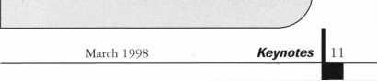

Legislative

Comment

im McMullen-Legislative

Manager

ALOA and NBFAA work together on legislative issues,

On Jan. 16,1998, ALOA President Dallas Brooks and Legislative Manager Tim McMullen met with representatives from the National Burglar and Fire Alarm Association (NBFAA) to discuss the current legislative agendas of the two organizations. Dallas clearly expressed to NBFAA that ALOA wanted fair licensing legislation that does not require locksmiths who do electronic security installation and repair to be subjected to unnecessary training and testing requirements. Using the Alabama and Texas situations as an example, Dallas emphasized the need to come together and decide upon standard industry definitions and skill sets. NBFAA agreed that they would like to work with us on developing such language. For instance, when Dallas brought up ALOAs displeasure regarding the National Association of Security and Investigative Regulators’ (NASIR) Electronic Security Licensing Act, they too indicated the document was unfair to locksmiths and needed to be changed.

The electronic and physical security industry is increasingly regulated at the state level. As licensing laws are enacted, there has been a great deal of confusion and misunder­standing regarding the scope and intent of this licensing. Specifically, there is confusion over the classes of work that are being regulated and the requirements to meet those regulations. In some instances, companies that are in what many would call the “locksmith” trade have been required to obtain “alarm installer” licenses. Often this means that companies that install automatic gates, electric strikes, access control systems, CCTV or even mechanical locks are required to take alarm installer training. Clearly, there is a lack of standard definitions for any of the terms commonly used in electronic and physical security licensing laws.

Much of the licensing activity that has taken place to date has been undertaken by members of NBFAA and ALOA based on their respective model state licensing statutes. Unfortunately, these two very different model laws have been a source of some of the confusion and misunder­standing that has taken place.

h ive (

pi able t

l be

)pa:i

; mo i<

ALOA and NBFAA

and developed an action

create a coalition of assoc

the various segments

physical security industry

This Electronic and Phys i<

Industry Coalition will

definitions and a commo

law that is fair and acce]

of electronic and physical

providing an adequate

the public’s interest. The

coalition is to present th<

Model Law to NASIR,  
they adopt them as the

This model law would

would encourage our stal <

want licensing to introdi l<

ask state regulators to

regulations after this

voice will make it easier

legislatures to pass our

column will keep you up

progress.

All ALOA members

new web page, especially

Update section. It provi

information on what’s

capitols all over the Uni

to-use site will have the

from your state and link;

home-pages. Check it

Finally, in the latest

Survey, when asked, “Dc  
ALOA’s responsibility tc  
locksmith industry from

legislation?” at least 75

resounding “YES!” When

important is it for ALOA

unfavorable legislation

national levels?” seventy

that it was very importa n

“How important is it for

promote practical locksr li

sixty-three percent said

important. However,

percentage of your dues

cause?” the percentage cfi

25 percent. The reality

eight percent of your dues

come together

plan in order to

ations representing

e electronic and

, and related trades,

leal Security

**g** eate standard

i model licensing

to all providers

security while  
el of protection in

intent of the

i^se definitions and

to advocate that

industry standard,

the document we

e chapters who

ice, and we would

tern their licensing

lei. Plus, having one

:o convince

legislation. This

to-date on the

>g(ll

: out

, wl lei

ic tes i

died J

Should check out the

the Legislative

up-to-the-minute

ng on in state

States. This easy-

atest legislation

to state legislature

at **unmv.aloa.org\**

^LOA Membership

you feel it is  
protect the  
objectionable

percent answered a

asked “How

to actively oppose  
the state and

five percent said

t. When asked,  
ALOA to actively

ithing legislation?”

t was very

n asked “What

ihould go to this  
ted most often was

that only about

goes toward

legislative affairs. That’s why it is important when you are renewing your membership that you take the time to donate a little extra to the Legislative Fund. ALOA is very aggressive this year in legislative matters, and it is important that we have the resources to fight legislation that is bad for locksmiths and promote legislation that is fair and equitable.

LEGISLATION UPDATE

This has been a busy time for locksmiths and others in the security industry. Just in the first two weeks of legislative sessions, ALOA is already tracking 15 separate bills related to our industry! Please note that all of the bills carried-over from the last session (See **Keynotes** January 1998) have had no movement so far this year. Below is a listing of the latest:

ARIZONA HB 2433

Relates to alarm businesses and agents; requires alarm agents to be registered with the state.

MARYLAND SB 61

Victory! The Economics and Environ­mental Affairs Committee rejected a bill drafted by the Maryland State Police on the definition of “security system.”

Reason cited: Locksmiths weren’t brought in on the legislative process from the beginning!

NEW YORK AB 5315

Establishes security requirements to be fulfilled by owners of multiple dwelling units including deadbolt locks, window pins, adequate lighting, solid core door and optical viewers.

RHODE ISLAND HB 7376 and SB 2303

Creates a board to regulate the profession of locksmi thing.

SOUTH DAKOTA HB 1131

Exempts locksmiths, locksmith shops, and locks made to individual order from the

March 1998

/

***Keynotes***

LegislativeComment

contractors excise tax; makes them subject to sales and use tax.

TENNESSEE SB 2780 and HB 2454

Redefines “alarm system” to include systems which “Monitor, detect or prevent unauthorized intrusion or departure within a designated area.” Redefines “intrusion” as unauthorized entry or departure within a designated area.

TENNESSEE SB 2391

Prohibits person with prior felony record from installing, modifying or servicing burglar alarm systems.

TENNESSEE HB 2251 and SB 2294

Establishes certification, licensure and/or registration requirements for any person who provides or offers to provide security services and/or investigative services to the general public by creating the Tennessee Security Commission.

VERMONT HB 671

Prohibits electrical installation work to be performed by electrician’s helpers and to permit only journeymen and register apprentice electricians to perform electrical installations under the supervision of a master electrician and only registered apprentice electricians to perform electrical installations under the supervision of a journeyman electrician.

VIRGINIA HB 509

Places electronic security contractors and electronic security employees in equal status regarding registration.

VIRGINIA HB 865

Grants to the Department of Criminal Justice Services the authority to certify private security training schools and instructors, unarmed security officers and electronic security personnel; authorizes the Criminal Justice Service Board to enter into reciprocal agreements with other states; clarifies the

definitions of certain private, security personnel; authorizes the recovery of costs of investigation and adjudication for violations.

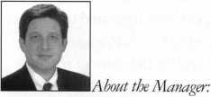

McMullen oversees legislative affairs for ALOA. He is a graduate of the District of Columbia School of Law and has an extensive background in legislative work. If you have information for Tim concerning federal or state legislation affecting the locksmithing industry, contact him at: ALO A; 3003 Live Oak Street; Dallas TX 73204; (214) 827-1701; (214) 827-1810; email: aloa@anet-dfw. com

The Texas  
Locksmiths  
Association

has established a fund for their  
legislative lobbyist. As many of you  
know, last year legislation was passed  
in that state that was very unfavorable  
to Texas locksmiths.

Those who would like to make  
a contribution to this effort  
may do so by making checks  
payable to:

Texas Legislative Fund  
Texas Locksmiths Association  
c/o Mike Clark, President  
P.O. Box 240937  
San Antonio, TX 78224-0937

— Remember —

Fighting bad legislation  
for locksmiths in one state  
is good for locksmiths  
in the other states.

Thank you for your support.

Security Industry Position Paper

The Security Industry Position Paper (see Keynotes February 1998) now has 71 supporters! The updated list includes:

1. Rifkin Co.

Abloy Construction Locking Abus Lock Company Ace Lock & Security Supply Adams Rite Manufacturing Co.

Aiphone Intercom System Alarm Controls Corp.

Armor Garage Door Locks Arrow Architectural Hardware

ASSA, Inc.

Capricorn Electronics Corp. Central Lock Company Cerberus Pyrotronics CCL Security Products Detex Corp.

Don Jo Manufacturing Door Alarm Devices Corp. Doorguard Systems, Inc.

DORMA Group Dukane Corp.

ECSI International Gil-Ray Tools, Inc.

The Hans Johnsen Company Hart Enterprises Ilco/Unican

Imperial Screen Co., Inc.

Industry Lab Infinetics, Inc.

Ingersoll-Rand Company

Jet Hardware Manufacturing Corp.

John Sterling Corp.

Kaba High Security Locks Corp. Kantech Access Control Systems Kenstan Lock Company La Gard, Inc.

LCN Closers Linear Corp.

Lock America, Inc.

Lockmasters, Inc.

Lori Lock

Lucky Line Products, Inc.

M.D.S.

Marks USA  
Master Lock Co.

Medeco Security Locks  
Medeco Canada

MMF Industries/Major Metafab Co.  
National Security Systems, Inc.  
Olympus Lock  
NT Monarch Hardware  
Preso-Matic Keyless Locks  
Progressive Hardware Co., Inc.

Pro Battery Inc.

Pro-Lok

R & R Sales Co., Inc.

Racon, Inc.

Rofu International Corporation  
Sargent Manufacturing Company  
Schlage Lock Company - Commercial  
Securex Americas  
Securitron Magnalock Corp.

Security Door Controls  
Security Electronics Manufacturing  
Select Products  
Sentry Security Fasteners Inc.  
Southern Steel Co.

Supra Products  
Telectrum

U-Change Lock Ind., Inc.

Von Duprin, Inc.

Winfield Architectural Lock Division

March 1998

Keynotes

Industry

News



Dept

ISC/ALOA Join Efforts

As many **Keynotes** readers are aware (see “Upcoming Events,” pp. 8-9), ALOA is offering an Educational Symposium at the ISC West show, March 22-23; at the ISC Chicago show, May 31-June 1; and also at the ISC New York show, Sept. 1-3. ALOA is pleased to be able to provide additional class­es at these events for the benefit of members and the overall security community. ALOAs contribution to ISC is in the response to requests from membership for more regional educational opportunities.

Two other organizations are also partici­pating in the May ISC show. Central Station Alarm Association (CSAA) and the Illinois Electronic Security Association (IESA) are endorsing ISC Expo/Chicago, to be held at the Metropolitan Navy Pier. CSSA counts among its members companies including ADT, Guardian Protection and Rollins.

IESA is the Illinois chapter of the National Burglar and Fire Alarm Association. CSAA’s endorsement of ISC EXPO/Chicago '98 will include holding CSAA board and committee meetings at the event. IESA’s participation will include a board meeting and some com­mittee luncheons.

Corporate Security Awareness

The corporate security function in Fortune 1000 companies is taking an increasingly strategic role in identifying, assessing and safeguarding against new and familiar securi­ty threats facing business operations. This is a key finding of a new survey of corporate security directors, conducted by Pinkerton’s, Inc., (NYSE:PKT) and the American Society of Industrial Security (ASIS). Corporate secu­rity directors are becoming increasingly focused on providing leadership and counsel to executive management; linking the securi­ty function to the company’s goals and strate­gy; and finding ways to productively mea­sure and communicate the value of their con­tribution. The study appears in the October issue of **Security Management** magazine. The security function has seen increased recogni­tion in corporate America, with 83 percent of security directors currently reporting to either executive-level management or the

head of the company. The

list of corporate issues to

extent management seek*

security professionals. Tl

percent) of respondents i

tives involve them in “ris

discussions, a positive in

importance of the securit **i**

involving consolidation

(78 percent) and staffing

(76 percent) were also higl

**Keynote’s** upcoming April  
tional Locksmithing” for

on this trend.)

study analyzed a

< letermine to what

the counsel of

e vast majority (92

indicated their execu-

c management

ic icator of strategic

function. Issues

cf corporate facilities

md hiring policies

;h on the list. (See

issue on “Institu-  
more information

and no. 5,443,339, gives unique protection to the technologies Axxess employs in the PC+ computerized key cutting machine capable of cutting to code and duplicating key blanks. PC+, introduced in mid-1996 is a joint development and marketing program of Axxess and Curtis, and has been chosen by almost 2,000 auto dealers in the United States as their solution to accurate and reli­able key cutting. The major auto rental com­panies have also made PC+ their system of choice. Today’s tight tolerance auto key sys­tems, along with transponder and VATS key blanks costing up to 50 times more than tra­ditional keys, demand precise and reliable key cutting.

Pomp and Circum:

Eight scholarship win i<

attend 1997-98 DHI

For the second consecutr r<  
MA Group has supported

Hardware Institute’s **coj**

tion by sponsoring scho]

who want to further thei  
careers. This year’s award

nifer M. Casedy of JC B;

Company, Albuquerque,

Ditta of Ditta Door and  
Jonesboro, Ariz.; Blaine

tributors LTD, Edmontojn

Lauchlin D. MacMillan,

Ryan & Sons, Inc., Thorir

Richard Copron of Bosker

Battle Creek, Mich.; Nan<

Security Lock Distributers  
Heights, Mass.; Rhonda F.

Wholesale Hardware, Mi;

Thomas E. Seidel of Hoi^si

ny, Altoona, Pa.

Each scholarship will

tuition and transportaticn

the December 1997 or

sion in Orlando, Fla., the

in Fort Worth, Texas, or

sion in Phoenix, Ariz.

New Axxess Gizm 3

The U.S. Patent Office

patent No. 5,676,504 ei

Machine with Key Tracijn.

Code Cutting Duplicate >n

Technologies, Inc. This

tion with two earlier pateni

Stance

iers were selected to

nical programs,

e year, the DOR-

the Door and  
nitment to educa-

**Ai** Lrships for students

knowledge and

winners are: Jen-

a idridge Lumber

N.M.; Anthony J.  
hardware, Inc.,  
iCing of Allmar Dis-

Alberta, Canada;

Jr. of Joseph C.

wood, N.Y.;

Brick Company,

icy J. Duntley of

, Needham

?. Lopez of Farrey’s

iami, Fla.; and

ton-Starr Compa-

cover the cost of

expenses to either

December 1998 ses-

March 1998 session

the June 1998 ses-

has issued U.S.

ntitled “Key Cutting

i**g** and Electronic

Mode” to Axxess

] >atent, in conjunc-

ts, no. 5,314,274

G’day, mate!

Detection Systems, Inc. reported that it purchased Electronics Design & Manufactur­ing Pty Limited (EDM), an Australian- based manufacturer of electronic security and fire control and communication equipment, for $5.1 million. In business since 1975, EDM is a major Australian manufacturer of security control equipment. EDM is now selling to Asian markets also, including Chi­na. Detection Systems and EDM have recent­ly completed supply agreements with Signa­ture Security, Australia’s fastest growing alarm installation and service company Detection Systems, Inc. is a supplier of equipment to the electronic protection industry, with facilities in New York, Cali­fornia, the United Kingdom, Belgium, France, Australia, New Zealand, Hong Kong and China. The company designs, manufac­tures and markets electronic detection, con­trol and communication equipment for secu­rity, fire protection, access control and closed circuit television applications.

Oh, Brazil!

Excelsior Group, a hardware and house- wares retailer, is searching for a U.S. hard­ware and houseware related company with strong interest to enter the Brazilian market. Excelsior is proposing to form a group of U.S. companies, six to 10 from the same sec­tor to enter an ever growing Brazilian mar­ket. **Excelsior Comercio e Representacoes** is a 48- year-old hardware and retailer located in the city of Belo Horizonte, in the state of Minas Gerais, with a population of two million peo-

141 ***Keynotes***

March 1998

|  |  |
| --- | --- |
|  | Industry |
|  | News |

pie and a total of four million in the greater metropolitan area. Belo Horizante is located in the south central region of Brazil state of Minas Gerais with a total state population of 16.5 million. MG’s gross domestic product (U.S. $55 billion) is equivalent to that of Columbia and Chile. Excelsior does market research, business negotiation and advertis­ing between Brazilian industries they repre­sent and their client distributors. Most recently, Excelsior represented URFIC-Solid Brass from Portugal, the largest European manufacturer of lock accessories by doing in- depth research and retail proposals.

A Tale about Tailpieces

Due to the discontinuation of Schlage’s B400 series and the redesign of their dead­lock tailpieces, Kaba will no longer supply tailpieces with Peaks or Gemini “60” style lost motion cylinders. Existing tailpieces should be used. Replacements can be obtained through your Schlage Distributor.

A new universal lost motion cylinder is cur­rently in Kaba engineering and will eventu­ally supersede the current design.

Ingersoll-Rand/Master Lock

Ingersoll-Rand today announced an agree­ment to purchase door hardware technology and intellectual property relating to residen­tial door locksets from the door hardware division of Master Lock, a subsidiary of For­tune Brands, Inc. The transaction, which covers patents and some manufacturing assets used to produce residential door locks, excludes padlocks. The lockset technology will be incorporated into Ingersoll-Rand’s Schlage Lock business. Federal Trade Com­mission approval is complete. The transac­tion is expected to be completed in the first quarter of 1998. Terms were not disclosed.

Dorma’s Growing

Spurred by continued business growth and the addition of three new product lines, Dorma Door Controls, Inc. has expanded its Reamstown manufacturing facility with a 25,000 square foot addition. Completed in October 1997, the $1 million, two-story addition allowed Dorma to reorganize its current manufacturing operations and begin production of three product lines that will be

introduced in 1998: the 9000 Series exit device, 7900/8900 Series narrow-projection surface closer and ED600 Series low-energy operator. Dorma will hire about 12 addition­al full-time employees from the Berks and Lancaster county areas to manufacture the new products and support the company’s continued growth. This addition will bring the total workforce to approximately 175 employees.

ASTM Celebrates With Contest

ASTM (the American Society for Testing and Materials) has committed 1998, its cen­tennial year, to highlighting how ASTM standards contribute to the promotion of health, safety, cost effectiveness, and efficien­cy, and how they beneficially impact com­merce and trade. One of the ways to do this is to accurately document how an ASTM standard or group of ASTM standards has made a measurable difference in a company, industry government agency, or in the lives of consumers. The contest is open to anyone except for current ASTM employees and the following prizes will be awarded to the top three papers. Papers submitted must accu­rately address the following issues in detail:

* A problem facing an industry government agency company or the consumer that was solved by an ASTM standard or ASTM stan­dards. Examples of such problems could be safety issues, impediments to trade, product inconsistency or high costs.
* The resources necessary for developing the standard, such as manpower, research, or interlaboratory testing programs.
* How the resulting standard(s) was applied.
* Most importantly, the beneficial impact of standard(s). The case study must demon­strate through measurable and quantitative details the tangible and intangible value of the standard, including cost savings, cost avoidance, product improvement, public safety, etc.

For registration information, contact Mario Sikoar at ASTM, 100 Barr Harbor Drive, W. Conshocken, PA 19428, (610) 832-9607,(610) 832-9623 fax;

[msikora@astm.org](mailto:msikora@astm.org) e-mail.

Yes!

ISO 9000, the international standard that signifies an assurance of quality and process control, was granted to Adams Rite Manu­facturing this past June for their design/development, production, installation and servicing of architectural hardware prod­ucts. The certification requires companies to run more effectively and with fewer prob­lems and product returns.

■Executive News

Big Doin’s At Yale

Yale Security Group is pleased to  
announce the addition of Scott D. Baker to  
its training staff. Group holds a degree in  
Architecture from the University of Illinois.  
Prior to joining Yale, he held sales and  
management positions with Rixson, Folger,  
Adam, and the Spargo Group, Yale’s sales  
agency in Chicago. He will join Lee A.  
Garver, AHC, David Loughran AHC/CDC  
and Joseph Yatsinko, DAHC in fulfilling  
Yale’s commitment to provide continuing  
industry education for architects, distribu-  
tors, building owners and sales personnel. In  
addition to his duties, Scott will continue as  
an AH 1-2 instructor for the Door and  
Hardware Institute in Tempe, Ariz.

Rutherford Sales Addition

Rutherford  
Controls, Inc., is  
proud to welcome  
David S. Smith as  
their new Eastern  
regional sales  
manager. Smith  
has an extensive  
background in electric  
locking and contract

hardware. Rutherford has added Smith  
as part of their program of innovation and  
service-oriented leadership.

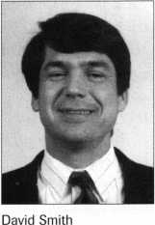

March 1998

Keynotes



The Hartford/Seabuiy and Smith

Alarm dealers help protect their customers’ assets by detecting events such as fires or break-ins. Now alarm dealers can look to The Hartford, one of the nation’s largest and most respected insurance companies, to protect their businesses.

AlarmPaC formerly called OnGuard is aimed at the nation’s 14,000 alarm companies that install, maintain, and monitor security systems for residential and commercial customers. The program was first introduced almost three years ago and has been growing rapidly, especially during the past year. AlarmPaC provides general liability protection, including errors and omissions coverage for monitoring systems the alarm contractor designs and installs, plus property, crime, inland marine, automobile, workers’ compensation, and umbrella. Employment Liability (EPLI) coverage is also available.

The Hartford (860) 347-4976 Seabury and Smith (212) 313-3053 ***Reader Service*** #7

Lockmasters

Lockmasters has announced the addition of LAB universal pinning systems to their product line. Available are Universal Pins, Original Manufacturers Pins, Original Pinning Kits, Semi-Pro Series Kits, Mini Dur-x Kits, Original 3-in-l Auto Kit, Inter­changeable Core Kit and more. Lockmasters provides free tool and equipment catalogs with replacement pin order forms. **Lockmasters 5085 Danville Road Nicholasville, KY 40356-9531 (800) 654-0637 (606) 885-7093 fax Reader Service** #8

Ingersoll-Rand

A redesigned line of automatic and constant-latching flush bolts introduced by the Glynn-Johnson Division of Ingersoll- Rand’s Architectural Hardware Group has passed UL fire tests. Some models use a single top bolt with a special bottom bolt (designed LBB) that does not require a floor prep. In addition, the new patent-applied-for

design requires consideral

previous versions. Instead

flush bolt that engages a

the new automatic and c<

models now incorporate

activated lower bolt that

extends from one door of

when the temperature e:

its fusible link. This help;

withstand the effects of fi

with the listing, yet no

flush bolt is required. B

conventional lower flush

models, the time required

cut almost in half. Opera  
further reduced, and field  
associated with the botto

caused but door and frame

eliminated.

Ingersoll-Rand  
2720 Tobey Drive  
Indianapolis, IN 46219  
(317)899-9440  
(317) 899-9432 fax  
***Reader Service*** ***#9***

tbly less force than

of a typical lower

floor strike, some of

cnstant-latching

temperature-  
utomatically

pair into the other

xieeds the rating of

secure the doors to

:e, in accordance  
nventional lower

>y eliminating the

Dolt on these

for door prep is

:ing forces are

problems

n latch, often

warpage, are

[2,0i

c red ]

Ace Lock and Secui

The new, technologies 11;

Fortronics Model 2,000  
electronic access control

immediately to locksmit

Lock and Security Suppl;

easy to operate, Model

stand-alone battery pow<

button keypad that offer: i

both code numbers and

or a combination of both,

combinations in the mill|i<

user to open a safe in a

hand dials, and is perfect

want to build profits

yet affordable safe lock.

Ace Lock and Security Supply

565 Rahway Avenue

Union, New Jersey 07083

(800) 223-5625  
(800) 223-3294fax  
***Reader Service*** ***#10***

Sargent and Greenleaf

Sargent and Greenleaf have added UL

Group 2M to their prod ict line. These new

mechanical combination locks are the 6600  
Series. The 6600 design meets the new

**l** fr ici

> with

rjty Supply

[y advanced

programmable  
safe lock, is available

is through Ace

**r.** Priced to sell and

00 is a rugged

lock with a 12

the flexibility of

e lectronic data keys,

with possible

ons. It allows the

tion of the time of

for locksmiths who

a highly desirable

requirements of Underwriters Laboratory’s standard for high security combination locks (UL768) Group 2M. The new category requires at lease two hour resistance to expert manipulation as well as all other operational and security requirements of the standard. The 6600 Series has the same high quality materials and workmanship as our traditional 6700 Series R Locks, the standard of the safe lock industry for over 35 years. The 6600 design utilizes an eccentric roller on the end of the drop lever, and five false gates per wheel. The product is available in 3-Wheel and 4-Wheel models. The 6600 Series will use the same S&G dials as the 6700 Series. **Sargent and Greenleaf (606) 885-9416 Reader Service** **#11**

Hanchett Security Systems, Inc.

The 5,000 Series is a new concept in electric strike, developed with only a 1-1/16" setback for low profile installations, but the strength of a high security product. During a recent forcing test, conducted by a UL rated facility, the 5,000U installed with a 501- Option in an ANSI metal jamb withstood over 2,385 pounds before the electric strike itself did not break open during the test. However, when energized the electric strike still operated. The 5,000U electric is designed with a heavy duty stainless steel inner structure to provide strength and durability. Additionally, the pivot and locking points have been kept close to the point of force, allowing the force to be distributed throughout the inner structure and into the door frame. This unique design allows the unit to be compact, yet have the strength equal only to the HES 1,003 series. **Hanchett Entry Systems, Inc.**

2040 W. Quail Ave.

Phoenix, AZ 85027 (602) 582-4641

Reader Service #12

Trimec

Trimec, a subsidiary of Trimec Australia Pty. Ltd. has announced the commencement of its U.S. Operations from Dec. 1, 1997. Trimec was incorporated in 1990 in Australia with the single aim to design and manufacture innovative locking products of high quality, and substantial security. In just

161 ***Keynotes***

March 1998

seven short years, Trimec has obtained a market share of 70% of the quality/security end of the market in Australia. Trimec “ES Burglar Resistant” strikes have been success­fully used in major projects throughout the world, including major airports, government buildings, major commercial and retail buildings, and local and international banks. In November 1997 the ES Series Strike met the standards of UL1034 for Burglar Resistant Electric Locking Mechanisms, helping to propel Trimec s initial launch into the U.S. marketplace.

Trimec

835 Sharon Drive Westlake**,** OH (414) 375-8330 ***Reader Service #13***

Securitron

The UL listed EXD-1 now includes the MXD-1 door movement exit delay initiation device. The MXD-1 was awarded Judges’ Choice from the Security Industry Association’s New Product Showcase at the recent IC East ’97. Securitron’s modular concept of exit delay allows complete freedom to choose the method of detecting exit delay; the MXD-1, the reliable TSB-3 series Touch Sense Devices, fire-rated mechanical panic hardware or the Latch monitor series of latch detection devices. The MXD Series is a unique initiate device that uses any standard model 32 or 62 Magnalock® and the reverse action plunger to allow code compliant door-movement initiation, up to one inch, while allowing automatic door return re-latch in case of accidental exit delay initiation. The MXD Series, designed in a stainless-steel housing, works with existing fire and non-fire doors rated hardware with no obvious initiate switch that eliminated tampering. Unlike other door movement devices the MXD-1 does not cause “false alarms” due to changes in building pressure or door “rattling.” **Securitron Magnalock Carp.**

550 Vista Blvd.

Sparks, NV 89434 (800) Magnalock (705) 355-5636fax ***Reader Service #14***

**Security**

Marketplace

Security Lock Distributors

Augmenting their inventory of Simplex residential and commercial products,

Security Lock Distributors stocks every replacement part and accessory, in all sizes, finishes and functions. Among the available products from Security are all 1,000 series heavy duty, primary locksets recommended for high traffic areas. The 1,000 series lockset includes key override and passage entry features. Security also carries the remainder of the Simplex line, which includes exit device controls, switch controls, auxiliary and cabinet locks, with all parts and accessories. **Security hock Distributors (800) 847-5625 (800) 878-6400fax**

[SECLOCK@lX.NETCOM.COM](mailto:SECLOCK@lX.NETCOM.COM) email

httpllwxvw.seclock.com

Reader Service #15

American Lock

American Lock Company has published a new service parts list. The newly updated parts list is a vital resource and reference tool for security professionals and distributors. It reflects new package quantity configurations, new model numbers and updated pricing for American Lock Key blanks, cylinders, shackles, retainers, cover plates, rim and mortise parts, etc. It includes parts required to service American Lock’s newest padlocks such as solid steel Models, 780, 790 and 2010.

American Lock 3400 Exchange Road Crete, III. 60417-2099 (800) 323-4568 (708)534-0531 fax ***Reader Service #16***

NT Dor-O-Matic

Why mess with a good thing, unless it’s to make it even better? NT Monarch, the manufacturer of a full line of panic/exit devices and precision door controls, announces the re-release of the Centron, its popular low-cost Grade 1 door hardware trim and pull. Once retired in favor of a one- piece design, the Centron has been brought back by market and distributor demand. The Centron is available in a stainless finish for durable wear and can be specified in locking or dummy trim, with or without an optional

51/2" CTC, 3/4" diameter round pull handle.

For added security the Centron features a new anti-rotational cylinder anchor to prevent security breeches caused by cylinder rotation. The trim is furnished left hand reverse unless otherwise specified. Available for the NY Monarch 19 Series only, Centron Trim is excellent for exterior back door use in high security commercial applications such as schools, churches retail stores, and office buildings.

The Centron, like all NT Monarch hardware, is built to meet or exceed ANSI/BHMA standards for security door trim and plates.

NT Monarch

805 North Buckingham Street Shepherdsville, KY (800) 826-5792 (502) 543-3089 [WWW.Newman](http://WWW.Newman) Tonks.com ***Reader Service #17***

ADI

ADI, a wholesale distributor of security, low voltage and structured cabling products has opened its 100th branch location. With centers located in the United States, Canada, Puerto Rico and Mexico, ADI has hit the 100 mark with the opening of its Tulsa,

Okla. center. It is located at 4731 South Memorial in Tulsa, OK, 74145. The phone number is (918) 663-2822 and the fax number is (918) 663-2803. ADI product lines include Fire, Burglary, CCTV, Access Control, Sound & Communications and Structured Cabling. Customer convenience programs include product training, technical and systems support, pick-up anytime, same day shipping, next day delivery, flexible credit terms, financing/leasing programs, acceptance of VISA, MasterCard and Discover, web page, comprehensive product and systems catalogs, and an on-going interna­tional Expo series. ADI is a subsidiary of the Pittway Corporation. To reach your nearest ADI location, please call (800) 233- 6261.

ADI

180 Michael Drive Syosset, NY 11791 (516) 921-6700 ***Reader Service #18***

***Keynotes \*** 17

March 1998

**changes to the ALOA Bylaws and**

**jview of the importance of this**

**The ALOA Board of Directors met in February, earlier than normal for its  
traditional spring board meeting. The main purpose of this early meeting was to**

**get a head start on all necessary or desirabl**

**the ALOA Certificate of Incorporation. In**

**measure, the board wanted its members, ii s lawyers and you, the ALOA  
membership, to have ample time to prepa e for the membership vote on the  
revisions long before the June 20 Member ;hip Meeting in Nashville, Tenn.**

**Why is the board suggesting these chaiges? In the beginning, they were just responding to the spring 1997 membersh p survey in which members indicated a strong preference for the ability to vote t y mail when they are unable to attend the annual ALOA membership meeting in person. When the board’s committee of the whole met in the fall of 1997 to figure out how to do this, they discovered that it would require changing the bylaws*. A closer look at the bylaws revealed that, in fact, portions of the “legal” docurr ents that established the Associated Locksmiths of America, Inc., were out-of-date, both from an operational standpoint and according to current New (York State law! (FYI: For those of you who joined in the years since the ALOA headquarters was moved to Dallas, the association was originally located in New York.) In the end, the board decided it was best to do a comprehensive review of i he entire ALOA bylaws, as well as the ALOA Certificate of Incorporation, to make everything easier to understand, more flexible, in compliance with New York state law and, most importantly, to provide ALOA members with the best for m of association governance and management possible.**

**The first draft of the proposed new Certificate of Incorporation and of the new bylaws are published at the end of this article. (The final version that you will**

**irticle needs to be changed to make the Secretary of the State of New York the**

**registered agent, and to instruct the Secretary to inform ALOA of official corre-  
spondence at the ALOA offices in Texas.**

**The final proposed amendment grants to the officers of the association the**

**authority to file the new certificate as amended by the members (i.e., you).**

**Don’t tune out yet—an exciting edition of “Inside the New Bylaws” is next.**

**vote on in Nashville will be reviewed andji**

**dotted and “t”s crossed. The “final” versioh**

**convention.) But first, let’s look at the reasons and intentions behind the recon-**

**struction.**

**approved by board this spring, “i”s**

11 **will be printed in Keynotes before**

One Law Leads to Another

**Here’s how it goes. The basic document that establishes ALOA as a legal**

**entity is the Certificate of Incorporation. "Tie certificate must be written in**

**keeping with the laws of the state of New York. In the event of a conflict**

**between the certificate and the law, the la v governs. Next, the bylaws must be  
written to agree with the certificate. But now, we’re getting ahead of ourselves.  
Let’s first discuss the changes the board is proposing to the first, third, fifth and**

**eighth articles of the certificate. (The other articles remain the same.)**

**The proposed First Article of the ALQA Certificate of Incorporation redefines**

**the objects and purposes of the associatior. These purposes haven’t substantially**

**changed—they were just in the wrong pi ice (at the beginning of the bylaws**

**instead of here where they’re really supposed to be.)**

**Proposed changes to the Third Article f**

**compliance with New York law. The original provided that the association**

**would operate in all “forty eight” states, t ut that the principal place of business**

**would be New York State. (OK, where is t**

**the ALOA offices are in Texas. The members, officers, directors and others**

**the Staten Island Ferry then?) In**

**addition, New York law requires that a a >unty in the state be named as the**

**“location” of the corporation-even though  
revised article would also provide that tht**

**are not to share in the earnings of the corporation except for reasonable compen-  
sation for services rendered. Part (b) of the change goes on to explain how assets  
of the corporation are to be distributed if the corporation were to be dissolved.**

**The Fifth Article sets the number of directors for the corporation. Currently**

**the number is between five and 15. The board suggests changing this article to  
allow the number of directors to be set by the bylaws. This gives the ALOA  
membership the ability to change this m< >re easily.**

**The Eighth Article of the Certificate 1 ad named Harry Gold as the registered**

**agent of ALOA. First of all, do any of yoij**

Keynotes

**primarily bring the Certificate into**

**know Harry? We didn’t. Anyway, the**

**Our bylaws are the basic Riles that govern ALOA. They are rules that may not**

**be changed without following procedures established for change. In the case of our  
association, the board makes changes that become effective when approved by the  
ALOA membership. Only the important rules needed to govern the association  
should be in the bylaws. (The board can establish other rules.)**

**Most of the changes recommended to the membership do not significantly alter ALOA operations. For instance, the reference to the ALOA Code of Ethics has been moved from Article II to Article III, Section 5. This makes it clear that members are required to abide by the Code of Ethics and that failure to do so may result in loss of membership.**

**Changes that are substantive include adding the right of members to vote by proxy! (At last, we’re back to the original project.) Actually, voting “by mail” in the most literal sense is not allowed under New York law. But voting by proxy is. Althought proxies may be used in a variety of ways, the board will propose rules. The board suggests that the rule be established so that the holder of the proxy can only use the proxy to vote the way instructed by the member who gave the proxy. Make sense? In other words, you will be able to give your proxy to another member and that individual will have to cast the vote as you specified. This makes it difficult for someone to gather up a large number of proxies and control a meeting. A final note, voting by proxy is only allowed for the election of officers and directors, and for voting on bylaws. Other issues requiring membership approval would still have to be voted on in person.**

**Another noteworthy change is one for which many ALOA members have voiced a preference. This change allows for more regionalized representation on the ALOA board. The proposed change would allow only members of a region to vote for the directors from their region. (We hear some cheers out there.) The number of directors will be set according the number of members in that region, with no region having more than three directors.)**

**The only officers on the board elected by the membership as a whole will be the president and the secretary. Happy?**

**Term limits have also been set for officers and directors. This is intended to give as many members as possible the opportunity to serve on the board.**

**We’ve also tried to respond to the needs and rights of our associate members—firms that have joined as corporate members. The new bylaws would allow a company one vote, just as individual members are allowed one vote. Associate members would be listed as a separate “region” and would be entitled to elect one representative to the ALOA board. This will allow the many companies that have supported the association to have representation on the board, and to lend their invaluable expertise to ALOA governance.**

**Finally, recognizing the difficulties we’ve had achieving and maintaining a quorum at the annual meeting, the proposed bylaws would change that from 250 to 100 (or 10 percent, whichever is less).**

**ALOA leadership believes that the preferences expressed by many members over the years were supported by the results of the spring membership survey. The leadership needed this clear direction along with a new understanding of how contemporary management methods can result in outstanding member service and industry growth. Together those provided the inspiration for all the extra work that had to go into formulating these proposed changes. Was it worth it? “ALOA members are always worth it,” responds ALOA President Dallas Brooks. “The silent majority of locksmiths in our association have waited a long time for us to go the extra mile for them. I’m glad we’re doing it.”**

Comments Welcome

**So this covers the major changes proposed. We didn’t discuss every new comma and semicolon, but you’re welcome to review the following in its entirety. Comments and questions should be directed to: ALOA Bylaws Project; 3003 Live Oak Street; Dallas, TX 75204; fax (214) 827-1801; email [publ@anet-dfw.com](mailto:publ@anet-dfw.com).**



Proposed Amendments  
To ALOA Certificate Of Incorporation

RESOLVED, that the Board of Directors of the corporation recommends to the members that the third paragraph of Article FIRST of the Certificate of Incor­poration of the corporation which begins with the words “The object and purpose” be deleted and replaced with the following paragraph:

The objects and purposes of the corporation are to serve as a trade association as defined in Section 501(c) of the Internal Revenue Code as amended, including but not limited to:

1. Educate, and to encourage, promote, aid in, and effect the voluntary interchange of data, information, experience, ideas, knowledge, methods, and techniques relating to the profession of locksmithing among members of the profession.
2. Elevate the position of those engaged in installing and servicing security products, in all its branches, and establish a standard of qualification for membership.

FOURTH. The county within the State of New York in which the office of the corporation is located is Ulster County.

FURTHER RESOLVED, that the Board of Directors of the corporation recommends to the members that Article FIFTH of the Certificate of Incorpo­ration be deleted and replaced with the following Article FIFTH:

FIFTH. The number of directors of the corporation shall be set forth in the corporation’s Bylaws.

FURTHER RESOLVED, that the Board of Directors of the corporation revokes the designation of Harry Gold as the corporation’s registered agent and recommends to the members that Article EIGHTH of the Certificate of Incor­poration be deleted and replaced with the following new Article EIGHTH:

EIGHTH. The Secretary of State of New York is designated as agent of the corporation upon whom process against the corporation may be served, and the Secretary of State of New York may mail a copy of any process served upon him or her to the corporation at 3003 Live Oak Street, Dallas, Texas 75204-6186.

1. Work with the manufacturers and distributors of security  
   products toward a sympathetic understanding of our mutual  
   problems.
2. Establish a uniform code of ethics and promote and  
   maintain friendly cooperation among all locksmiths.
3. Cooperate with organizations related to the industry.
4. Perform and do any and all such acts as are necessary and  
   proper to the attainment of these objects and purposes.

RESOLVED, that the Board of Directors of the corporation recommends to  
the members that Article THIRD of the Certificate of Incorporation of the  
corporation be deleted and replaced with the following new Article THIRD:

THIRD, (a) No part of the net earnings of the corporation  
shall inure to the benefit of, or be distributable to its  
members, directors, officers, or other private persons, except  
that the corporation shall be authorized and empowered to  
pay reasonable compensation for services rendered and  
to make payments and distributions in furtherance of the  
purposes set forth in Article FIRST hereof.

(b) Upon the dissolution of the corporation, the  
Board of Directors shall, after paying or making provision  
for the payment of all of the liabilities of the corporation,  
dispose of all of the assets of the corporation exclusively for  
the purposes of the corporation in such manner, or to such  
organization or organizations as shall at the time qualify as an  
exempt organization or exempt organizations under Section  
501**(cX**6) or Section 501(cX3) of the Internal Revenue Code of  
1986 (or the corresponding provision of any future United  
States Internal Revenue Law), as the Board of Directors shall  
determine. Any assets not so disposed of shall be disposed of  
by the Circuit Court of the county in which the principal  
office of the corporation is then located, exclusively for such  
purposes or to such organizations, as said Court shall  
determine, which are organized and operated exclusively  
for such purposes.

FURTHER RESOLVED, that the Board of Directors of the corporation

recommends to the members that Article FOURTH of the Certificate of Incor

poration be deleted and replaced with the following Article FOURTH:

BOARD PROPOSES CHANGES TO

INCORPORATION/BYLAWS

ARTICLE I  
NAME

The name of the corporation shall be Associated Locksmiths of America, Inc.

ARTICLE II

NOT FOR PROFIT CORPORATE  
STATUS; PURPOSES

Section 1. Not For Profit. The corporation is organized under and shall operate as a New York not-for-profit corporation, and shall have such powers as are now or as may hereafter be granted by the New York Not-For-Profit Corporation Law, as amended.

Proposed Bylaws of the  
Associated Locksmiths of America, Inc.

FURTHER RESOLVED, that upon receiving the approval of the members with respect to the foregoing amendments to the Certificate of Incorporation, the appropriate officers of the corporation be, and the same hereby are, authorized and directed to execute such documentation and take such other action as is necessary to amend the corporation’s Certificate of Incorporation.

March 1998 Keynotes

Section 2. Purposes. The purposes of the corporation are those set forth in its Articles of Incorporation.

ARTICLE III  
MEMBERS

Section 1. Classes of Members. The corporation shall have seven classes of members: Active, Apprentice, Retired, Life, Allied, Associate and Honorary, all with the respective rights and privileges as herein described.

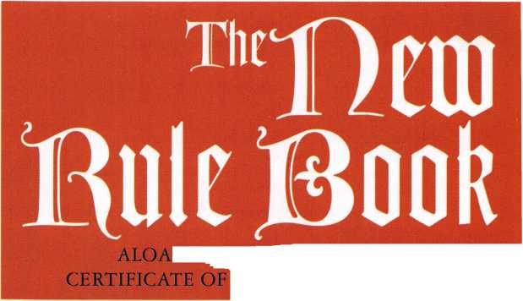

1. Active Members. Persons who have been actively engaged in the locksmith/access control industry for a minimum of two years and can provide at least two of the following items:
2. Character reference from a member of the corporation or a local locksmith association;
3. Character reference from two locksmith/access control industry related sources; and
4. Proof of employment in the locksmith/access control industry.
5. Apprentice Members. Persons who are undergoing training to qualify as an Active member. No person shall be an Apprentice member for more than two years.
6. Retired Members. Persons who have been:
7. Active members for at least fifteen (15) years, have reached the age of sixty-two (62) and have withdrawn from active engagement in the locksmith/access control industry; or
8. Active members who have become disabled and have withdrawn from active engagement in the industry.
9. Life Members. Persons who are past Presidents of the corporation, or who have provided exceptional service to the corporation, as determined by at least a two-thirds vote at a meeting of the Board of Directors.
10. Allied Members. Persons who have a position in the locksmith/access control industry that relates to locksmiths, meet requirements 1 and 3 of Active membership, and can qualify for no other class of membership.
11. Associate Members. Firms that manufacture or distribute material or equipment, or provide services, for the locksmith/access control industry.
12. Honorary Members. Persons who have made a significant contribution to the locksmith/access control profession or the attainment of the corporation s objectives, as determined by at least a two-thirds vote at a meeting of the Board of Directors.

Section 2. Eligibility; Admission of Members. No person shall be eligible for membership if he or she has been convicted of any crime involving fraud, dishonesty or breach of trust. Applicants for all classes of membership (other than Life and Honorary membership) shall be admitted to membership upon the full and accurate completion of a membership application, certification by the applicant that he, she or it meets the relevant membership criteria and payment of applicable dues.

Section 3. Rights of Members. Only Ac tive, Apprentice, Retired, Life, and Associate members shall have the right to vote, and each such member shall be entitled to one vote on each matter submitted to a vote of members. An Associate member shall notify the Secretary of its employee who shall be its designated representative to vote and be eligible to serve as an officer or Director on behalf of the Associate member. Only Life members and persons who have been Active, or Associate members for the prior three years are eligible to serve as officers and voting directors of the corporation. All members are eligible to serve as non-voting directors.

Section 4. Resignation. Any member may resign by sending a written resigna­tion to the Secretary at the principal office of the corporation. Such resignation shall not relieve a member of any outstanding obligation to the corporation.

Section 5. Termination of Membership. Membership in the corporation shall automatically terminate whenever a member is ninety (90) days in default of any dues, assessments or other financial obligations to the corporation. Membership in the corporation may be terminated by action of the Board of Directors for conduct deemed detrimental to the corporation, for conviction of any crime involving fraud, dishonesty or breach of trust, or for violation of these Bylaws, the Corporation’s Code of Ethics, or any rule of the corporation. Termi­nation by action of the Board of Directors shall be by at least a two-thirds vote at a meeting of the Board of Directors; provided, however, that prior to any such action, the member involved shall be given due notice and shall be entitled to a hearing before the Board of Directors. Any member who is terminated by the Board has the right to appeal the decision to the Membership at the Annual Membership meeting. Such an appeal must be made in person, or by representative, and the Corporation must be provided with a written notice of the intent to appeal that must be received no less than 30 days prior to the Annual Membership meeting.

St ction 6. Reinstatement. A former member terminated by reason of default in the payment of dues, assessments or other financial obligations to the corpo­ra ion may be reinstated by showing proof of qualification and paying all m Dneys due and owing to the corporation.

St ction 7. Dues and Assessments. The Board may determine from time to tii ne the amount and method of payment of any and all applicable dues and as iessments.

ARTICLE IV

MEETING OF MEMBERS

S< ction 1. Annual Meeting. An annual meeting of the members shall be held at such time and place as the Board of Directors may determine for the purpose of conducting such business as may come before the meeting.

Si action 2. Special Meeting. Special meetings of the members may be called b **r** the President, by the Board of Directors, or by not less than ten percent (10%) of the members having voting rights.

S iction 3- Notice of Meetings. Unless otherwise required by the New York b ot-For-Profit Corporation Law, as amended, written or printed notice stating tl ie place, day and hour of any meeting of members shall be delivered, either p ?rsonally or by mail, to each member entitled to vote at such meeting, not less titan ten (10) nor more than fifty (50) days before the date of such meeting, by o: at the direction of the President, or the Secretary, or the persons calling the n leeting. In the case of a special meeting, or when required by statute or by tl tese Bylaws, the purpose or purposes for which the meeting is called shall be si ated in the notice. If mailed, the notice of a meeting shall be deemed d divered when deposited in the United States mail addressed to the member at his or her address as it appears on the records of the corporation, with postage t lereon prepaid. Any member may waive notice of any meeting.

S ection 4. Quorum and Manner of Acting. A quorum of the voting n lembers shall be the lesser of one hundred voting members or one-tenth of the v oting members. If a quorum is not present at any meeting of members, a r lajority of the members present may adjourn the meeting without further r otice. If a quorum is present, the affirmative vote of the majority of the r iembers represented at the meeting and entitled to vote on a matter shall be §t ie act of the members, unless the vote of a greater number is required by law, t ie Articles of Incorporation or these Bylaws.

5 ection 5. Proxies. A voting member may vote by proxy with respect to the e lection of officers and directors and the amendment or modification of these 1 lylaws, provided the proxy is executed in writing by the member or his or her c uly authorized attorney-in-fact. No proxy shall be valid after eleven months f -om the date of its execution unless otherwise provided in the proxy.

ARTICLE V OFFICERS

Section 1. Officers. The officers of the corporation shall be a President and a {lecretary. The offices of President and Secretary shall not be filled by the same ] >erson.

! lection 2. Election and Term of Office. The officers shall be elected by the ' noting members for a two year term. A person may serve as the President of the corporation for no more than one (1) term, and may serve as the Secretary for no nore than four (4) consecutive terms. The officers shall be elected in odd- lumbered years at the special meeting of the members, and shall serve until :heir successors have been duly elected and qualified. Candidates for offices shall :>e nominated in accordance with policies adopted by the Board of Directors.

Section 3. Removal. Any officer elected by the members may be removed by :he members. Any officer elected by the Board of Directors to fill a vacancy may :>e removed by the Board of Directors.

Section 4. Vacancies. A vacancy in the office of President or Secretary because )f death, resignation, removal, disqualification or otherwise, may be filled by :he Board of Directors for the unexpired portion of the term.

Section 5. President. The President shall be responsible for the integrity of the Board of Directors governance in accordance with policies adopted by the Board. He or she shall preside at all meetings of the Board of Directors, and shall be the Chairman of the Board. He or she may sign, with the Secretary, any deeds, mortgages, contracts, or other instruments which the Board of Directors has authorized to be executed, except in cases where the signing and execution thereof shall be expressly delegated by the Board of Directors or by these Bylaws or by statute to some other officer or agent of the corporation.

Section 6. Secretary. In the absence of the President or in the event of his or her inability or refusal to act, the Secretary shall perform the duties of the President by action of the Board, and when so acting, shall have all the powers of and be subject to all the restrictions upon the President. The Secretary shall

Keynotes

March 1998

be responsible for the integrity of the Board s documents, including Bylaws, policies and minutes; shall see that all notices are duly given in accordance with the provisions of these Bylaws or as required by law; and shall perform such duties as set forth in policies adopted by the Board.

ARTICLE VI

BOARD OF DIRECTORS

Section 1. General Powers. The corporation shall be governed by its Board of Directors.

Section 2. Composition. The number of directors shall be between 9 and 23. The Board of Directors of the corporation shall be composed of the President, the Secretary, the directors elected by the Associate Region, and six geographic regions (the Regions) established and modified by the Board (the Northeast, Northwest, North central, Southeast, Southwest and South central Regions) and the non-voting directors described in Section 3 of this Article VI (the Non- Voting Directors).

All directors other than the President, the Secretary and the Non-Voting Directors shall be elected on a Regional basis. Each member shall be deemed to be from the Region where the member has listed his business address with the corporation, except Associate members shall be deemed members of the Associate Region. A voting member may vote only for a director or directors to represent his or her Region. Each Region shall be represented on the Board of Directors according to the following formula:

1. or fewer voting members - one director
2. to 2,000 voting members - two directors
3. or more voting members - three directors

The number of voting members in each Region shall be determined by the membership census report in effect on the April 1 of the preceding year.

Candidates for Regional director positions shall be nominated in accordance with policies adopted by the Board of Directors. On an annual basis, the President shall call a special meeting to be held prior to the annual meeting of members for the purpose of electing directors from approximately one-half of the Regions. Directors shall be elected by a plurality vote. Each voting member in a Region may cast only one vote for each open position.

Section 3 Non-Voting Directors. As long as the number of directors does not exceed twenty three (23), the President may appoint no more than two (2) non­voting directors to serve on the Board of Directors.

Section 4. Term. The term of the directors (other than the Non-Voting Directors) shall be for a duration of two years. Non-Voting Directors shall serve at the pleasure of the President. No individual (other than the President and Secretary) may serve more than three (3) consecutive terms as director without an absence from the Board of at least one (1) year. Time served filling a vacancy or serving as an officer shall not count towards the director term limits. The terms of the directors (other than the Non-Voting Directors) shall be staggered so that approximately one-half of the directors are elected each year. Directors from the Northeast, South central and Northwest Regions shall be elected in even-numbered years, and directors from the Southeast, North central and Southwest Regions shall be elected in odd-numbered years.

Section 5. Regular Meetings. A regular annual meeting of the Board of Directors shall be held at such time and place as may be designated by resolution by the Board of Directors without other notice than this Bylaw and such resolution.

Section 6. Special Meetings. Special meetings of the Board of Directors may be called by or at the request of the President or the greater of three directors or twenty-five percent (25%) of the directors. The person or persons authorized to call special meetings of the Board may fix any place, either within or without the State of New York, as the place for holding any special meeting of the Board called by them.

Section 7. Notice. Notice of any special meeting of the Board of Directors shall be given at least three days prior thereto in writing, delivered personally or sent by mail or facsimile transmission to each director. If notice be given by mail, such notice shall be deemed to be delivered on the day following the day such notice is deposited with postage prepaid to a nationally recognized overnight courier service. If notice be given by facsimile transmission, such notice shall be deemed to be delivered upon confirmation of the receipt of the transmission. Any director may waive notice of any meeting.

Section 8. Quorum. Sixty-percent (60%) of the Board of Directors shall constitute a quorum for the transaction of business at any meeting of the Board, provided, that if less than sixty-percent (60%) of the directors are present at said meeting, a majority of the directors present may adjourn the meeting without further notice.

Section 9- Voting; Manner of Acting. Each director other than the Non- Voting Directors shall have one vote. The act of a majority of the voting directors present at a meeting at which a quorum is present shall be the act of the Board of Directors, except where otherwise provided by law, the Articles of Incorporation or these Bylaws.

Section 10. Informal Action By Directors. Any action required to be taken at a meeting of the Board of Directors or any action which may be taken at a meeting of directors may be taken without a meeting if all the voting members of the Board consent in writing to the adoption of a resolution authorizing such action.

Section 11. Vacancies. If a director (other than the President, the Secretary or the Non-Voting Directors) resigns, is removed from office or otherwise ceases to serve, the members of the Region who elected such director shall fill such vacancy in accordance with policies adopted by the Board.

Section 12. Attendance by Communications Equipment. Members of the Board of Directors may participate in and act at any meeting of the Board through the use of a conference telephone or similar communications equipment allowing persons participating in the meeting to hear each other at the same time. Participation in such meeting shall constitute attendance and presence in person at the meeting of the person or persons so participating.

Section 13.Removal. Any director (other than the Non-Voting Directors) may be removed for cause by the members electing such director. Directors shall be automatically removed upon missing three Board meetings during any two- year term. A director elected by the voting members in a Region shall be auto­matically removed upon changing his address of record to outside of the region.

ARTICLE VII  
COMMITTEES

Committees, not having and exercising the authority of the Board of Directors in the management of the corporation, may be designated by a resolution adopted by a majority of the directors present at a meeting at which a quorum is present. Except as otherwise provided in such resolution, the President of the corporation shall appoint the members thereof.

ARTICLE VIII  
BOARD OF TRUSTEES

The corporation shall have a Board of Trustees composed of the three most recent past Presidents of the corporation. Trustees shall attend all Board Meetings to serve as advisors, to the Board.

ARTICLE IX

CONTRACTS AND CHECKS

The Board of Directors may authorize any officer or officers, agent or agents of the corporation, in addition to the officers so authorized by these Bylaws, to enter into any contract or execute and deliver any instrument, including but not limited to checks, drafts, and notes, in the name of and on behalf of the corporation and such authority may be general or confined to specific instances.

ARTICLE X

AMENDMENTS TO BYLAWS

These Bylaws may be altered, amended or repealed, and new Bylaws may be adopted, by a majority of the directors present at any regular meeting or at any special meeting, provided that at least fifteen days written notice is given of the intention to alter, amend or repeal, or to adopt new Bylaws at such meeting and, provided further, that any such alteration, amendment, repeal or adoption is approved at a subsequent meeting of the voting members, who shall be given at least thirty (30) days prior written notice of such proposed alteration, amendment or repeal.

ARTICLE XI  
INDEMNIFICATION

The corporation shall indemnify all officers and directors of the corporation to the fullest extent permitted by the New York Not-For-Profit Corporation Law, as amended, and shall be entitled to purchase insurance for such indemnifica­tion of officers and directors as determined from time to time by the Board of Directors of the corporation.

ARTICLE XII  
CHAPTERS

The corporation may recognize chapters pursuant to policies adopted by the Board of Directors from time to time. Any such chapters shall operate in accordance with rules and guidelines adopted by the Board of Directors.

* * *

Questions and suggestions regarding the proposed changes can be directed to:

ALOA Bylaws Project, AL0A Board, 3003 Live Oak Street, Dallas, TX 73204, fax: (214) 827-1701, email: [publ@anet-dfw.com](mailto:publ@anet-dfw.com).

March 1998

Keynotes

I Ipplied security theory can be broken down into five basic categories that are commonly known as the Five Ds of Security. These categories are demarcation, deterrence, detection, discretion and delineation.

Demarcation

Demarcation is an applied security concept that refers to the ability of the designer to inform those persons entering a given area that the area in question has been cordoned off for a very specific reason. Demarcation can be both aesthetic as well as functional.

An example of the functional may be seen by using a barrier at an amusement park to keep people in an orderly line. Such a manner of demarcation may not even need verbiage to accompany it. A no-nonsense sign in a typical hospital may be affixed to the door of a room in which prescription drugs are kept. A sign in English, and any other applicable languages stating that entry is forbidden, must be printed in a clear and concise manner. This sign should also include a warning that indicates in no uncertain terms the penalties for such unautho­rized entry. An area or institution that has been clearly marked in the prescribed manner demon­strates a significant reduction in both crime and vandalism.

An example of the aesthetic approach is most commonly seen in what modern security system designers like to call “Crime Prevention through Environmental Design.” This approach utilizes a unique approach to the construction of entrance ways and exits to control traffic by clearly marking those routes and pathways that are acceptable.

The principle of deterrence is one of the most fundamental in all of security. Simply stated, it involves the element of fear. It was the essential component of our cold war foreign policy. We had nuclear weapons. The Soviet Union had nuclear weapons. No one ever initiated a strike against the other, because each side knew that it meant certain death to attack the other side. The same is true in the field of security. We as practi­tioners of the locksmith s (physical security specialist’s) art must create an environment that makes the thief think over the questions, “Is the prize worth the effort?” and “How likely is it that I will be apprehended?” These questions often form the basis for the “Theory of Displacement,” which we discussed earlier.

Deterrence

Deterrence can be either offensive or defensive. When deterrence is offensive, it relies on active security procedures such as a large well­

22

March 1998

armed security guard in full view of everyone who  
may be at that institution, a conspicuously placed  
closed circuit television camera, or a large  
deadbolt lock with armored security cover  
mounted on the entrance way door. When

it is just as effective, but

t(ie point of being hidden,

type of deterrence would

include a hidden closed circuit television camera,  
an inconspicuous electronic lock that has been

installed by being mo tised into the door, or a  
panic switch that sene s a coded message to the  
police department whm a teller pulls the last bill  
out of a money drawei at a local branch bank.

deterrence is defensive

less obvious, even to

Such examples of this

Detection

The third member

the concept of detectiDi

not enough to merely

enhanced physical s<

to detect his presence,  
entrap him safely and

and alert authorized

apprehend him. Needli

creates a sense of urge n<

of urgency causes

thieves to become ne:

mistakes. Careless m:

theft and or an incre;

will be caught after

resulting in clues that

evidence (i.e. a rando

of clothing, a hair, etj:

Detection may

simple alert devices

classified as audio sti

which are classified

sophisticated devices

detection.

r take

related to a sense of g

involves the ability to

prudent to safeguard

question. Discretion

aesthetic or functional.

When discretion

of shrubs or a painte d

of the Five Ds of Security is

»n. Remember that it is

delay a thief through

;edurity, it is your obligation

pinpoint his location,  
securely within the facility,

law enforcement officers to

ess to say, this process

icy in the thief. This sense

the most experienced

tvous and make careless  
j stakes lead to a bungled

likelihood that the thief

fact as a result of errors

can be used as direct

i m fingerprint, a torn piece

•).

a variety of forms from

(^uch as alarms, which are

i, and flashing lights,

visual stimuli) to such

as passive infrared

■ased J

t be f

i nuli.

Discretion

Discretion, as its ijiame suggests, is strongly

;ood judgment. Discretion

do what is necessary and

the area or people in

can take two forms:

aesthetic, a simple row  
white line may prove

to be all that is need ?d to control traffic flow in a particular institution. The important element here is that discretion does not allow overkill. A plain cloi hes off-duty police officer may be a good idea 10 keep things under control, provide a visual deterrent, and promote an overall sense of well-being in a typical suburban high school.

However, all discretion would be thrown to the wind to see this same officer in his SWAT uniform carrying a fully loaded automatic weapon in the same environment.

When discretion is functional, it could involve the use of a double-sided deadbolt lock on the door of a residence where that door features a large pane of glass. By using the double-sided deadbolt, the knowledgeable locksmith would eliminate the possibility of a potential thief breaking the window, insetting his hand, and turning the knob on the inside of the single-sided deadbolt to gain easy access to the interior. There is nothing to turn on the inside of a double-sided deadbolt.

However, if this same locksmith knew that there were handicapped, elderly or young children in this same house who would find it difficult or impossible to locate the key, insert the key fully into the lock cylinder, and unlock the lock to gain easy to the outside, he would show an equal amount of discretion to recommend the single-sided deadbolt. Sometimes the advantages of protecting the inhabitants against the greater likelihood of fires or other natural emergencies outweigh the likelihood of an attempted burglary.

Delineation

The most important aspect of delineation, the last of the Five Ds, is to clearly, using the concept of discretion, delineate public from private, unauthorized from authorized, and acceptable levels within the ranks of authorized personnel (i.e. areas on a military base open to a general as opposed to those that are accessible to a private).

**THE HISTORY OF LOCKSMITHING**

Shhhhhh! Please be quiet! After all, we are in a museum.

I would imagine that the majority of you are here for the first time. I really do not like to brag, but I can honestly say that since I was born in Chicago, and lived most of my life there, that I have been in the Field Museum of Natural History several dozen times. And, as the story goes, I learn something new and significant each and every time! Since we are in the ideal setting, why don’t you sit down and make yourself comfortable? And since you seem so interested in locks and keys,

I will tell you a little about the history of security, and about the development of locks and keys.

Keynotes



**A SHORT DISCOURSE ON THE HISTORY OF LOCKSMITHING**

Today we are going to visually examine what many experts in the field of locksmithing believe to be the oldest example of a modern lock. It is made entirely of wood, and though it does not rely on tumblers (in most cases, spring-loaded blocking elements) but wards (fixed blocking elements), it is truly a sight to behold—



a classic example of a master’s art! This lock, as any serious student of locksmithing knows, was produced after much brilliant innovation and laborious effort by the Egyptians almost 3,000 years ago. This lock is much larger than the majority of locks in existence today. Such a lock was generally used to secure stately doors that designated the entranceway into a temple of worship, a municipal grainery storage silo, or even the doors that led into the individual city-state itself! Such locks were so crucial to the security of the city-states that only the king, high priest or one of his most trusted ministers was allowed to “keep” the key, by wearing it around his neck at all times. Given the enormous size of the key this was no small feat!

Another type of an ancient wooden lock contains the first example of (non-spring- loaded) tumblers that were operated by gravity using a simple but ingenious key to

align the tumblers in such a manner that they were lifted up and out of the keyway to allow the blocking element or bolt to be removed, and the door to be unlocked and opened.

These locks and keys were characteristic of the school of thought that subscribed to the theory that “bigger was better.” The greater the size of the lock and the corresponding key, the greater the strength of the mechanism, and therefore the greater the overall security. At this point in the evolution of security, this concept was not far from the truth. Sophistication alone did not guarantee a more difficult time with unauthorized entry as the ancient Greeks learned. Many of these people relied on a system of complex knotted ropes to secure their doors in the closed position.

Perhaps the parable that best illustrates the validity of the preceding example is the tale of the Gordian Knot. In ancient times a very complex and sophisticated series of knots were intertwined using a wide variety of different types of ropes in an almost infinite array of angles and twists that soon became known as the Gordian Knot. Wise men from all over the world came to try their hand at unraveling the enigmatic puzzle. For the longest time no one succeeded until a young man entered the picture who was destined to conquer the world before his 21st birthday. His name was Alexander. Soon he would be known to all the people of his time as “Alexander the Great.”

As the legend goes Alexander looked at this puzzle for only a second. He snatched his sword from its scabbard and, in the blink of an eye, raised the razor sharp blade over his head. In one fell swoop, the young man severed the Gordian Knot into thousands of limp, ineffectual pieces of rope! So much for sophistication without substance! All the wise men simply stared in awe and disbelief. That wasn’t fair, they cried. Neither are thieves. Remember this story. At least, the legend of Alexander grew. If someone makes a shambles of your security system in this manner, your reputation will diminish significantly!

Many historians even believe that there may be examples of locks that pre-date the Egyptian artifact that we found in the museum. One possibility may be the lock that guarded the city of Samos circa 600 B.C. This key was worn around the neck by the

March 1998

Keynotes



ruler, Theodorus, of this city. The reason that this date has been questioned is the reference to the description of this same type of lock and key that was alluded to in Homer’s masterworks The Iliad and The Odyssey. This would pre-date Theodorus’ key by almost three hundred years!

Even though Greek locks and keys came after the locks produced by the Egyptians, it is a well-known fact that the Egyptian locks were of a more complex nature. However, it has been a commonly accepted fact for some time that credit for the invention of the keyway has gone to the Greeks. The reason that this is significant is the enormous size of ancient Greek locks. The locks and corre­sponding keys were so large that it was a burden just to carry around the key. It did, however, provide a deterrent to the thief who would have had to conceptualize the correct key, manufacture it, then tote it inconspicu­ously to the location of the lock that it had been fabricated to operate. This was no small task. The locks and keys were so large, in fact, that the individual would have to insert his entire arm through the door to be able to align and operate the key.

The idea of a keyway was the brilliant conceptual change that ultimately paved the way for the reduction in the size, but not in the efficiency of modern security devices. The well known scientist and writer Arthur C. Clark has stated that the greatest invention of the 20th century will be miniaturization. Only when sophisticated devices can be made to fit in the palm of your hand and operated by people of average intelligence will an overall acceptance of a given type of technology occur. Witness the phenomena of the home computer.

The next great step in the evolution of locks and keys occurred during the years of the Roman empire. Much of this was due to the high level of Roman engineering (i.e. the famous system of brilliantly conceived and well engineered Roman roads that resulted in the famous quote, “All roads lead to Rome.”) However a goodly portion of lock evolution at this time was due to the fact that the known world was beginning to enter the age of iron. The utilization of metals in the making of keys would change the world and the field of security more than anything until the time of electricity!

The reason that much can be made of the Romans’ contributions to the field of security is that many examples of Roman locks and

24

ar id

i al s

: for

keys in reasonably good

available for us to examiijii

today. However, beyond

became the choice of raw

which to fashion locks

of wood, the improvemi

over literally hundreds o

virtually insignificant

As the period known

commenced, two groups

One group was known

named after the European

and the other group was

Carolingians, named aftei

Charlemagne. Once agai

difference between the

certainly nothing signifi  
Any small differences in

artisans are generally coi

slightly more complicai

more ornate than their

parts) are more of a histc r:

brought about by cultui

ences, and not by signifies

The only real reason tha

are worth mentioning

that we must account

during the evolution oi

journey to the current t:

we live.

The Gothic Era (usu* 11;

through the 15 th centu 4

beginnings of the first

locks by British artisans

still to this day) called i

necessarily locksmiths,

created by British ironmi

the flat metal variety

the ancient Greek conc<

horizontal keyhole. The*

were vertical.

During the Renaissa: i<

technical innovations

However, the value that

wealth and power rose

people (such as successf ll

moneylenders) who did

wealth, but not the pol: t:

military might to protect

their wealth behind hi

locking systems

The more money ths t  
more resources that wei|e

the desire to produce ti

key systems reached a \ n

during this period with

first truly practical sprii i:

condition are

ie and analyze

the fact that metal

material from

keys over use

iepts in technology

years were

' and

is the Middle Ages

of artisans arose.

; the Merovingians,

ruler Merowig,

known as the  
r the French king

n, there is little

vo styles of locks,

:ant to an engineer,

design (Carolingian

ijisidered to be

and significantly

I lerovingian counter-

ical footnote

and ethnic differ-

ent structural ones,  
these two groups  
all is due to the fact

this period of time

if ocks and keys on our

ime period in which

: al­

ly seen as the 12 th

ies) brought the

-metal keys and

who were (and are

i onmongers, and not

- dost of the keys

ongers are now of

feature a twist to

of a key way or

;e new keyways

:ept (

ice period, very few

ire introduced,  
was placed upon

significantly. Those

merchants or

indeed possess great

ical influence or

it, sought to secure

doors and complex

ties vy

was spent and the  
brought to bear on

secure lock and

atershed mark

the invention of the  
ig. At last, a master

roly

locksmith had produced a lock that would be activated when the door was closed. In fact, when one of the forerunners of our modern locksets was on a door that had been closed, the door was not merely closed any longer, but locked up tight!

The technical ingenuity that was heralded by the spring-loaded locking mechanism made the other honored guilds finally bestow the recognition so desperately deserved by the locksmiths. This led to the fact that the finest practitioners of the locksmithing craft were finally recognized enough to be awarded the highly regarded status of a master craftsman, which in this case led to the title master locksmith with all the honor, respect and awards due to a man in this esteemed position.

In order to continue to intrigue the wealthy of Europe, including many of the houses of royalty, the master locksmiths began creating even more ornate locks with sophisticated trappings. Some historians regard this era as the period of time when master keying was introduced. As you know, master keying is a system by which one key will work any number of different locks, yet each lock will have its own individual key that will open that specific lock. However, security alone was not enough to satisfy these true craftsman* These locks not only became effective ingenious security devices, they literally became works of art!

After many years of perfecting the artistic side of their craft-master locksmiths began to realize that it was essential to begin to make significant strides in the technological end of the security field. This point was driven home during the early days of industrial­ization at the dawn of the 19th century when everyone was fanatically interested in the benefits of new inventions from such geniuses as Thomas Alva Edison (the wizard of Menlo Park) and Alexander Graham Bell (the father of modern telecommunications).

The first lock that can be truly classified as “modern” in every sense of the word was invented by a man from Great Britain by the name of Robert Barron. This unique lock featured not only a specific keyway protected by wards, but it also featured spring-loaded pin tumblers as did some of the more advanced locks several hundred years earlier. However, this lock utilized the modern concept of tumblers that were shaped like cylinders of different sizes! Now for the first time a lock required a key, that not only had

Keynotes

March 1998

the specific characteristics of a modern key such as millings or grooves to fit into the keyway, but it also has cuts or bits of specific sizes to satisfy the corresponding different­sized tumblers. Once this lock was introduced, it took the newly security conscious industrialized nations by storm.

Despite the popularity of this lock, there was no way in which the inventor Robert Barron could satisfy the incredible demand for his product. This more pragmatic problem was successfully tackled by Joseph Bramah in 1784. Being an engineer Bramah attacked the problem by introducing the two most important concepts in manufacturing during that period of time, namely: mass production and interchangability of parts.

His successful efforts were the beginning of the modern lock manufacturing era.

The next great step in the evolution of the lock occurred when three brothers joined together in 1818 to begin what was to become an internationally famous business known as the Chubb Corporation. The Chubb locks were based on the same

principles used today. Lever locks are still the primary style of lock used in Europe and much of the rest of the world (except America where the standard spring-loaded pin still reigns supreme).

It was not until the mid-19th century that there were any significant changes in the security field. It was only when an American by the name of A.C. Hobbs (considered by many to be the finest locksmith in the United States) became interested in designing a lock, instead of merely picking and repairing them, that a major change occurred.

Hobbs was successful in compromising all the most important locks of his day. He then carefully constructed a lock that was considered “beyond compromise” until one of his own staff succeeded in compromising the lock almost a year later. To this very day, all professional locksmiths strongly believe that there is no such thing as a physical security device that can not be compromised. However, the difference between locks lies in the level of skill needed to compromise the

lock, and the amount of time necessary to perform the complex procedures necessary to successfully accomplish the compromise. Next month: Electronic Security

About the author: Steven B. Spiwak is a fourth generation locksmith who specializes in a variety of variety of areas including crime prevention and institutional security. His broad experience in the security field spans 20 years of writing, teaching and consulting. Spiwak s lengthy client list includes Ford Motor Company, Exxon, The Chicago Tribune, Sears, Westin Hotels, the U.S. Treasury Department and the Federal Bureau of Investigation. Most recently he formed Lockport, Inc.—a security consulting company for industrial, commercial, institutional and govern­mental clients. Readers with article suggestions or requests for him can contact ALOA at email [publ@anet-dfw.com](mailto:publ@anet-dfw.com) orfax to (214) 827-1810.

"Hawkeye™ Products are the professional's choice when only the best will do!"

Hawkeye offers three  
size kits:

HEB-7

7" fiberoptic probe  
w/ 90 mirror tube and  
power handle $490.00

HEB-12

12" fiberoptic probe w/ 90  
mirror tube and power  
handle $600^0 $580!!!

HEB-17

17" fiberoptic probe w/ 90 mirror tube and power handle $70**0.00** $670!!!

Adjustable-Focus allows you to see objects near or far with clarity.

Special... Purchase any Hawkeye Borescope Kit and receive the  
Hi-Lite 150 light generator for only $225.00 ... Save $50!!!

(regularly priced at $275)

127 SE 29th Street ♦ Topeka KS 66605 888 798 8464 ♦ FAX 800 798 TIME (8463)

Reader Service **#** 1

March 1998

Keynotes

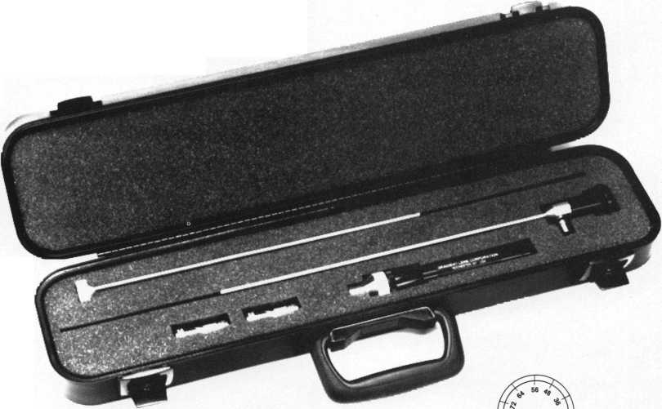

Keynotes

March 1998

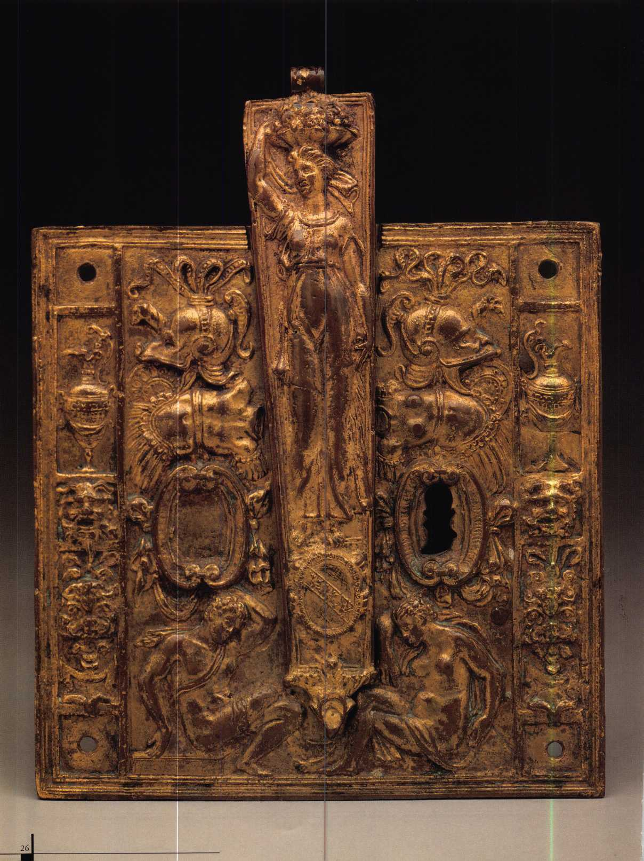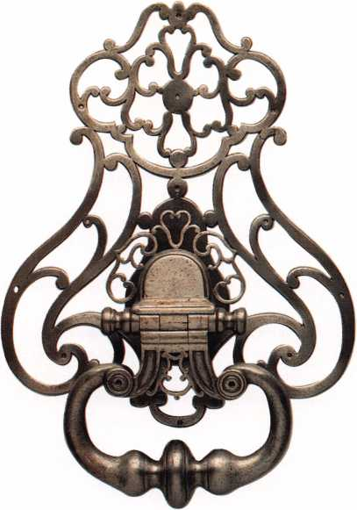

**Craftsmen as Artisans**

The Wendy and Emery Reves Collection



These days, a lock is a lock right? And a key is just a key? Of course, to the average person such is the case, but for those in the locksmithing industry, there’s a sense of majesty to various pieces of security hardware.

But while modern day appreciation for locks and keys may be limited to technical capabilities and overall reliability, the locks of centuries past have an ornate appeal that nearly outweighs their functionality.

Of course, security technology was a fairly primitive concept hundreds of years ago, but the metallic structuring, carved artistry and tricky designs that many of yesteryear’s locks possessed, exemplified discipline, wit and craftmanship. One who had a unique fondness for

rare and unusual antique locks was noted author, humanitarian, and philanthropist Emery Reves. His collection of these rare, lavish, antiques is indeed a treat for those fascinated in the history of security tools as well as for art enthusiasts. Reves wrote the classic political dissertation, Anatomy of Peace, published in 1945 (which is unfortu­nately out of print). Referred to by Albert Einstein as “the political answer to the atomic bomb,” the volume was hailed by critics of the era as being both revolutionary and inspirational. It was eventually adopted as standard text at Columbia, Yale and Harvard as well as being published in 25 languages in more than 30 countries.

Anatomy of Peace began Reves’ activities within the political  
science arena. Advocating a “world government,” one of his most

I Preceding page: Lockplate and hasp, c. 1550-1580 I Above: Door hammer, c.1700-1750

All photos courtesy of the Dallas Museum of Art, The Wendy and Emery Reves Collection.

March 1998

Keynotes L

prolific quotes from the aforementioned Anatomy is “Human freedom is created by law and can exist only within a legal order, never without or beyond it.”

Perhaps this attitude and audacity could be attributed to the fact that he abandoned his home twice in order to escape the Nazis. Born Emery Revesz in 1904 in the Hungarian village of Bacsfoldvar, he was a first cousin of Sir Georg Solti, who would become the conductor of the Chicago Symphony. Himself an accomplished pianist, Emery Reves studied at the University of Zurich in 1936. He was also the founder of Cooperation Press Service, which published essays on current events from leading statesmen and distributed them through as network that grew to more than 400 newspapers in 70 countries. Among his published works were the memoirs of Winston Churchill.

It was his wife, New York fashion model Wendy Reves, who inspired his art collecting. This extensive collection was donated to the Dallas Museum of Art by Mrs. Reves following her husband’s death in 1981. It can be viewed on display within a special section of the Dallas Museum of Art. For more information, feel free to call the museum at (214) 922-1200.

Lockplate

The estimated date for this piece is around the late 1400s—early 1500s and its approximate origin is Germany. Medieval European artisans employed a variety of materials, predominately masonry architecture and stained glass. Iron, however, was another favorite element (as seen here) and was used for a variety of functional purposes. As is evident by the intricate ornamentations, Middle Ages metal-smiths forged designs of near flawless beauty. It can be assumed that this piece was part of the fittings for a large wooden door and is a prime example of Germanic metal work of the late

G othic period. During this period lockplates with scalloped edges and applied tracery weren’t uncommon to other European cities but the delicacy of its lining indicate that it may have come from a large G erman metal-working center like Nuremberg.

Knocker

Another work of iron, this 18th century piece is from France. Composed of wrought iron that was shaped by hammers on an anvil, this knocker’s backplate was cut from sheet iron. Notice the elaborate biroque style scrollwork of the backplate, a characteristic of 18th c mtury hardware much like the hinge structure that contains “ Duttons” where the knocker is connected. Behind the hinge, a bolt v ould connect the knocker to the door as the backplate is held in place by nails driven through visible holes.

Eiox

A virtual “safe deposit box” of around the 17th or 18th century. This miniature strongbox was perfect for storing valuables such as coins, jewelry, important documents and other items. This box is r lade of iron, but is relatively lightweight and has a convenient carrying ring. Perfect for traveling, or home use, this piece (which is estimated to have come from Nuremberg, Germany) has a very inter- e sting aspect—“trick” two faces. One side features the true hasp, the c ther—a phony. Intruders would have to manipulate both sides to f gure out which was workable before it could be successfully broken i ito. The bird decorations and foliate scrollwork appear to be ‘ masked off’ with varnish. Plus, acid seemed to have been used to eat £ way the background. Nuremberg (located in the southern portion of (Germany) was widely recognized for decorations much like this.

i \bout the Author: Mike Emery is the Associate Editor for Keynotes and *c * freelance ivriter specializing in jazz and blues music.

11 At left: Small chest with key, c. 1600-1700 11 Upper right: Lock Plate, c. 1475-1523

All photos courtesy of the Dallas Museum of Art, The Wendy and Emery Reves Collection.

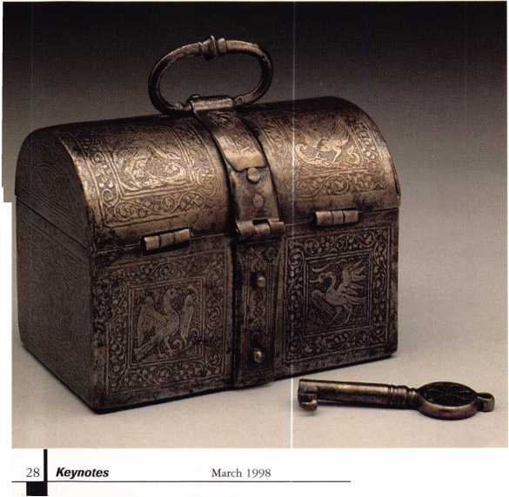

ALOA ’98 International Convention & Security Expo

ALOA sweetens the music by helping orchestrate your new product introduction.

The new products brochure, Inside Track, is a three-time hit! Handed out during the Security Expo, inserted in the August Keynotes, AND tied into the “Sneak Peak”

(formerly “Parade of Stars”) and the New Products Display Area!

Inside Track Introduction Guide

|  |  |  |
| --- | --- | --- |
| Sneak Peak | FREE | May Keynotes |
| New Product Display Area | FREE | June Convention Site |
| Sneak Peak | $100 | May, June/July, August Keynotes |
| The Whole Package | $500 | “Sneak Peak” (May, June/July, August Keynotes),  New Product Display Area (June Convention Site), new products brochure, Inside Track (June hand-out, August insertion) |



ly i i ■

*n*

gift



**id**

*-m*

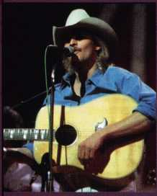

Space reservations

are due by March 26, 1998.

Contact ANELIA or D’ANNA for specific pricing and information.

**Nashville Convention Center**

**Nashville, Tennessee**

**June 14-20, 1998**

*Associated Locksmiths of America*

*214.827.1701*

*800.532.2562*

*214.827.1810 fax*

*e-mail [convtion@anet-dfw.cnm](mailto:convtion@anet-dfw.cnm)*

**The life span of a Chevrolet Corvette manufactured between 1953 and 1985 (pre-VATS) that is not garage kept and does not feature a security system is seven hours! It is no small wonder that insurance companies encourage car owners to either purchase cars with existing sophisticated security systems or add a quality system available in the after market. This action actually lowers their auto insurance premiums, making it desirable to spend the necessary money on a quality auto alarm**

March 1998

• the

system. Not only does this

peace of mind due to the

likely (not an impossibilit r)

will be stolen, but over

average new car loan (60

lower insurance premium;

compensate the car owner

money spent at the time

Moreover, the security sys  
removed from the existing

on a new car when the tirqi

another purchase for a

of a new security system,  
charge a small additional

the car with the alarm. A;

i frac t

or

see, an auto security system

situation for both the car

provide a greater

ffcct that it is less

that their car

course of the

• 72 months) the  
will often

for the extra

cf purchase.

:em can be

car and reinstalled

e comes to make

ion of the cost

the owner can

ee for selling

you can clearly

is a win-win

owner and the

insurance company.

However, this does not

benefits to the locksmith

perform this type of work

consider the aspect of custoj

are now the only nation

there are more motorized

trucks, lawn mowers, mo :<

etc.) than people. Perforrr i

secures the average persor

prized possession is looke 1

quite favorably by your ex:

and potential customers.

Remember, in many case; i

not the price of an item

we can compete with the

fierce competitors in today

marketplace. Rather it is

quality and variety of cus  
oriented service where we

distinguish ourselves fror l

rest of the competition!

in distinguishing ourselv

this manner we can creat^

own, more professional i<

This action enables other;

to perceive us in a more

illustrate the many

vho chooses to

First, we should

>mer service. We

this planet where

vehicles (cars,

orcycles, fork lifts,

ng a service that

professional light. This is a factor of invaluable proportions when we consider the fact that we are the ones who secure the families, businesses and possessions of an entire nation. Third, the more technically oriented our business, the less competition we face from non-professionals—as well as the simple financial fact that anyone who pursues and masters state-of-the art technology will be the one to reap greater monetary rewards and significantly higher profitability.

Remember, the second most expensive and important personal purchase that the average man or woman will make during their lifetime is an automobile (of course, the purchase of their home is usually the most important purchase). So with those factors in mind, let us take a closer look at one of the most highly regarded auto security systems available—the MaxiGuard.

MaxiGuard of America is based in Elk Grove Village, 111. This company sets itself apart from its many competitors by its emphasis on physical as well as electronic security. The form that the physical security

upon

listing

**MAXI-LOK DIAGRAM D**

S|econd,

;s in

our

c entity.

I teDfr

Radiator Front Panel

30

Keynotes

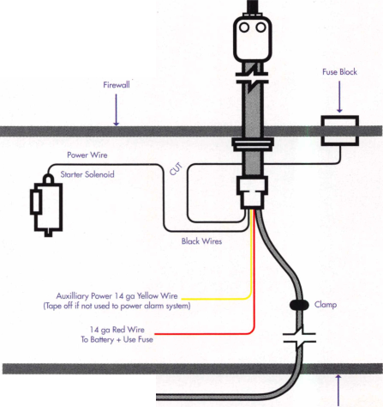

Override

Switch

I Wire ™ 3 Positive {■( Jerminol

Unlock

DUAL ZONE **r** SHOCK SENSOR

takes is a high security hood lock. The  
reasoning behind this component is simple.  
The physical portion of the security system  
should delay the attempted theft long  
enough to enable the electronic portion of  
the system to do its work. Therefore, if you  
can significantly delay or prevent a would-be  
thief from compromising the electronic  
components under the hood, then the alarm  
is free to do its work. Simply stated, the  
work of an alarm is two-fold. First, an alarm  
should create a sense of urgency in the thief  
by drawing attention to him and his illegal  
actions. Second, an alarm should bring  
someone in authority to thwart the  
attempted theft and apprehend the trans-  
gressor, or alert a passerby who can in turn  
inform the necessary authorities.

Now let us begin by examining the  
MaxiGuard Hood Lock in detail. MaxiGuard  
offers three types of hood locks: the Maxi-  
Loc, the Mega Lok, and the Maxi-Blok  
Electro. The Maxi-Lok features a Medeco  
high security key lock for the highest  
resistance to picking and drilling procedures.

The flexible case hardened steel tubing  
provides greater security because it is  
stronger than comparably sized rigid steel  
pipes. The diameter of the flexible case  
hardened steel tubing is greater than the jaws  
of most conventional bolt cutters can handle.  
In addition the case-hardened flexible steel

tubing features a thicker than standard

wall with a unique

convoluted  
pattern  
incorporated  
into the tubing

itself that is specifically engineered to make  
tubing cutters useless. Another more  
practical reason for the flexibility of the case-  
hardened steel tubing is to make installation  
in virtually every car easy without requiring  
dozens of different parts for dozens of  
different car models.

thicker than standard

*AUTl*

...

CRUSADER

Red/Black Wire Positive Output for optional p|

Purple/Black Wire Channel 3 Negative (-) Output. ' Brown/Black Wire Channel 2 Negative (-) Output. 50

Orange Wire Positive (+) door input trigger (FORD Brown/White Wire Negative (-) door input trigger (GM Brown Wire Negative trigger input for added hood or trunk svi

*t ALARMS*

By Steven Spiwak

March 1998

***Keynotes*** | 31

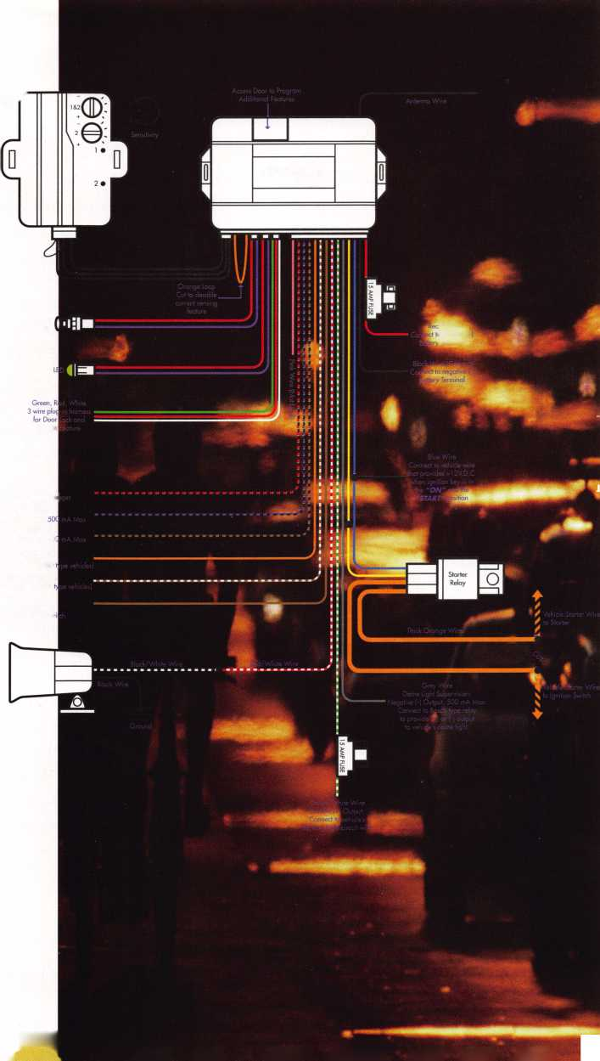

The reason for the tube itself is simple. Since the key lock is situated conveniently under the dashboard, there is a vulnerable area between the under side of the dashboard and the firewall separating the passenger compartment from the engine compartment.

Another feature of the Maxi-Lok is the starter interrupt mechanism. This device prevents the car from starting while at the same time preventing any damage to the ignition system and without allowing the engine to die while your customer is driving the car. Since installation is the same for both gas and diesel powered vehicles, there is no need for expensive electrical components for diesel engines.

This system also features an easy-to-see LED indicator that remains illuminated while the system is activated to give your customer the peace of mind that the system is working. This also serves as a deterrent to a would-be thief who can see that this car is protected by a security system.

In addition, since cars come in different sizes from sub-compact cars to luxury cars, so do the Maxi-Loks—which are available in four, five, six and seven foot lengths.

cable lengths as the Maxi-Lok.

The third option for yoi r automotive physical security needs is s )ecifically designed to be used with t le hood release in your own vehicle when yoi ir customer decides that he or she does not want a Maxi- Lok or a Mega Lok. This unique device is the MaxiElectroBlok NO (No rmally Open).

This item is used to block the mechanism that unlocks the hood rele ise cable. This mechanism remains in the normally open position to allow you or yc ur mechanic easy assess to the engine comps rtment. However, if your vehicle is attacked ind the alarm sounds, the car’s normal h x)d release is blocked, preventing a woi id-be thief from tampering or stealing any components under the hood.

The MaxiElectroBlok can interface with any vehicle security syster i due to its universal electromagnetic locking device that automatically locks the N axi-Blok, preventing the hood relea >e of virtually any automobile from activating. Moreover, this device requires no severing of the hood release inner cable wire. E ather, it is quick and easy-to-install becaus i it mounts

**The system automatically arms itself**

**when the user removes the key from the ignition**

**and leaves the vehicle...**

Finally, the Maxi-Loc features two 30 amp switching circuits with silver contacts for alarm activation and starter interrupt. This eliminates the need for alarm override switches.

The Mega Lok is the more economical version of the Maxi-Lok. The Mega Lok features a tubular key lock in place of the Medeco high security key lock. As a result of this construction, all that your customer needs to do to operate this system is to push in the spring loaded tubular key lock instead of turning the Medeco high security key lock. The Mega Lok features the same four

32

March 1998

anywhere in line with  
hood release cable.

The second half of thi:

system is the electronic

a unique remote control! ?<

system that can be used

or without the Maxi-Lok,

MaxiElectroBlok. The G

MaxiGuard is available i:  
Crusader 2000 and the n  
Crusader 1000.

The Crusader 2000

art technology. There are

remote controls. The ke>

yoi ir vehicle’s own

auto security

portion. The alarm is

‘d vehicle security

l conjunction with  
Mega Lok or

usader by

two forms: the

Lore economical

feiti

ures state-of-the-

two three-channel

ring transmitters

are all your customer needs to program and activate a wide variety of unique security functions. The basic operation of the Crusader auto security system is simple.

Press button #1 once to arm the system.

Remember that when the user arms or disarms the system, that system is considered active. The system automatically arms itself when the user removes the key from the ignition and leaves the vehicle, and automat­ically disarms the system when the user returns to the car and turns the key in the ignition. The system is then classified as passive.

The siren will respond with an easily iden­tifiable chirp. The lights will then flash one time, indicating that the system has been armed. Upon your customer’s return to the vehicle, button #1 is pressed one time. This time the siren will emit that characteristic chirp twice, and the lights will flash twice, indicating a disarmed status. There is an additional bonus. If your customer’s vehicle is equipped with power door locks (and you install this option for him) his door locks will lock when the system is armed and unlock when the system is disarmed. If your customer chooses he can eliminate the chirping sound by pressing button #1 and button #2 simultaneously. This action will result in silent arming or disarming. Another unique feature of this system is the “car finder.” By pressing button #2 alone the siren will chirp once, but the lights will flash six times to indicate the position of your customer’s car in a crowded parking lot— great in the dark!

There is even a personal protection option that can be accessed by pressing and holding down button #1 for two seconds to activate the panic alarm. Press again to deactivate the panic alarm. Your customer even has the option of activating a remote trunk release (channel #2) or a remote starter (channel #3). This is accomplished by pressing and holding button #2 for three seconds to

Keynotes

activate channel #2, and pressing and holding buttons #1 and #2 together for three seconds to activate channel #3.

There is also a valet mode available. With the ignition in the “ON” position, press and hold buttons #1 and #2 together for three seconds to activate the valet mode. This will cause the red LED to illuminate constantly, unlike the dash mounted blinking red light that is featured when the alarm is armed. If this option is purchased by the customer the doors will lock and unlock in this mode. To deactivate this option, press and hold buttons #1 and #2 together for three seconds.

Another interesting feature of this alarm system is the prior attack indicator. This feature informs your customer of a prior attack upon the car for the time period during which they were away from the vehicle. Anytime that there is an attempted compromise of the vehicle, the siren will sound for 60 seconds before resetting 20 seconds, if the car is bumped by another car so that it will be ready to respond to any further attempted intrusions. However, when your customer returns to the vehicle, the LED will be blinking very rapidly and the siren will chirp four times to attest to the fact that there was an attempt to compromise the security system, and steal the car. Also included with the Crusader 2000 is an impact and shock sensor that will activate the alarm in response to breaking any of the windows.

The Crusader security system also features a starter interrupt feature. When the system is armed, the vehicle can’t be started, even with the correct ignition key! The system must be disarmed in order to allow normal starting of the vehicle. In case of a malfunc­tion or a lost remote control unit, the Cmsader can be disarmed by turning on the ignition cylinder and pressing the hidden override switch.

Another unique feature of the Crusader is the anti-scan or shut down provision. If a

**Believe it or not, there is an optional pager that will alert you to an attempted theft of your car**

**up to one-half mile away...**

high tech thief is trying to gain entry by “scanning the system,” the receiver unit will shut down temporarily to refuse acceptance of any codes. This provision does, however, leave the rest of the system fully armed and operational.

When you install this unit it can be programmed to either arm automatically or to the commands that you issue from the remote control unit. By the way, if you install a second system on another car for the same customer, you can use the same remote control unit by sliding the switch on the side of the transmitter for vehicle #1 or vehicle #2.

If your customer finds himself in a threat­ening situation, he will be glad that you recommended the optional anti-car jack feature. This feature is activated by pressing a hidden switch. Sixty seconds later the siren will sound 10 chirps. The full alarm will then sound along with flashing lights using a combination of both sight and sound to alert passers by or authorities who are in the vicinity of the potential crime. At this point the vehicle will still run, but if the engine is turned off, only the use of the hidden override switch can allow the vehicle to once again start in the normal fashion.

Believe it or not, there is an optional pager that will alert you to an attempted theft of your car up to one half mile away so that you can promptly alert authorities from a safe distance as to what is happening. Finally, the Crusader system has included a low battery warning feature, so that if the red LED dims or the operating range decreases, you can immediately replace the 12V type 23A battery.

When you review the installation instructions for the premium Crusader,

Model 2000, please note that the Model 1000 is just as easy for your customer to use and for you to install, but excludes a couple of optional features such as the anti-carjack feature, and the 2 and 3 channel functions, etc. as a means of making the unit more affordable.

I hope that this article encourages you to analyze the high tech, high profit auto alarm market. For further information concerning products, pricing, installation, or servicing for the items mentioned in this article, please feel free to contact MaxiGuard at the following address:

MaxiGuard of America 1401 Landmeier Road Elk Grove Village, Illinois 60007 (847) 364-6700

<http://www.maxiguard.comm> See you next month in KEYNOTES, if I do not see you beforehand in one of my lectures as I travel around the country.

0

the author. Steven B. Spiwak is a fourth generation locksmith who specializes in a variety of variety of areas including crime prevention and institutional security. His broad experience in the security field spans 20 years of writing, teaching and consulting. Spiwaks lengthy client list includes Ford Motor Company, Exxon, The Chicago Tribune, Sears, Westin Hotels, the U.S. Treasury Department and the Federal Bureau of Investigation. Most recently he formed Lockport, Inc.—a security consulting company for industrial, commercial, institutional and govern­mental clients. Readers with article suggestions or requests for him can contact ALOA at email [publ@anet-dfw.com](mailto:publ@anet-dfw.com) or fax to (214) 827-1810.

March 1998

Keynotes

BEYOND&IT ALARMS

By Paul Ct andler

J

Most locksmiths who work on commercial property have installed  
or serviced hardware designed to sound an alarm if anyone exits  
through a door designated for “emergency exit only.’’ There are devices  
that are installed separate from any locking hardware on the door, and  
there are units that combine locking and alarming functions. Many  
manufacturers of panic devices offer alarm kits for their products.  
Manufacturers such as Detex and Alarm Lock are primarily known for  
their exit alarm devices.

The presence of the alarm function discourages most people from  
using such a door. You might say that it keeps honest people honest.  
For those who are less honest, however, alarmed exits are not always an  
adequate deterrent. For this reason, some unscrupulous property  
owners have violated life safety codes, and chained or padlocked doors  
that are meant to allow free egress in the event of a fire or other  
emergency. This has cost people their lives.

DELAYED EGRESS SYSTEMS

Delayed egress systems are an alternative for  
emergency exit doors and combine respect for life  
safety with a higher level of security. The idea is to  
allow a person to exit, but not immediately.

Attempting to exit through a door with a delayed  
egress system initiates a 15 second (in some cases a  
30 second) delay period. During this interval a local  
alarm signal or warning is sounded. A remote alert  
may also be activated so that staff can respond,  
perhaps before the door ever unlocks. CCTV surveil-  
lance of the door could be tied in to the system as  
well, providing a visual record of the violator.

Fifteen seconds may not sound like a long delay.

When you’re standing in front of a door with an  
armful of ill-gotten loot, it probably feels like a  
lifetime.

Many years ago I worked on the maintenance crew  
in a very large geriatric hospital in Boston, Mass. On  
the floors where most of our Alzheimer’s disease

patients were located we had alarms on the stairwell doors that alerted  
nursing personnel if the doors were opened. One night a patient let  
himself out on the fifth floor landing and fell to his death before any  
staff could come and get him. I think of that poor gentleman whenever  
the subject of delayed egress comes up.

NFPA 101, known as the “Life Safety Code” makes provisions for  
systems of this kind (“Special Locking Arrangements”). Several specific  
requirements are stipulated. For one, the building must have some sort  
of electronic fire detection system. This may be an alarm system  
involving detectors and pull stations, or it might be an automatic  
sprinkler system that is electronically monitored for water flow. No  
provision is made for delayed egress in buildings with no fire system,  
because another requirement of these systems is that they must  
instantly release if there is a fire. All manufacturers of approved delayed  
egress systems must include a fire alarm interface that overrides the  
delay feature upon activation.

Once the system is activated, the delay timer must begin an irre-  
versible countdown to unlocking. Allowance is made for a short (one  
to three second) nuisance delay so that the sequence isn’t initiated by

someone merely bumping into the door. Once the door has unlocked,

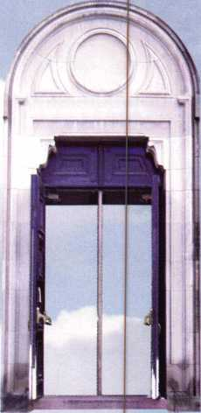

is required that someone manually reset the system at the door. This

means that a second and third person seeking to escape, in a valid  
emergency, will not need to wait for 15 seconds each time.

The code also stipulates the type of warning signs to be used, the

need for emergency lighting at the doorway and other specifics.

Manufacturers can, and do, build systems to comply with NFPA

101 as well as UBC, BOCA, SBC and the National Building Code of

Cmada. It is important to understand, though, that these codes are not  
laws. They are merely sets of recommendations that the “local authority  
having jurisdiction” can adopt in whole, or in part. Regardless of what  
tfie Code says, it is up to the Fire Marshal, Building Inspector or other

uthority” in your city, county or other local “jurisdiction” to decide

hether to allow delayed egress systems at all. If he or she decides to

ai low them, they may adopt additional regulations governing their use.  
They may arbitrarily approve certain products and reject others, even

though they are all UL listed for use in delayed egress  
systems. This is a subject you will have to research  
locally before you sell or install such systems.

TYPES OF SYSTEMS

If delayed egress is acceptable in your area, there are  
a variety of products on the market designed for the  
purpose. These fall into one of two categories: those  
based upon electromagnetic locks and those based  
upon electromechanical exit devices.

Electromagnetic locks (a.k.a. mag locks) have  
become very popular for all types of electric locking  
arrangements due to their dependability and physical  
strength. Life safety authorities like the fact that elec-  
tromagnets release instantly and are inherently fail-safe  
(unlock when power is removed). A delayed egress  
system utilizing a mag lock consists of the lock, the  
timer/controller electronics, a means to reset the system  
and a way to initiate the exit process. (A means of  
unlocking the door for authorized entry or exit and  
remote annunciation of alarms are options.)

There are two principle ways to initiate the delayed egress process.

J ome systems use a separate input device, such as a touch-sensitive bar  
(»r an exit device with a micro switch, to send a request-to-exit signal to  
t he controller. In systems of this sort a conventional mag lock is used  
i nd it is the only lock securing the door. Since a person on the outside  
cannot reach the input device on the inside of the door, security is  
maintained. This type of system is well-suited to doors where delayed  
(gress is combined with some form of access control, such as a card  
i eader or keypad. Entering a valid code or card releases the mag lock to  
allow entry without triggering the delayed egress function.

On doors where no entry is permitted the delayed egress system may be  
nitiated by door movement. A door movement system uses a special elec-  
romagnetic lock that permits the door to be opened a short distance (less  
ban one inch) before stopping. A sensor detects this movement and  
nitiates the delayed egress process. Different manufacturers have  
leveloped unique ways to allow minimal door movement while keeping  
:he door secure. For example, Locknetics has developed a “rocking  
nagnet” that pivots in a special housing to permit detectable door  
movement. Securitron has developed a spring-loaded sex bolt that attaches  
:he armature to the door and allows up to one inch of movement.

Keynotes

March 1998

What prevents someone on the outside from pulling the door enough to start the delayed egress process? Mechanical hardware, either an exit device or a conventional lockset, are used to keep the door shut unless operated from the inside. This combination of a mag lock and a mechanical lock offers some advantages. For one, in the event of a power failure the door is not left unsecured. In addition, if the system is installed on a fire-rated door you must include a mechanical device that will positively latch the door when closed.

Door movement systems are difficult to use when outside access is required because you have to both release the mag lock and retract or release the mechanical latch to gain entry. Yes, it can be managed, but it is a pain.

The other category of delayed egress systems are those utilizing special exit devices. Unlike conventional exit hardware, these have electromechanical components added to cause delayed operation. Pushing against one of these devices does not immediately retract a latch or bolt, but does initiate the delayed egress process. An internal noisemaker sounds to alert the user that the system is timing out. After 15 seconds the internal electromechanical device is triggered and latch retraction is no longer prevented.

The controller/timer electronics, local noisemaker and reset keyswitch are usually contained in the exit device. Since the system must be hardwired to the building fire alarm system, you need to run wiring from the frame to the door. You can do this with a wire-through hinge, a hidden power transfer device or with an armored door cord.

This type of delayed egress system has many of the same advantages of the door movement mag lock systems while being more convenient for doors needing authorized entry. A mechanical key cylinder can be used to retract the latch for entry. Where electronic access control is preferred you can use a suitable electric strike along with a card reader or keypad.

During the 15 second delay period, all delayed egress systems must sound an alarm signal at the door so that the person seeking to exit will know that he has successfully started the exit process. A mandatory sign on the door explains that the door will unlock in 15 seconds. But what about people who can’t read, or who read another language?

What about the hearing-impaired who won’t benefit from the audible alert? To address these special needs Security Door Controls has developed the “101 Exit Check.” This is a door movement mag lock system that features an LED display that counts down from 15 to zero to show the hearing impaired that the process is underway. It also talks to you. Using a voice synthesizer the lock announces “Exit in 15 seconds. Security has been alerted. Exit in 10 seconds. Exit in 5 seconds. Exit now. Exit now.” This should take care of the illiterate person, or the one too frightened to understand the door sign. In areas where more than one language are common, the 101 can be ordered with a dual language message. How’s that for high tech?

**ISNT IT TIME?**

The security hardware industry has put a lot of research and devel­opment into delayed egress in the past few years. More and more retail stores, hospitals, libraries and other commercial properties are protecting assets and lives with this technology. Opportunities abound. Isn’t it time to move beyond exit alarms?

About the Author: Paul Chandler, CRL, is the manager of the Electronic Security Department for I.D.N. - ACME in Houston, Texas.



Reader Service #2

ALOA Members only.

AT&T offers members of Associated  
Locksmiths of America, Inc. an additional 5%  
discount on your business long distance. You  
can literally “profit by your association!”

Call 1 800-822-7756 ext. 737F to sign up now.

Ip AT&T

Reader Service **#3**

March 1998

Keynotes

afety Technology International, Inc. (STI)  
in Waterford, Mich, makes a wide variety

of products designed to help protect

mounted items such as smoke  
detectors, fire extinguishers, and  
many other items from

vandalism and tampering.

After all, a security

device can’t do its

job if it has been

broken or stolen. It  
seems that  
sometimes even  
protective devices  
need protection.

STI makes wire  
cage style covers that

can be installed to  
protect a smoke

detector from theft  
and tampering,  
while still allowing  
smoke to reach the  
sensor in case of fire.

The same type of  
protective covers in a  
wide variety of shapes and  
sizes are effective for other  
mounted devices that are

tempting targets for theft or  
vandalism, but that can’t be completely  
locked away. You get protection but still  
maintain visibility.

Aside from making devices that just  
physically shield, STI makes a variety of  
electronic devices that protect by sounding  
an alarm to call attention to someone  
tampering, vandalizing or stealing. Self-  
powered with standard type batteries, STI’s  
alarm devices range from exit alarms that  
sound when someone opens a restricted  
access door to alarms that sound if someone  
walks off with a fire extinguisher or some  
other mounted item. Plus there are clear  
shields that trigger the alarm when someone  
lifts the cover to get to the item inside.

Photo 1 shows the 6400 Exit Stopper. It is

an electronic exit alarm that mounts on a

door separate from the

red and shaped like a stop

catch the attention of soi  
otherwise walk through

It uses a double bitted Ch(<

switch lock to turn the ex

It has spanner style tan l]

screws that secure the cov£i

electronic components in*

style screwdriver is shown

is used to undo the screws

cover. With the cover re;

is possible to customize tl

specific applications. By

number of Jumpers, you

such as alarm volume,

The exit alarm is presei

side

, duj ai

hardware. It is

sign in order to

one who might  
alarmed doorway,

icago-style key  
t alarm on or off.  
per resistant

-r over the

it. A spanner

in photo 2, which  
and remove the

ved in photo 3, it

e exit alarm for

positioning a

control things

tion and more,

to a high volume

sound of 120 dB, but can be reset to 85  
dB. It can also be set to arm immedi-

ately when the key switch is turned,  
or to have a 15 second arming

delay. The delay setting

allows someone to arm the  
device and then exit

through the same  
door without  
triggering the  
alarm. You can  
also change when  
the alarm is  
tripped. It is  
preset to trigger  
instantly, but can

be likewise  
changed to a 15

second delay.  
The duration

of the alarm has  
three settings.  
The factory  
setting is for 30  
seconds. When  
triggered in that

mode, the alarm will  
sound for 30 seconds and  
then reset itself. It can also be

set to run for 180 seconds and  
then automatically reset itself. In  
continuous mode, the alarm will  
continue until it is reset with the key

switch or when the battery dies. The unit  
uses one nine volt battery. There is a fourth  
setting called “Door Prop Mode,” but I’m  
not entirely clear as to what purpose it serves.

There is a relocatable reed switch that can be positioned at the top, bottom or either side of the unit. Photo 4 shows a magnetic contact being held just above the reed switch currently positioned at the top of the unit. Pairs of plastic posts hold the reed switch in any of the four possible positions. The position that you locate the reed switch will depend on where you mount the unit on the door, whether it is mounted at the top of the door or the hinge or opening side of the door. It should be in line with the magnetic contact installed on the door frame.

Photo 1

Photo 2

Photo 3

36 Keynotes March 1998

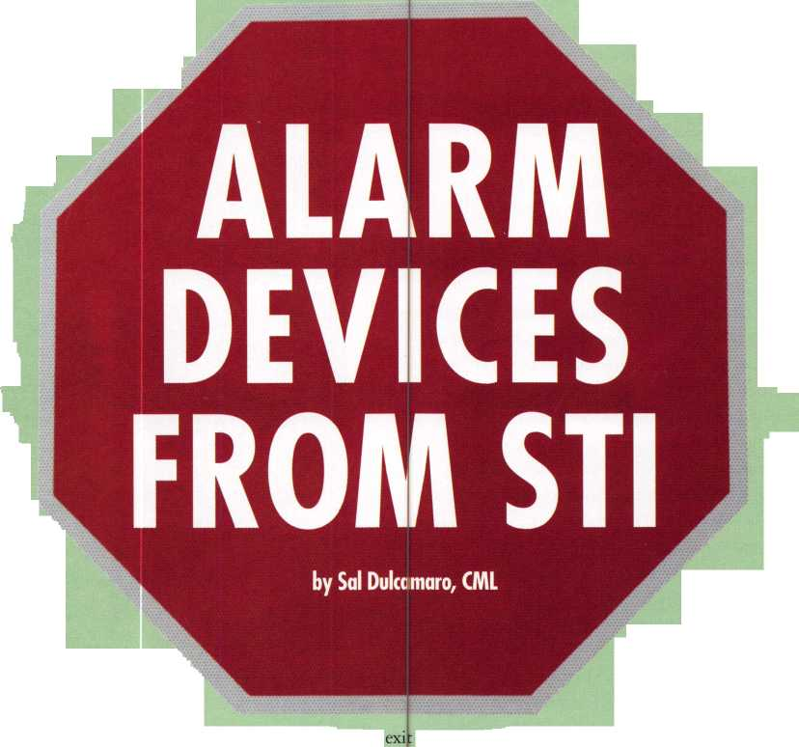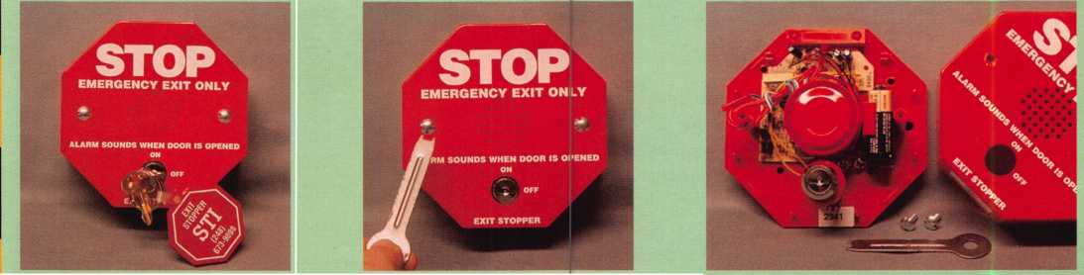

The Exit Stopper can be added to a door where exit hardware already exists and is in good working order. This unit can be added to the door separately without having to replace the current door hardware with elec­tronically enhanced hardware. There are also the Exit Stopper #6402 for double doors, and #6403 with a remote horn.

The STI #6200 Fire Extinguisher Theft Stopper is shown in Photo 5. Its appearance is similar to the exit stopper, but its function is considerably different. It has no on/off switch, so it is always in the alarm mode. An adjustable cable is used to attach to a fire extinguisher (or potentially anything else to which you wanted to attach it) and crimped so that the cable cannot be slipped off the fire extinguisher. The end of the cable is inserted into the hole in the center at the bottom of the unit. A very short piece of coated cable comes pre-inserted into that hole so the alarm will not go off before the full length cable is inserted. Pulling the cable out of the hole triggers the alarm, and reinserting the cable turns off the alarm.

Photo 6 shows the STI #6255 Mini Theft Stopper. It is physically smaller than the previous two stopper units, although it is also red and shaped like a stop sign. It is sort of a multi-purpose alarm device. It includes accessories that will allow you to customize it in order to protect things in a variety of different ways. There is no on/off switch. A jack at the bottom of the unit will accept the cable from either the reed switch (bottom left in photo) or the activation clip (bottom right in photo).

With the reed switch and magnet, the unit will be triggered if the magnet is moved a relatively short distance away from the reed switch. Depending on your needs, you could mount the reed switch on a non-moving surface and the magnet on another surface that would normally be moved if someone was trying to take or tamper with the item you are trying to protect.

The activation clip requires that something keep the two contact ends together in order to prevent the alarm from sounding. Either something sitting on top of it or squeezing the contacts together would work. You could protect some fairly unusual types of items in this way. If the item you were protecting was moved or picked up, the two ends would probably separate and trigger the alarm.

In Photo 7, something that looks like a carrying strap has been removed. Attached to that strap is a de-activation pin, that has been unplugged from a different jack at the left side of the unit. If the de-activation pin is

removed, the alarm unit will reset about three minutes after the magnet comes back in contact with the reed switch or (if the activation clip is used) when the activation clip is reset. The de-activation pin must be used if you don’t want to wait three minutes for the unit to reset. In that case, the alarm will stop as soon as the contacts are returned to their pre-alarm condition.

The Stopper II with Horn, STI #1100 False Fire Alarm Stopper is shown in Photo 8. It is a clear polycarbonate protective cover for a fire alarm pull station. STI makes similar devices for many other uses. It is designed to deter pranksters who might run past a fire alarm pull station and quickly set off the alarm, running away quickly before anyone noticed them.

The Stopper II requires a person to lift the cover, thereby setting off a horn in the cover unit itself, before he can actually set off the fire alarm. In case of a real fire, the person lifting the cover would not be concerned that someone else is looking at him. A prankster, by contrast, would probably run when the horn in the Stopper II unit went off. Fear of discovery might prevent the second act of actually setting off the fire alarm, which would be a false alarm for the fire department.

The Stopper II may be ordered in a choice of red, green, yellow or blue with custom labeling for specialized applications. This type of unit could have other possible appli­cations for limiting tampering with ther­mostats, controls, switches or anything else. Although the standard unit has a built-in warning horn, it may also be ordered in 24 volt remote powered models with or without relay contacts that may be used to trigger external devices.

For additional information on these or other products, or to get a copy of their catalog, contact: Safety Technology Interna­tional, Inc.; 2306 Airport Road; Waterford, MI 48327-1209; ( 800) 888-4784 or 248/673-9898; (248)673-1246 fax; e-mail [info@sti-usa.com](mailto:info@sti-usa.com); [www.sti-usa.com](http://www.sti-usa.com).

About the Author: Sal Dulcamaro,

CML has been in the locksmith business for over  
22 years, lie is president of All Pro Security, Inc.  
in Michigan and has been an AL0A member for  
15 years. A past president of the Locksmith  
Security Association of Michigan, Sal currently  
serves as editor of the association newsletter. He was  
named “Keynotes Author of the YeaY for both  
1996 and 1997.

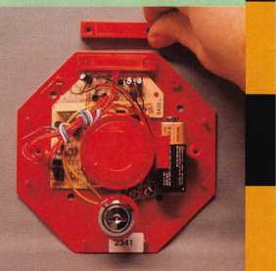

**STOP**

**EMERGENCY USE ONLY**

**ALARM SOUNDS WHEN  
EXTINGUISHER IS REMOVED**

Photo 4

Photo 7

Photo 8

March 1998

Keynotes 37

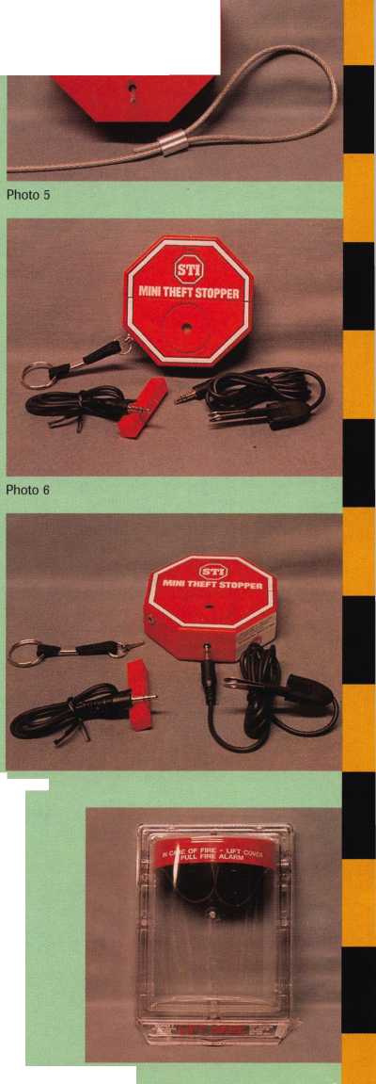

**PART** 2

By Greg Perry, cml, cps

Last month I shared with you the Master Key Chart we use in our shop. I explained the various levels of master keys and showed you how to find them. This month I want to show you some of the various ways to use them. I also want to explore some other variations for a master- k( yed cylinder. You will need the charts printed last month to follow tl is month’s study.

A little review of terms and ideas.

1. The master key system we are working with is a two-step progression with 10 possible cut depths.
2. A five-pin master-keyed cylinder with all five chambers containing one master wafer has 32 different cut keys that operate it. Until one of these keys is cut as a part of the system, it is considered a ghost key. If we identify them we find:

* one change key

'» five first-level master keys

* 10 second-level master keys
* 10 third-level master keys
* five fourth-level master keys
* one top master key.

1. A first-level master key contains one cut in any position in common with the top master key. A second-level master key contains two cuts in common. A third-level master key contains three cuts in common.

A fourth-level master key contains four cuts in common with the top master key.

So far we know what they are, how to find them, and how many t] lere are; but what do we do with all of these ghost—or different 1( vel—master keys?

The traditional way to master key is to divide up the change keys ii ito groups and create “sub-masters” for each group. This is typically d one in a vertical arrangement as the chart is written, and frequently I v rill use the chart that way This arrangement might work great for a hotel, where you want to limit the maids’ access to a group of rooms while allowing the management to have wider access. It would also a pply in the situation of a factory with one boss, a couple of department 1 eads, and some individual offices. What if you need to cross-key or r iason-key? This means more than one change key operating the same cylinder. Many locksmiths will leave one or more chambers empty, or stack a lot of master pins into the cylinder. This decreases the security and may even leave them open for liability.

In smaller systems, you can use the first-, second-, or third-level r Tasters, and still pin all the chambers of the lock without stacking r naster wafers.

How do we do this? Let’s look at the 10 second-level masters of the a ery first change of our system—AA1.1 am using change AA1 as a

|  |  |  |  |  |  |  |  |  |  |  |  |  |  |  |  |  |  |  |  |
| --- | --- | --- | --- | --- | --- | --- | --- | --- | --- | --- | --- | --- | --- | --- | --- | --- | --- | --- | --- |
| Customer  Buildinq or Location | | | | | | | | | | | |  | VALID CUTS TO USE IN EACH CHAMBER.  NO CUTS FROM THE MASTER ALLOWED. (2 STEP INCREMENTS) | | | | | | |
| Date Chart Started Kevwav | | | | | | | | | | | | 1 | 2 | 3 | 4 | 5 | 6 | 7 |
| Method of Stamping on Keys  Soecial Notes |  | | | | | | | | | | |  |  |  |  |  |  |  |
|  | | | | | | | | | | |  |  |  |  |  |  |  |
|  | | | | | | | | | | | |  |  |  |  |  |  |  |
| v-narr wrinen Dy  D Bow to Tip CH Tip to Bow  Control Key Cuts | | |  | | | | | | | |  | |  |  |  |  |  |  |  |
| 1 | 2 | 3 | 4 | 5 | | 6 | 7 | Master Key Cuts | | 1 | 2 | 3 | 4 | 5 | 6 | 7 |
|  |  |  |  |  | |  |  |  |  |  |  |  |  |  |
|  | | | | | | | |  | | | | | | |
| DOOR OR ROOM NUMBER,  OR THE NAME OF THE CHANGE | NUMBER OF  CYLINDERS | NUMBER OF  KEY CUTS | | | ID NUMBER  ON KEYS | | | DATE PUT  INTO SERVICE | | | DATE  REMOVED | STD  KEY ID | CUTS OR PINNING  OF THE CYLINDER | | | | | | |
| 1 | 2 | 3 | 4 | 5 | 6 | 7 |
|  |  |  | | |  | | |  | | |  |  |  |  |  |  |  |  |  |
|  |  |  | | |  | | |  | | |  |  |  |  |  |  |  |  |  |
|  |  |  | | |  | | |  | | |  |  |  |  |  |  |  |  |  |
|  |  |  | | |  | | |  | | |  |  |  |  |  |  |  |  |  |
|  |  |  | | |  | | |  | | |  |  |  |  |  |  |  |  |  |
|  |  |  | | |  | | |  | | |  |  |  |  |  |  |  |  |  |
|  |  |  | | |  | | |  | | |  |  |  |  |  |  |  |  |  |
|  |  |  | | |  | | |  | | |  |  |  |  |  |  |  |  |  |
|  |  |  | | |  | | |  | | |  |  |  |  |  |  |  |  |  |
|  |  |  | | |  | | |  | | |  |  |  |  |  |  |  |  |  |
|  |  |  | | |  | | |  | | |  |  |  |  |  |  |  |  |  |
|  |  |  | | |  | | |  | | |  |  |  |  |  |  |  |  |  |
|  |  |  | | |  | | |  | | |  |  |  |  |  |  |  |  |  |
|  |  |  | | |  | | |  | | |  |  |  |  |  |  |  |  |  |
|  |  |  | | |  | | |  | | |  |  |  |  |  |  |  |  |  |
|  |  |  | | |  | | |  | | |  |  |  |  |  |  |  |  |  |
|  |  |  | | |  | | |  | | |  |  |  |  |  |  |  |  |  |
|  |  |  | | |  | | |  | | |  |  |  |  |  |  |  |  |  |
|  |  |  | | |  | | |  | | |  |  |  |  |  |  |  |  |  |

March 1998

Keynotes 139

starting point, but we could use DD64, or any key in between. The same type of relationship exists between all the keys. It will help to look at them on the full-size chart from February Keynotes, and use these additional charts as a guide.

Looking at the 10 keys in a graphical fashion makes it easier to cross key. A small company with a couple of departments might be keyed as follows:

Front Door Key Accounting Manager's Office Accounting Clerk's Office Maintenance Foreman's Office Maintenance Shop Quality Control Laboratory

President of Company Executive Secretary

AA1

2nd level 1

1st level AA1, AA2,AA3,AA4 2nd level 2

1st level AA1,AB1,AC1,AD1 2nd level 4

1st level AA1,BA1,CA1,DA] Top Master Key 2nd level 5

The executive secretary also needs access to the sales department, so the lock will be pinned to change key AA17.

Additional changes are available for expansion if need­ed, although care should be taken since each first-level master is operated by two different second-level masters.

If no master key is needed, a different use of these 31 master keys might be in an office building with a com­mon bathroom or front door. In this case, we can master- key a cylinder and use the 32 different keys that operate it to key the individual offices.

The last thing I leave you with is the page I use to log my chart. I fill it out in pencil, so changes can be easily made as needed for the life of the system.

You are welcome to copy any part of this article, and will find the charts especially useful. The original of the chart reproduced in February Keynotes was 17"x22'! You may want to take it to a copy center and have it enlarged to that size. I will often photo-copy a section of it along with the key at the top to use as my chart for a system. This makes a lot of sense when you have a system that will grow to be fairly large, but only requires a couple of changes to start. I hope I’ve explained the chart and its use fully. If you have questions, write to me at Security Engineering, 127 W. Ridgecrest Blvd., Ridgecrest, CA 93535, or email to [glmperry@juno.com](mailto:glmperry@juno.com)

About the Author: Greg Perry has been in the locksmith industry for 18 years. He has spent half that time as a field technician far the Security Engineering in Ridgecrest, Calif Greg is also a past president of Desert Counties Chapter of the California Locksmiths Association.

mm

- AEJNS - .1

**HiHSii** iiffli

DEJNS

ilii iiii

AEKNS  
BEKNS

**Silil** HE

A E L N S || || || gjlfeBss

BELNS

^CELNS^j:

DELNS III IIIH

e„-iii In

EMNS

CEMNS

DEMNS

II III S:III IIII

IIII IIII IIII

ini iiii mi

**SECOND LEVE|, 1 AA1-16**

mm

AEJNS t:„ .:

mm isiljiiii IIII

mi

; C E J N S

IIII IliD e j ns ill IIII

**iiii** nil **ms iiii**

IIII III-jNT

mi nlr

IIII IIIaejnuIII IIII  
IIII IIIbejnIii IIII

E j nu

ifiiiriigEJNiin nil

**iiii** ini **.** am **iiii**

m

IIII IliUUfii ini

inn jffEjNviii' mi iftiri ml **Iiii** iiiiii

iiii mi ini iiii

**SECOND LEVEL 2**

**AA1-4, AB1-4, AC1-4, ADI-4**

mm

mn\

;sn iiii iiii iiii |

III AEJNS AFJNS AG J NS AH J NS

**iff! Ill; WjHMB**

AEJNS AFJNS AGJNS AHJ NS

|  |  |  |
| --- | --- | --- |
| Iiii iiii iiii iiii |  | iiii iiii iiii IlMl |
| fill Jill fill fill |  | ssssssss wssswrw ssas ssbwswN  AEJPS AFJPS AG J PS AHJPS -K |
| nil Ini iiii iiii |  | iiii iiii iiii iiii |
| IIlAEJMT A F J NT AG J NT AHJNT | | AEJQS AFJQS AGJQS AHJQS If |
| Ills iiii iiii iiii! |  | mm iiii ini |||| |
| IIII IIII IIII IIII  -ssui ^^ n—« |  | tAEJRS AFJRS AGJRS AHJRS M- |
| iiifi sin iiii iiii |  | IIII IIII iiii! IIII |
| IIIaejnu afjnu agjnu ahjni | J | mi iiii inn iiii |
| nil till ill* "ill |  | iiii iiii iiii iiii |
| fill fill fill fill |  | fill fill fill fill |
| Iiii fill Iiii iiii |  | IIII nil IIII BBSS |
| HiiAEJNV AFJNV AGJNV AHJNV | | IIII IIII IIII IIII |
| Iiii Iiii iiii iiii |  | iiii iiii iiii iiii |
| IIII IIII IIII IIII |  | nn mi mi mi |

**SECOND LEVI:**

**AA1, 17, 33,**

**AC1, 17, 33,**

**L 6**

**49; AB1, 17, 33, 49;  
49; ADI, 17, 33, 49**

**SECOND LEVEL 7**

**AA1, 17, 33, 49; BA1, 17, 33, 49; CA1, 17, 33, 49; DAI, 17, 33, 49**

Keynotes

March 1998

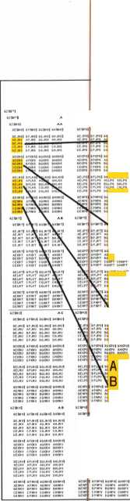

|  |  |  |  |  |  |
| --- | --- | --- | --- | --- | --- |
| mm |  |  | mm |  |  |

Hill Hill 1111 1111 Ill'll Ill'll

**pl'llli** i'i'lfsi' fSSSM

tAEJNS AFJNS AGJNS AHJNS ..." IBEJNS BFJNS BGJNS BHJNSS CEJNS CFJNS CGJNS CHJNSi ;; DEJNS DFJNS DGJNS DHJNSji.

ini mm ini jiii iiii llffill Sliii III!

ini ini ini ini

mu mi ini

mi

in **ii** in mu **iiii**

liisii'i pi

AEJNS ' AE J PS AEJQS, AEJRS BEJNS IBEJPS BEJ QS BEJRS

cejns' |cejps cejqs' cejrs

DEJNS. DEJPS DEJQS, DEJRS

SHHsi SBSi HfeiB miH

ini ini mi mi

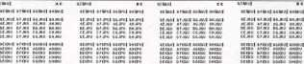

**iiii iiii** iiii nn

mi nn nn nn mi nn nn nn

HUM

« j AEJNS AFJNS AG J NS AHJNS

lilirfiil nn 11111

■sir» AEKNS AFKNS AGKNS AHKNS

11I!M|1I IIII Hill

iiiilUplaelns aflns aglns ahlns

iiii liSl'iii! BIB]

IsIlS l!'i3AEMNS AFMNS AGMNS AHMNS

IIII Hill IIII Rff

nn iin nn nn

**iiii** nn nn nn

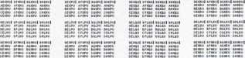

nn **iiii** nn nn

nn nn nn nn

**;ECOND LEVEL 3 SECOND LEVEL 4 SECOND LEVEL 5**

**^AI-4, AA17-20, AA33-36, AA49-52 AA1-4, BAt-4, CA1-4, DAI-4 AA1, 5, 9, 13, 17, 21, 25, 29, 33, 37,**

**41, 45, 49, 53, 57, 61**

mm

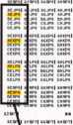

AEJNS ijAEJPS

**iiii** tin

EAEKNS iAEKPS

gggg Hkwww

^fAELNS^AELPS

iiiif iiii

|AEMNS |AEMPS

EJQS SS A E J R S

IIII Illii

SAEKQS gAEKRS

jggg ssss\

^'AELQSifiAELRS

ini iiiu

|AEMQS IIAEMRS

IIII IIII IIII IIII

nn nn nn nn nn nn nn nn **iiii nn iiii nn**

**ECOND LEVEL 8**

**lAI, 5, 9, 13; BA1, 5, 9, 13;**

**A1, 5, 9, 13; DAI, 5, 9, 13**

mu

|fpii~AEJNsi Hi! iiii I I'll AEKNS I IIII IIII I III aIlns'I IIII nil

Will aImnsI fill Iiii

[ffpit/cijwi iiii iiii

1 III aIkntI IIII IIII

**i** in **aIlntI iiii** nn mm AEMNt? **iiii iiii**

iiii iiii

1' **AEKNul** i'ilil 11111111

I aelnP IIII Iiii

I A|SWI fill IIII

iHpinAi^i iiii iiii

I III AEKNv'I IIII IIII

I III **AM# iiii iiii**

**IMii a fwnnn nn**

**SECOND LEVEL 9**

**AA1, 5, 9, 13; AB1, 5, 9, 13;**

**AC1, 5, 9, 13; ADI 5, 9, 13**

mm

1111 1111 1111 1111

iAEJNS ilAEJPS iiAEJQS — AE J RS

liEiiii llli iiii I ill

iiii iiii iiii iiii

iiii Iiii iiii pill

IjAEJNT |AEJPT lAEJQT |aEJRT

IKilllf islllir IllfliE iSriS

IIII iiii iiii iiii



Hess 1E H B IliEES llEEE

iiii iiii iiii iiii

|III |111 1111 fill

aejnv |aejp\§ |aejqv |aejrv

1 B**1 i If B** B §11B m II1B11

iiii iiii iiii iiii

**SECOND LEVEL 10 AA1, AB1, AC1, ADI, BA1, BB1, BC1, BD1, CA1, CB1, CC1, CD1, DAI, DB1, DC1, DD1**

March 1998

Keynotes I

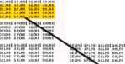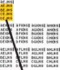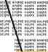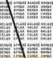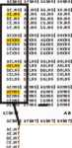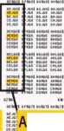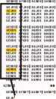

Since 1939, our goal has been

o c

K S M I T H



**Professionalism Through  
Education"**

cOGN/£

to provide you, the security

specialist, with technical

information that is both

accurate and relevant to your

ever-changing role in the

marketplace. In addition to

serving you each month

through the pages of

Locksmsth Leo n # :ave

published *Ui\ i i r c ; . ||

k

educational and refe* 3k v

material to help you prosper

* Technical Reference Manuals
* Instructional Videos

in the '90s.

Prop Information - **RppH**

**•** Computer Software

pr ftprvirp Hard #4



A national survey on telephone courtesy  
was recently conducted. This survey was  
conducted by a St. Louis, Missouri-based  
customer service and telephone skills  
training company. The result: 85 percent of  
consumers questioned revealed that  
telephone courtesy made “much difference”

in their decision to buy goods or services  
from a business. Half the respondents  
said that they refused to do business  
with a company that treated them  
poorly over the telephone. The decision  
to use your locksmith service company  
can happen in the first few seconds of a  
telephone call. How does your telephone  
customer service measure up?

As a locksmith, there are good ways  
and bad ways to deal with customers  
over the phone.

A telephone call may be the first  
contact with a potential new customer.

This is especially true when your  
business does not have a storefront. It  
may also pertain when someone “finds

you” in the telephone directory or  
through newspaper advertising.

Keep your customers or potential  
customers happy with your  
telephone service by following

some of these guidelines.

Try to project a positive  
attitude. Smile while  
speaking on the telephone.

Answer the phone by saying  
“good morning,” “good  
afternoon,” “happy holidays,”  
or some other pleasant  
greeting. Then identify  
yourself and the name of your

business. A positive and friendly  
attitude will translate across the  
phone lines!

Also, speak clearly and avoid

mumbling. Remember that just because  
you are familiar with a brand name or  
product doesn’t mean your customer is.

Be patient and polite. Your products and services may be routine to you, but it may be the first time your customer is exposed to the idea, terminology or products. Take time to explain. (There was a time when you needed this information explained to you too!). Also, in the event of an emergency situation (lockout, etc.), your customer is calling you and is probably already upset. There is no reason to add “fuel to the fire” by a lack of customer courtesy.

Be attentive. Listen carefully. Be brief with opening remarks and get right down to basics. Find out what the caller’s needs are. For the successful locksmith, extracting information quickly and accurately is they key to good telephone service and good business. If you don’t understand the customer’s needs, you will not be prepared to

order parts correctly or to mn a service call. Treat all questions as if they were equally important, no matter how many times you have heard them.

Avoid “terminal hold.” Although it can be a viable necessity, the hold button ranks as the consumer’s biggest pet peeve. It’s not being put on hold that bothers people, but how they are being put on hold. People know they may be put on hold when they

call but they prefer to be asked if they can  
wait, rather than being told to do so.

Keep the following in mind:

Tell people you will be back in a minute  
only if you’ll literally be back in 60 seconds  
or less. If customers are on hold longer than a  
minute, periodically check back with them.  
Offer to take a message and call back later.

Know your product lines and  
services. Being unable to provide  
information may be the only thing  
worse than terminal hold.

Be prepared to transfer the call to  
the right person immediately. If you  
don’t know the answer to a question,  
find someone who does.

Return your calls—promptly.  
Customers expect to hear from you if  
they leave a message. If you don’t have  
time to return a call, have someone  
else on your staff who is qualified do it  
for you.

Maintain a professional demeanor.  
When a customer is rude on the  
phone, let that individual finish  
speaking. Eventually, they will run  
out of steam. “I’ve listened to you,

and now, if you’ll please allow  
me, I’ll explain what  
happened.” The tactic usually

works. If you gently say  
“Please,” nine out of 10  
people will listen.

End on a positive note.  
Two words may do more  
than any other toward  
ensuring harmony with your  
phone service—“Thank you.”  
Any employee that deals

with customers needs to be  
trained in phone etiquette!

A telephone call can be your first

contact with a potential customer and  
can lead to a long and successful  
business relationship. Try calling your  
company (as a customer). What  
feedback do you get across the phone

lines? Based on a telephone call, would you  
want you use your business?

About the Author: Claire L. Cohen, the second woman to become a CML, has been in locksmithing since 1911 and has been writing articles for Keynotes since 1981. She is an active member of the Locksmith Association of Washington, D.C., where she has taught many classes.

TELEPHONE

CUSTOMER

SERVICE

HOW DO YOU MEASURE UP?

March 1998

Keynotes

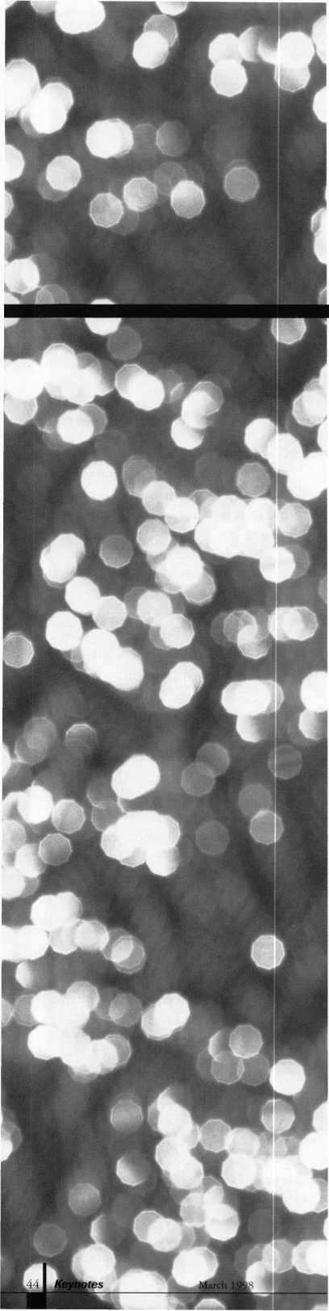

IEditor’s Note: The artici ?

read was written to those in

and the author sent us a copy

Keynotes readers would he

where insiders in the alarm  
industry is headed.}

you are about to

i he alarm industry,

We thought

interested in hearing

s xtor think their

All of us are always nervo

future brings, whether it  
or our personal lives. We

soothsayers, try to predict

but at best it is always an

Most of the time though

learned from the past ex]

and define what our fututle

serve as a guide into the

unknown which is the fu

2000 draws near, we must

and be ready to meet the

are to come. As an alarm

l wh )L

can reposition your com]

demands of the constant^

and, together with your

associations, you can becc u

a force to help raise public

security industry as a

could definitely mean a

profitable alarm industry

The burglar alarm bus

made some great strides

century. It truly has been

the triumph of independ

so intrinsic to the fabric

business. There is a new,

alism about our alarm in ii

security professionals. Ho1

there are new forces at wi

companies, whose busine si

is about what the  
ie in our business  
ilways try to be

our own future,

educated guess,

it is lessons

:p|eriences that shape

can be and often

^orld of the

ure. As the year

open our minds

new challenges that  
professional, you

ip any to meet the

changing market

sjtate and local

me a force within

awareness of the  
e. The end result

] nore thriving and

iness has indeed

i >ver the last quarter

the incarnation of

nt small businesses,

of American

distinct profession-

ustry—we are all

iwever, predictably,

i >rk here. Larger

s is not necessarily

security related, have gotten onto the security picture by buying security companies. At this point in time, the margins are being taken out of the installa­tion end of the residential business. This is done to quickly obtain the brass ring— monitoring and the recurring revenue.

Commercial installations have a little more margin built in and there is less competition. There is lots of room in this arena for new businesses and higher revenues. This, for many, is “where it’s at.” However, you must all stay in this because you, as security professionals, are the only ones who can do this, as big margins in recurring revenues are what separates you from the other contractors. It seems, though, that many are neglecting commercial business. Why not start thinking about leasing commercial accounts as the bigger companies lean more towards residential in their acquisitions? For example, ADT is still big, but they seem to be of a residential focus.

In order to compete, you must lower prices while maintaining your base. Anyone can be a freebie. Set your sights on reasonable prices for starter installations and get your price back up there quickly by just adding ancillary convenience items and complimen­tary services. As an independent alarm company, you should also consider market areas such as cameras, card access, video intercom and locksmithing. By having a mix of services, you offer the customer the wider width concept of total security. As long as you keep servicing them in a high quality manner, you will have customer long term

by Donna Soloway

and benefit from recurring revenue.

Since the economy is thriving and construction is booming, also consider focusing on profitable service contracts. This way, you will be able to get recurring revenue from customers in these areas as well as higher margins from the installations. With all this new housing, developers are a prime market for high volume new business. Open up your mind, the world is your oyster and business is yours for the asking. Look for new areas to grow, but bring with you the mentality of the alarm business—recurring revenue and strong service.

According to a survey done by Joe Freeman, of J.P. Freeman, the market pene­tration of electronic security systems in the United States is about 15 percent, which means about one in six homes have them. By the end of 1997, it is expected that this will go up to 20 percent, or one in five American homes will be secured with alarms. While this percentage is increasing, the pie is still way too small!!!! The market penetration is nowhere where it should be—which of course is 100%!

In order to reach this lofty goal, the public—the community-at-large—must learn about us as an industry and, most importantly, they must feel good about us to increase the element of trust. We must create positive awareness of the alarm industry, which translates into public relations. An active community relations program will not only promote public awareness of your company, but will foster understanding and awareness of fire and crime problems in your

community and what solutions your associa­tion has to offer to solve them. It is incumbent on you to report to the news media stories such as alarm equipment saving lives and children of law enforcement officers winning scholarships. Other examples of good community programs to become involved in include holiday toy programs, visits to children’s hospitals, Big Brother sports programs, or anything where a spirit of good is transcended.

In conclusion, in order to meet these new challenges, we must be creating the trends, but at the same time responding to the actual trends of the present marketplace. This is a delicate balance that needs to be constantly fine-tuned. There is lots of room for expansion in both arenas, your business and public awareness. The two go hand-in- hand to spell success.

About the author: Donna Soloway is the Director of Security Industry Relations for NAPCO Security Systems, Inc.

Uuick Facts rl r About the electronic security Industry rrpm rthe .National burglar and Fire Alarm Association

I ndustry Growth

In 1996, Americans spent an estimated $13.2 billion on

professionally installed electronic security products.

Spending on electronic security products and services is growing at an estimated 4.3 percent per year.

In 1995, an average of 13,100 businesses in the United States were classified as "alarm installing entities."

By the end of 1997, more than one in five homes (20

percent of U.S. households) will be electronically protected.

From 1988 to 1993, consumers spent more than $5

billion on home security installations. (This figure does not  
include monitoring costs.)

Size oF Alarm Businesses



About one-half of the businesses installing alarm systems have annual revenues of less than $250,000 per year and employ four or fewer employees.

The average price of a security system has decreased in the last six years, dropping from $1,509 in 1990 to $1,255 in 1996.

Burglary Statistics

Homes without electronic security systems are about three times more likely to be broken into than homes with electronic security systems. (Actual statistics range from 2.2 times to 3.1 times, depending on the value of the home.)

Businesses without electronic security systems are 4.5 times more likely to be burglarized than commercial locations with electronic security in place.

There were 2.59 million burglaries in the United States in 1995 and 581,000 robberies.

March 1998

Keynotes L



|  |  |  |
| --- | --- | --- |
| Associate |  | ® |
| Members | \ |
| Manufacturers | American L  3400 West Exch; Crete, IL 604 (708) 534-2000; FAX  • i | ick Co.  £ nge Road ' 7-2099 [708) 534-0531  l» |
| A & B Safe Corp.  171 S. Delsea Dr.  Glassboro, NJ 08028 (800) 253-1267; FAX (609) 863-1208  9 9 9 9 | American Secur  11925 Pacifi Fontana, CA 92 (800) 423-1881; FAX  ^ | ty Products  ; Ave.  337-6963  (909)685-9685  > |
| Adesco Safe Manufacturing Co.  16720 S. Garfield Ave.  Paramount CA 90723 (800) 821-6803; FAX (310) 408-6427  • | Arrow Lock (  10300 Foster Brooklyn, N> (718) 257-4700; FAX  SCI | ompany  Avenue  11236  718) 649-9097  > 9 |
| ASSA Inc.  10300 Foster Ave.  Brooklyn, NY 11236 (800) 235-7482; FAX (718) 257-2772  • | Auto Security Proc  P.0. Box Redmond, WA J (425) 556-1900; FAX  9 i | lucts CA. S. P.)  10  8073-0010 (425) 558-1205  t |
| Abus Lock Company  3555 Holly Lane North  Plymouth, MN 55447-0507 (800) 352-2287; FAX (612) 509-9939  9 | Baton Locks & K  14275 Comm Garden Grove, (714) 265-3636; FAX  9 4 | ardware Co.  erce Dr.  CA 92643 (714)265-3630  1 |
| Adams Rite Manufacturing Co.  P.0. Box 1301  LaPuente, CA 91749-1301 (562) 699-0511; FAX (562) 699-5094  9 9 | Chicago Lock  10100 88t Pleasant Prairie, \A (800) 445-3204; FAX  9 | Company  i Ave.  1 53158-0069 (414) 947-7178 |
| Adrian Steel Company  906 James St.  Adrian, Ml 49221  (800) 677-2726; FAX (517) 265-5834  9 | Corbin Russwin Arch  P.O. Box: Charlotte, N (800) 543-3658; FA)  9 9 4 | tectural Hardware  5288 ^ 28229 (800) 447-6714  9 • |
| Alarm Lock Systems, Inc.  345 Bayview Ave.  Amityville, NY 11701 (800) ALA-LOCK; (516) 789-3383  9 | Curtis Ind  6140 Parkland E Mayfield Heights, ( (800) 555  9 < | jstries  Ivd. Ste. 300  IH 44124-4103 -5397  9 |
| Aiphone Intercom Systems  1700-130th Avenue, NE  Bellevue, WA 98005 (206) 455-0510; FAX (206) 455-0071  It9 | DETI  302 Det< New Braunfek (800) 729-3839; FA)  9 9 ' | X  x Dr.  ,1X78130 (210) 620-6711  9 9 |
| All-Lock Company  900 Ravenwood Dr.  Selma, AL 36701  (334) 874-9001; FAX (334) 874-6011  • • | Don-Jo Manufn  P.O. Bo;; Sterling, M* (508)422-3377; FAX  9 1 | cturing, Inc.  929  ^ 01564  (508) 422-3467  9 |
|  |  |  |
| Keynotes March 1998 | |  |

Associate members of the Associated Locksmiths of America (ALO A) manu­facture or distribute materials or equip­ment, or provide services, for the securi­ty industry. Many have donated money, services and equipment to ALO A in addition to their annual dues. Their sup­port of ALOA projects enhances overall membership benefits and we encourage our members to patronize these firms. If you know of a potential candidate for associate membership, please contact the ALOA Sales staff at (214) 827-1701. Associate member dues are $500 per year and entitle the payor to use the ALOA logo, and selected discounts on ALOA products and services.

Le**g**end

9 Alarms: Personal, vehicle, electronic, fire, burglar, and exit

9 Automotive: Lockout equipment, key chains/rihgs

9 Builders Hardware: Door closers, furniture/decorative hardware, viewers, emergency exit devices

Books, reference guides, publications, computer software

9 CCTV/Photo Imaging: Cameras, monitors, photo ID equipment, cables

9 Electric/Electronic Security: Card access control and readers, surveil­lance, electric/magnetic locks and strikes, keypads

0 Lock Devices: Auto locks, cylinders, emergency exit/entrance control, locks (various types), strikes

9 Tools A Supplies: Key blanks, cutters, picks, rings/hooks, custom van/truck supplies

9 Safes/Vaults

9 Other

|  |  |  |
| --- | --- | --- |
| Door Controls International  2362 Bishop Circle East  Dexter, Ml 48130  (800)742-3634; FAX (800) 742-0410 | Hurd Corporation  503 Bohannon Rd.  Greeneville, TN 37744-1450 (423) 787-8800; (423) 787-8817 | Locksmith Publishing Corp.  850 Busse Hwy.  Park Ridge, IL 60068 (847) 692-5940; FAX (847)692-4604 |
| • • • • | • • • | • |
| Emtek Products, Inc.  15250 E. Stafford St.  City of Industry, CA 91744 (800)356-2741; FAX (800) 577-5771 | llco Unican  400 Jeffreys Road  Rocky Mount, NC 27804 (919)446-3321; FAX (919) 446-4702 | Lori Lock  P.O. Box 1040  Southington, CT 06489 (860)621-3605; FAX (203) 621-5972 |
| • • | ••••••• | • • |
| ESP Lock Products, Inc.  375 Harvard Street  Leominster, MA 01453 (508) 537-6121; FAX (508) 537-1699 | Industries, C.L. Inc.  9730 Gouin Blvd. West  Pierrefonds (PQ) H8Y 1R5 (514)683-6282; FAX(514) 683-9015 | Lucky Line Products  7890 Dunbrook Rd.  San Diego, CA 92126 (619)549-6699; FAX (619) 549-0949 |
| • | • • | • |
| Federal Lock Company  14247 E. Don Julian Rd.  City of Industry, CA 91746 (800)682-9851; FAX (708) 378-4767 | International Electronics, Inc. (I.E.I.)  427 Turnpike St.  Canton, MA 02021 (800)343-9502; FAX(617) 821-4443 | M.A.G. Engineering & Mfg. Inc.  15261 Transistor Lane  Huntington Beach, CA 92649 (714) 891 -5100; FAX (714) 892-6845 |
| • | • | • • • |
| Folger Adam Security, Inc.  16300 W. 103rd Street  Lemont, IL 60439  (630) 739-3900; FAX (630) 739-6138 | Jet Hardware Mfg. Co.  800 Hinsdale Street  Brooklyn, NY 11207 (718)257-9600; FAX(718) 257-0973 | MARKS USA  5300 New Horizons Blvd.  Amityville, NY 11701 (516) 225-5400; FAX (516) 225-6136 |
| • ® | • | • |
| Fort Lock Corp.  3000 N. River Rd.  River Grove, IL 60171 (708) 456-1100; FAX (708) 456-9476 | KABA High Security Locks  P.O. Box 490  Southington, CT 06489 (860)621-3601; FAX(860) 621-9727 | Master Lock Company  2600 North 32nd Street  Milwaukee, Wl 53211 (414) 444-2800; FAX (414) 449-3114 |
| •••••• | • | * • |
| Gardall Safe Corporation  P.O. Box 30  Syracuse, NY 13206 (315) 432-9115; FAX (315) 434-9442 | Kenstan Lock Company  101 Commercial St  Plainveiw, NY 11803-2412 (516) 271 -2700; FAX(516) 271 -2759 | Medeco Security Locks  P.O. Box 3075  Salem, VA 24153  (540) 380-5000; FAX (540) 380-5010 |
| • | e e | • • • |
| Grobet File Co. of America  750 Wasahington Ave.  Carlstadt, NJ 07072 (800) 962-7242; FAX (800) 243-2432 | KEY-BAK; Div. of W. Coast Chain Mfg. Co.  1460 S. Balboa Ave.  Ontario, CA 91762 (909) 923-7800; FAX0O9) 923-0024 | Meilink Safe Company  111 Security Parkway  New Albany, IN 47150 (800) 634-5465; FAX (800) 896-6606 |
| • | • • • • | • |
| H.E.S., Inc.  2040 W. Quail Ave.  Phoenix, AZ 85027 (602) 582-4626; FAX (602) 582-4641 | Knaack Manufacturing Co.  420 E. Terra Cotta Ave.  Crystal Lake, IL 60014 (800) 456-7865; FAX(815) 459-9097 | MUL-T-LOCK USA, Inc.  300-1 Route 17 South Suite A  Lodi, NJ 07644  (800) 562-3511; FAX (201) 778-4007 |
|  | e | • • • |
| Highland Glen Products, Inc.  218 Parkdale Ave.; P.O. Box 924  Buffalo, NY 14213 (716) 883-1110; (800) 248-KEYS | LCN Closers (Division of Ingersol)  121 W. Railroad Ave.  Princeton, IL 61356 (815)875-3311; FAX (815)875-3222 | National Cabinet Lock  200 Old Mill Road, P. 0. Box 200  Mauldin, SC 29662 (864) 297-6655; FAX (864) 297-9987 |
| • • | • | • |
| Hill Security Products  711 East Walton Avenue  Spokane, WA 99207 (509) 487-1142; (800) 722-1142 | LAB Security  700 Emmett St.  Bristol, CT 06010  (800) 243-8242; FAX (203) 583-7838 | The National Locksmith Magazine  1533 Burgundy Parkway  Streamwood, IL 60107 (630) 837-2044; FAX (630) 837-1210 |
| • | • | • |
| HPC, Inc.  3999 N. 25th Avenue  Schiller Park, IL 60176 (847)671-6280; FAX(847) 671-6343 | La Gard, Inc.  3330 Kashiwa Street  Torrance, CA 90505 (310)325-5670; FAX (310)325-5615 | Newman Tonks  805 N Buckman St  Shepardsville, KY 40165 (800) 826-5792; FAX (800) 777-8229 |
| • • • | • | • # |
|  |  |  |
|  | |  |

Keynotes 147

March 1998

|  |  |  |  |
| --- | --- | --- | --- |
|  | |  | |
| NKL Industries Ltd.  1111-13 Cavalier Blvd.  Chesapeake, VA 23323 (800) 528-9900; (757) 485-0271  • • • • | Sully Too  3515 Noddint Fairfax, VA (703)689-3416; FA) | l» Inc.  3 Pine Ct.  : !2033  ( (703) 787-0869  © | American Security Distribution  4411 E. La Palma  Anaheim, CA 92807 (714)996-0791; FAX (714) 579-3508  ^ @ (p (Q ($ $ |
| Prime-Line Products Company  5405 Industrial Pkwy.  San Bernadino, CA 92407 (800) 255-3505; FAX (909) 880-8968  • • | Hmemast  127 SE 29tl Topeka, KS (785)232-8705; FA>  @ (0 (Q | i r, Inc.  i Street l S6605  t (800) 798-8463  © © © | Andrews Wholesale Lock Supply  544 S. 9th St.  Lebanon, PA 17042-6608 (717) 272-7422  • |
| ROFU International Corp.  2004-B 48th Ave.; Court E  Tacoma, WA 98424 (800) 255-7638; FAX (253) 922-1728  • | Trine Products  1430 Ferris Bronx, NY (718)829-4796; FA)  © © | Corporation  5 Place  10461  < (718)792-9127  © | Boyle & Chase Inc.  P. 0. Box 74  Accord, MA 02018-0074 (800) 325-2530; FAX (617) 335-5342  © © © |
| Rutherford Controls Inc.  2697 Internal Pkwy, Bid 5 #100  Virginia Beach, VA 23452 (757)427-1230; FAX (804) 427-9549  • | U-Change Loci  1640 W. H\ Mustang, Ol (405)376-1600; FA)  © © | i Industries  ty. 152 ; 73064 (405) 376-6870  © | Clark Security Products, Inc.  4775 Viewridge Ave.  San Diego, CA 92123-1641 (800) 854-2088  •••••••••• |
| Sargent & Greenleaf, Inc.  P.O. Box 930  Nicholasville, KY 40340-0930 (606) 885-9411; FAX (606) 887-2057  ^ @ (0 ^ | Vindicato  3001 Bee C Austin, TX 7f (512)314-1200; FA)  © • < | ' Corp.  ives Rd.  746-5561  (512)314-1270  » • | Cook’s Building Specialties  2441 Menaul Blvd. NE; P.O. Box 37320 Albuquerque, NM 87176-7320 (505)883-5701; FAX (505) 883-5704  •••••• |
| Schlage Lock Co.  1915 Jamboree Suite 165  Colorado Springs, CO 80920 (800)847-1864; FAX (800) 452-0663  • © | Weiser Lock  6700 Weiser 1 Tucson, A 2 (520)741-6338; FA)  © < | Company  ock Blvd.  85746  : (520) 741-6363  » | DiMark International  3117 Liberator St., Unit A  Santa Maria, CA 93455 (800) 235-2435; FAX (805) 928-8034  © • |
| Schwab Corporation  3000 Main St.  Lafayette, IN 47903-5088 (765) 447-9470; FAX (317) 447-8278  • | Wilson Safe  3031 Island Avenu Philadelphia, (215)492-7100; (  © | Company  i/P.O. Box 5310  PA 19153  BOO) 345-8053 | Dire’s Lock & Key Co.  2201 Broadway  Denver, CO 80205 (303) 294-0176 |
| Securitron Magnalock Corp.  550 Vista Blvd.  Sparks, NV 89434  (800)624-5625; FAX (702) 355-5636  O • | Yale Secu  P.O. Box Charlotte, NC (800)438-1951; (  © © < | rity Inc.  25288  28229-8010  100) 338-0965  » © | Doyle Lock Supply  2211 W. River Road N.  Minneapolis, MN 55411 (800) 333-6953; FAX (612) 521 -0166 |
| Security Door Controls  3580 Willow Lane  Westlake Village, CA 91361 (805) 494-0622; FAX (800) 959-4732  • | Distril | tutors | Dugmore & Duncan Inc.  30 Pond Park Rd.  Hingham, MA 02043 (800) 225-1595; FAX (617) 740-4043  ••••••• |
| Sentry Group  900 Linden Ave.  Rochester, NY 14625-2784 (716)381-4900; FAX (716) 381-8559  • | Accredited Loc  P.O. Bo) Secaucus, NJ (800)652-2835; FA  • • • € | k Supply Co.  1442  37096-1442  K (201.) 865-5031  (Q | Ewert Wholesale Hardware  4709 W 120th St  Alsip II 60658 (800)451-0200  © © © © © |
| Silca Key U.S.A. Inc.  400 Jeffreys Rd.  Rocky Mount, NC 27804 (919) 446-3321; FAX (919) 446-4702  • © | Ace Lock & Seci  565 Rahv Union, NJ 0 (908) 688-7666; (  © © © © | rity Supply Co.  ay Ave.  083-6631  100) ACE-FAX4  • • • • | Fairway Supply, Inc.  2631 Lombardy Lane  Dallas, TX 75220  (214)350-0021; FAX (214) 352-4299  ^ @ ^ ® |
| STRATTEC Security Corp.  3333 W. Good Hope Rd.  Milwaukee, Wl 53209 (414) 247-3333; FAX (414) 247-3329  ^ | Akron Hardware I  2579 South Ar Akron, O  (800) 321-9602; F/C  © © | Consultants, Inc.  ington Road  1 44319  < (800) 328-6070  • | Foley-Belsaw Company  6301 Equitable Road  Kansas City, MO 64120 (800)821-3452; FAX (816) 483-5010  ^ (j^ |
|  |  |  |  |
| ©Bank security equip.  ’plaroiiliiiife■ w Lock Devices | | it & Fit ‘ ^ ^ ••• • ‘ :v-  H • Tools & Supplies  ® Safes/Vaults Vdf ■. •  ' . -. 3 ; ™:’,_ uttter | |
| Keynotes March 1998 | |  | |

|  |
| --- |
| Fried Brothers, Inc.  467 N. 7th St.  Philadelphia, PA 19123 (800) 523-2924; FAX (800) 541-3489  •••••••••• |
| HS&S Wholesale Distributors  12915 West 8 Mile Road  Detroit, Ml 48235 (800) 521-2202  @ (p (j^ (j} |
| Hans Johnsen Company  8901 Chancellor Row  Dallas, TX 75247  (214)879-1550; FAX (214) 879-1530  •••••••• |
| Hardware Agencies, Ltd.  1220 Dundas Street East  Toronto, ON M4M 1 S3 (416)462-1921  •••••••• |
| Hardware Suppliers of America  P.O. Box 2208  Winterville, NC 28590 (800) 334-5625  • • |
| IDN, Inc.  1000 S. Main, Suite 280  Grapevine, TX 76051 (817)421-5470; FAX (817) 421-5468 |
| Intermountain Lock & Supply Co  2300 W. 2nd Ave., Unit B  Denver, CO 80223  (800) 323-8046; FAX (303) 698-2094  •••••••••• |
| Jo-Van Distributors Inc.  929 Warden Ave.  Scarborough, Ontario MIL 4C6 (416) 752-7249; FAX (416) 752-3845 |
| JLM Wholesale, Inc.  3095 Mullins Ct  Oxford, Ml 48371-1643 (800) 522-2940; FAX (800) 782-1160  • • • |
| Key Sales & Supply Co., Inc.  9950 Freeland Ave.  Detroit Ml 48227 (313) 931-7720; (313) 931-7758 |
| Lockmasters, Inc.  5085 Danville Road  Nicholasville KY, 40356 (606) 885-6041  • • • • |
| Locks Company  2050 N.E. 151 St.  N. Miami, FL 33162 (800)288-0801; FAX (305) 949-3619  • •••••• |
|  |

The Locksmith Store Inc.

1229 E Algonquin Rd. Suite E  
Arlington Heights, IL 60005  
(847) 364-5111; FAX (847) 364-5125

M. Zion Company

17 Murray Street  
New York, NY 10007  
(212) 349-8677

Strauss Safe & Lock Company

1801 Second Avenue  
Des Moines, IA 50314  
(515)288-9571; FAX: (515)288-9752

Top Notch Distributors, Inc.

3151 Goni Rd.

Carson City, NV 89706-7922  
(800) 722-4210; FAX (800) 248-3620

McDonald-DASH Locksmith Supply

5767 E. Shelby Dr.

Memphis, TN 38141  
(800)238-7541; FAX (901) 366-0005

Turn 10

P. O. Box 746  
Marietta, OH m45750  
(800) 848-9790; (800) 391-4553

McManus Locksmith Supply, Inc.

P.O. Box 9231,1309 Central Ave.  
Charlotte, NC 28299  
(702)333-9112

U.S. Lock Corporation

77 Rodeo Drive  
Brentwood, NY 11717  
(800) 925-5000; FAX (800) 338-5625

McMaster-Carr Supply Company

600 County Line Rd,

Elmhurst, IL 60126-2081  
(630) 833-0300; FAX (630) 834-9427

Webster Safe & Lock Company, Inc.

3020 Millbranch  
Memphis, TN 38116  
(901) 332-2911; FAX (901) 332-2878

Monaco Lock Co.

339-345 Newark Ave.

Jersey City, NJ 07302  
(800) 526-6094; FAX (800) 845-LOCK

Service

Omaha Wholesale Hardware

1201 Pacific Street, PO Box 3628  
Omaha, NE 68108  
(800) 238-4566

Alarm Monitoring Service, Inc.

5021 Fairfield St.

Metairie, LA 70006  
(504) 454-2163; (504) 456-8737

E. L. Reinhardt Co., Inc.

3250 Fanum Road  
Vadnais Heights, MN 55110  
(800) 328-1311; FAX (612) 481-0166

Allstate Insurance Company

2775 Sanders Road, Suite A5  
Northbrook, IL 60062  
(847) 402-8196; FAX(847) 326-7509

Security Lock Distributors

40 A Street

Needham Heights, MA 02194  
(800) 847-5625; FAX (800) 878-6400

GEICO

One Geico Blvd.  
Fredericksburg, VA 22412  
(540) 286-4399; FAX (540) 286-7106

Sentry Security Fasteners

8109 N. University  
Peoria, IL 61615

(309) 693-2800; FAX (309) 693-2872

The Hartford Financial Services Co.

55 Farmington Ave.; P.O. Box 2908  
Hartford, CT 06104  
(860) 520-2915; FAX (860) 520-2264

Southern Lock and Supply Co.

Box 1980,10910 Endeavor Way  
Pinellas Park, FL 34664  
(800) 237-2875; FAX: (800) 447-2299

!••#••••<

Pine Technical College

1000 4th Street  
Pine City, MN 55063  
(800)521-7463; FAX (612) 629-7603

Stone & Berg Wholesale

99 Stafford Street  
Worcester, MA 01603  
(800) 225-7405; FAX (800) 535-5625

Unlocks, Inc.

3505 Tarpon Woods Blvd. G409  
Palm Harbor, FL 34685  
(800) UNLOCKS; FAX (813) 787-7960

; ■ j

it a a

Mmm&

*i"mam*m

March 1998

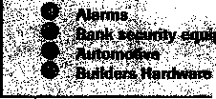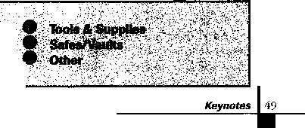

Keynotes

Classified



Dept)

■Employment

Automotive Locksmith Wanted

3/F/3: Relocate to south Florida and throw away your deadbolts and three keys for a dollar. We run over 300 calls per week. You must own a truck with tools and code equipment to cut all for­eign and domestic keys. You can earn $800 to $1,500 per week. Please, no calls if you don't have a truck or tools.

Contact: South Florida Lock and Safe (800) 928-2926

Security Technician Wanted

3/F/3: Suburban Chicago compa­ny seeking top notch security technician for permanent full­time position, top pay, health insurance, paid vacation, retire­ment plan, company vehicle pro­vided. Ninety percent commer­cial work, this is an excellent opportunity for the right person. **Contact: Ron at (847) 272-2211**

Locksmith Wanted

l/F/3: Boston based safe company needs organized, management type person to supervise service and delivery crews. Technical background helpful. Salary plus bonuses based on experience.

(800) 367-3453 (617) 497-7542fax

Locksmith Whnted

l/F/3: Locksmith wanted for shop and mobile unit. Minimum three years experience. Good dri­ving record and good communi­cation skills. Call anytime.

Plaza Locksmith Ventura, CA 93003 (805) 653-6946 (805) 644-6622 Ask for Mike or Darlene

Locksmith

l/F/3: Established lock shop in operation 50 years, friendly staff, looking for a qualified locksmith for outside road work. Knowl­edge and experience in various areas of the industry. Safe open­ing knowledge essential. Mini­

mum five years’ experience. Pro­fessional attitude, organized, good communication skills, clean driving record. Benefits include health insurance, paid vacation, holidays. Vehicle, tools, two-way radio provided. We’d like to have you join our team. **Resume and references to:**

Dawn Barnes 135 Main St. D12 Wes thorough, MA 01581 (508) 366-8864 fax

Experienced Locksmith Whnted

l/F/3: Join an established lock­smith company in beautiful Marin County, Calif. Just 35 minutes north of San Francisco. Pleasant year-round conditions. Good base pay plus commission, profit sharing, paid absence. Paid health and pension also available. Must be proficient in all phases of locksmithing, neat appearance and good driving record. Back­ground check will be required for state license.

Resume, references and salary requirements:

Novato Lock 7395 Redwood Blvd.

Novato, CA 94945 (415) 892-9111

Locksmiths Wanted

2/F/3: Largest Locksmith in Las Vegas needs experienced locksmiths (two years minimum) for road technicians and counter help. Base salary plus generous commission program. This is a career opportunity with paid holidays and vacation, medical benefits, 401K plan, and a great advancement potential.

Resume to:

Liberty Lock & Key 5470 W. Sahara Las Vegas, NV 89102 (702) 876-5470

Store Manager/

Locksmith Whnted

l/F/3: Work in beautiful, grow­ing Denver, Colo. Position now available with 27 year company operating three stores and nine service vehicles. Presently look-

i ag for a hard working, enthusi- ^ Stic individual with good lock- smith skills to operate all facets of store operations including inventory control, sales, purchas­ing, and technical service. No mobile or on-call. Paid vacations, holidays, medical/dental, educa­tional classes, and uniforms fur­nished. Salary offering varies with experience level, 33k base ] or qualified applicants. **j Resumes to:**

i Inglewood Lock and Safe, Inc.

4310 S. Broadway i Inglewood, CO 80110 800)257-2568 303) 789-3748fax

.ocksmith Wanted

2/F/3: Minimum two years experience in service work.

Safe, alarm and access control experience a plus. Must have dean driving record, good rommunications skills, be lard working and neat in ippearance. Salary and benefits rommensurate with experience and training.

Resume to:

Lockbusters, Inc.

PO Box 72045 Houston, TX 77272-0475 (281) 265-3335 (281) 265-9434 fax

Locksmith Wanted

2/P/3: Stanford University seeks a Lock Shop Supervisor with an extensive understanding of locks, safes and security systems, and working knowledge of journey-level locksmithing.

Your primary responsibility is to supply efficient, timely and value-added services to the University facilities. In addition, you will supervise the work of seven locksmith technicians.

To qualify, you must have a supervisory background, strong business management skills and experience using preventative, routine and reactive maintenance practices. Excellent time management, organizational and communication skills are a must, as is the ability to think clearly and analytically and identify/

solve problems. A valid California driver’s license or ability to obtain one prior to start date is required. For a full description of this and other positions, see us on the Web at: www-leland.stanford.edu/group /employment. AA/EOE **Resume and cover letter to:**

Stanford University Human Resources Services,

Req. **#** J972511 655 Sierra St.

Stanford, CA. 94395-6110

Locksmiths Wanted

2/F/3: Colorado’s largest locksmith company seeks locksmiths with experience in impressioning, master keying and automotive. Top wages and benefits available for the right persons.

Resume to:

Colorado Security Products, Inc.

5005 South Kipling; Unit A-8 Littleton, CO 80127 (303) 761-4899, Monday through Friday, 8 am - 5 pm, MST

LOCKSMITH

Mystic Lake Casino Hotel, a leader in Minnesota’s gaming industryjs seeking an independent, discreet locksmith with at least three years’ experience in a lockshop environ­ment and training in low voltage electricity to join our team of nearly 4,000 employees. You’ll need exten­sive knowledge of Medeco and BEST lock hardware, master systems and architectural hardware. Must be pro­ficient in opening cars. We offer a competitive salary and benefits package. All tools are supplied. For confidential consideration, please send your resume to:

Mystic Lake Casino Hotel  
Team Employment  
2400 Mystic Lake Blvd  
Prior Lake, MN 55372

***Keynotes***

March 1998

JR

numbr for  
information on

ich item.

Reader Service

‘March! 998

Name _

_Title

Company

Use this card to obtain more information about the products and services advertised or described in this issue.

**Card valid until July 1,1998.**

Street Address _ City

.State

Phone_

_Country

FAX

_ZIP_

|  |  |  |  |  |  |  |  |  |  |  |  |  |  |  |  |  |  |  |  |  |  |
| --- | --- | --- | --- | --- | --- | --- | --- | --- | --- | --- | --- | --- | --- | --- | --- | --- | --- | --- | --- | --- | --- |
|  |  | 1 | 6 | 11 | 16 | 21 | 26 | 31 | 36 | 41 | 46 | 51 | 56 | 61 | 66 | 71 | 76 | 81 | 86 | 91 | 96 |
|  |  | 2 | 7 | 12 | 17 | 22 | 27 | 32 | 37 | 42 | 47 | 52 | 57 | 62 | 67 | 72 | 77 | 82 | 87 | 92 | 97 |
|  |  | 3 | 8 | 13 | 18 | 23 | 28 | 33 | 38 | 43 | 48 | 53 | 58 | 63 | 68 | 73 | 78 | 83 | 88 | 93 | 98 |
|  |  | 4 | 9 | 14 | 19 | 24 | 29 | 34 | 39 | 44 | 49 | 54 | 59 | 64 | 69 | 74 | 79 | 84 | 89 | 94 | 99 |
|  |  | 5 | 10 | 15 | 20 | 25 | 30 | 35 | 40 | 45 | 50 | 55 | 60 | 65 | 70 | 75 | 80 | 85 | 90 | 95 | 100 |

Use this card to obtain more information about the products and services advertised or described in this issue.

**Card valid until July 1,1998.**

a mber for  
" information on

sach item.

Card valid until July 1,1998.

Reader Service

‘March! 998

Name _

_Title

Company

Street Address _ City

_State

Phone_

.Country

FAX

_ZIP_

|  |  |  |  |  |  |  |  |  |  |  |  |  |  |  |  |  |  |  |  |
| --- | --- | --- | --- | --- | --- | --- | --- | --- | --- | --- | --- | --- | --- | --- | --- | --- | --- | --- | --- |
| 1 | 6 | 11 | 16 | 21 | 26 | 31 | 36 | 41 | 46 | 51 | 56 | 61 | 66 | 71 | 76 | 81 | 86 | 91 | 96 |
| 2 | 7 | 12 | 17 | 22 | 27 | 32 | 37 | 42 | 47 | 52 | 57 | 62 | 67 | 72 | 77 | 82 | 87 | 92 | 97 |
| 3 | 8 | 13 | 18 | 23 | 28 | 33 | 38 | 43 | 48 | 53 | 58 | 63 | 68 | 73 | 78 | 83 | 88 | 93 | 98 |
| 4 | 9 | 14 | 19 | 24 | 29 | 34 | 39 | 44 | 49 | 54 | 59 | 64 | 69 | 74 | 79 | 84 | 89 | 94 | 99 |
| 5 | 10 | 15 | 20 | 25 | 30 | 35 | 40 | 45 | 50 | 55 | 60 | 65 | 70 | 75 | 80 | 85 | 90 | 95 | 100 |

Card valid until July 1,1998.

ALQA Mentor

|  |  |  |  |
| --- | --- | --- | --- |
|  |  |  |  |
| Name | | PRP | ALOA# |
|  |  |  |  |

City State Zip

Years Experience

Areas of Locksmithing

ODomestic Auto OForeign Auto OAuto Opening OCCTV

that you are pr**of i c** i ent i n ;

OCommercia L OMaster Keying

OResidentiaL OAccess Control

OSafe Servicing OSafe Opening

OComputers OBusiness

Other

**Avail a b L e for ca L L s :**

**Phone** **numbers**

Weekdays

Saturday

Sunday

**am** to

AM tO AM tO

PM

PM

PM

Days

Nights

Pager

BUSINESS REPLY MAIL

**FIRST-CLASS MAIL PERMIT NO 16501 DALLAS TX**POSTAGE WILL BE PAID BY ADDRESSEE

NO POSTAGE  
NECESSARY  
IF MAILED  
IN THE

UNITED STATES



PO BOX 11602 RIVERTON NJ 08076-7202

Mini.I

BUSINESS REPLY MAIL

**FIRST-CLASS MAIL PERMIT NO 16501 DALLAS TX**POSTAGE WILL BE PAID BY ADDRESSEE

NO POSTAGE  
NECESSARY  
IF MAILED  
IN THE

UNITED STATES

Keynotes

PO BOX 11602 RIVERTON NJ 08076-7202

**III...U,IIm.I.mI.IImIm.ImI.III I.II..I.**

P Lace Stamp Here

Robert DeWee Bear Lock & 205 C Leve Lan Baltimore, M

se, C PL

Security, Inc . d Ave .

D 21222-4237

|  |  |  |
| --- | --- | --- |
|  | | Keynotes |
| Classified Advertising Policy  Classified advertising space is provided free of charge to ALOA members, and for a fee of $.60 per word, $15 minimum for non-members. Classified ads may be used to advertise used merchandise and overstocked items for sale, “wanted to buy” items, business opportunities, employment opportunities/positions wanted and the like.  Members or non-members wishing to advertise services or new merchandise for sale October purchase a “Commercial Classified Ad,” for a fee of $1.30 per word, with a minimum of $40. Each ad will run for two issues.  For blind boxes there is a $5 charge to members and non-members. All ads must be submitted in writing to the  ALOA office by the fifteenth of the month, two months prior to issue date. Send to Keynotes Classifieds, 3003  Live Oak St., Dallas TX 75204-6186. ALOA reserves the right to refuse any classified advertisement that it deems inappropriate according to the stated purpose of the classified advertising section. |  |
|  | ClassflTed |

Businesses for Sale

For Sale

3/F/3: Locksmith shop for sale in upper-Midwest town of over 60,000. Business is 10 years old and still growing. Average gross for '93-'97=$236,000. Three person operation, but could easi­ly support more. Very little com­petition, with 80% commercial and automotive accounts. Two fully-equipped service vans (1200s Adrian steel cabinets,

110 vt. power, etc.).

Good lease on shop with option to buy. Buyer must be competent in all aspects of the trade. Owner will stay on as needed to insure smooth transi­tion. This is a turn-key opera­tion, and a good buy for the right person. Local banker will­ing to prepare and finance a SBA loan. Owner wishes to relocate out of state. Selling price of $181,000 - includes all invento­ry, equipment, vans, accounts, and a very good reputation. No CDs. Serious inquiries only. Respond to:

Keynotes Classifieds 3003 Live Oak Dallas, TX 73204

For Sale

3/F/3: Well established lock­smith business, many commer­cial, and industrial accounts, res­idential and automotive work is also a part of this very successful shop. Established in 1971, we have continued to grow reaching a $180K Gross. Located in cen­tral Wisconsin near good fishing, hunting, and recreational areas. This community is growing, with a strong base of industry, large office complexes, and a state university. Our service area is unlimited in the surrounding counties. This is the right oppor­tunity for the right individual. Owner wants to retire, but will stay on for a smooth transition. The asking price is negotiable according to equipment and vehicles desired.

Call: (713) 341-9163

Manufacturing Company for Sale

l/F/3: Lock technology corp. New Rochelle, NY, Lock Manufacturing company est. 1974. Owner is retiring.

For details, call Frank (914) 632-4373

Business For Sale

l/P/2: Branson, Mo.—America’s live country music capitol. Service the start! Established five years and growing. Full service mobile locksmith business. $65,000 net year.

(417) 333-2329

Businesses for Sale

l/F/3: Commercial, industrial, residential and automotive. Storefront and mobile service. 25 years in Colorado foothills com­munity of47,000. Busy and pro­ductive business with continued growth. Buyer needs experience in all phases of locksmith appli­cations and hardware installation to meet customer demand. Keynotes Classifieds 3003 Live Oak St.

Dallas, TX 73204

Sunny Southern California

l/F/3: Established in 1962, same owner since 1977. Located in suburban, growing commu­nity near California’s largest water reservoir project. Well- established commercial accounts. Sale includes van, inventory, equipment and com­mercial property. Training avail­able. Owner willing to stay during transition.

(909) 638-2777

■Wanted to Buy/Sell

For Sale

3/F/3: Safe Dialer for sale. ITL1000 auto safe dialer without the new dial clamp. $1000. Serious inquiries only.

Call: (618) 466-9347

Wanted

3/F/3: Lefebure 7301 and 7302 double big and big nose little safe deposit locks or hornplates,

with or without keys.

Call Harold at (800) 697-6033 (233) 846-2291 fax

Safes for Sale

l/F/3: 100 safes, various sizes. Low prices. For a catalog:

Empire Safe Co (800) 343-3412 (212) 941-9073 fax Attn: Wholesale Department

Tools and Products for Sale

l/F/3: All types. Safe deposit locks, parts, sections of 50 boxes and bank equipment parts, etc. Best source for Security/ Kumhari Locks.

For information, price list, or ordering:

(800) 642-8763 (972) 289-8476 fax

Antiques for Sale

l/F/3: Private collection of old key lock antique safes seven in all: Samuel Jones Improved Sala­mander, Boston E.R. Morse Safe Maker, Boston, E.F. Miller and Sons Safe Maker, Providence, R.I., M.B. Bigelo & Anson Hardy (1884) Valentine Butler, New York, Alum Patent 35" tall, Valentine Butler Alum patent, New York 55" tall. A most distinct collection.

Milton Wolfserder American Safe & Lock Co.

117 N. Main St.

Providence, RI 02903 (701)331-3013

For Sale

2//F/3: Curtis Automatic/ Manual Key Machine MOD. 3100-040. Practically new - $450.00 +.

Call:

Thompson Lock and Security (912)373-3331

(912) 373-8330 beeper

Key Blanks Wanted

l/F/3: Wanted, Old Auto key blanks, Hurd, and Briggs and Stratton—will pay $1.00 each.

Douglas Vogel 1100 Shady Oaks Ann Arbor, Ml 48103

For Sale

l/F/3: Norton Powermate 6610POR door operators. Regular dealer $1500/each.

Will sacrifice for $ 1000/each. Purchase all seven for $850/each. (783) 823-6237 Ask for Lonnie

For Sale

l/F/3: Scotsman key machine (Ace type), model 747XU, cuts three sizes. Used but in good condition. Asking $250. Also, Taylor 137S (small) and Taylor 137A (large) key blanks. 20 cents each (approximately 200 pieces).

AAA Distributors

286 Franklin Street

Buffalo, NY 14202

(800) 462-8180 (northeast only)

(716) 836-2261

■Commercial Classifieds

3/P/3: Quality Master Key Sys­tem. Let our 30 years experience and quick turnaround establish any level master key system.

Ship us any manufacturers cylin­ders. We will cut/stamp keys, master key locks, and ship back to you.

Contact:

Locknology Industries, Inc.

(888) 730-LOCK [locknology@torchlake.com](mailto:locknology@torchlake.com) email

Tryout Keys, Depth Keys

l/P/3: Aero Lock does not use key duplicator machines to produce its tryout keys or depth keys. Only original computer controlled code cut. Buy the best.

Aero Lock

3673 New Getwell Rd. **#9** Memphis, TN 38118 (800) 627-9433 (901) 362-1197 fax e-mail: [aerolock@ix.netcom.com](mailto:aerolock@ix.netcom.com), http-.llwww. aerolock. com

March 1998

Keynotes l

ALOA **Vidleo** Library

Order Form

nd

Policies of the ALOA Video Tape Library a:

1. Videos are loaned to ALOA members, chapters and

are VHS format. Notice: All video tapes are prote

1. Only one tape per order is allowed unless prior ar:

holding educational events.

1. Charges: $7.50 per tape for shipping and handling,

$10.00 per day late charge. Late charges

$100.00 per tape for loss or damage.

1. Payment for shipping and handling must acconj]

will be billed to the borrower.

1. A credit card account number must be included on

credit card will be billed for late charges or for lossjd;

Credit card #

procedure for ordering videos:

local associations for a period of one (1) week. All tapes

under the US copyright laws and may not be duplicated,

rabgements have been made with the ALOA office; e.g., chapters

are assessed for tapes more than 2 days late.

ipany the order, except for faxed orders. Any additional charges

the video order form as a deposit. If the video is not returned, your

amages.

Expiration date

1. It is the responsibility of the borrower to insure ea<

videos to the ALOA Library.

1. Failure to remit shipping and handling, late, or any
2. To order a video, indicate 1st, 2nd, and 3rd choice:

mail the entire form to: ALOA Video Departure]

1. Orders may also be faxed to (214) 827-1810.

ch tape for the $100 against loss or damages when returning

other charges may result in suspension of borrowing privileges,  
on this form, fill out the bottom portion completely, and

lit, 3003 Live Oak St., Dallas, Tx 75204

* except for faxed orders and orders from outside the US

□

□

□

□

□

□

□

□

□

□

□

□

□

□

□

□

a

□

□

□

□

99 Rim Device Installation Advanced Door Panel Servicing Volume 1

Air Bag Steering Columns Volume 1

Air Bag Steering Columns Volume 2

Auto Lock Servicing Update #1 Automatic Dialer Basic Car Opening, Vol. 1 Basic Door Panel Servicing Basic Locksmithing, Volume 1 Beretta & Corsica: Opening and Fitting Keys Business Locks and Locking Devices Car Opening Update #1 Car Opening Update #2 Car Opening Update #3 Car Opening Update #4 Car Opening Update #5 Car Opening Update #6 Car Opening Update #7 Car Opening Update #8 Chrysler Double-Bitted Locks Chrysler Pin Tumbler Locks Chrysler Steering Columns

□

□

□

□

□

□

□

□

□

□

□

□

□

□

□

O

□

i Hoi [ii

; Co] ui

! Door

a

□

□

□

□

□

□

Detention Locks  
The Door to Bus

The Door to

Filing for Dollar:

Ford Locks

Ford Steering Cc|l

GM Locks

GM Steering

Home Security  
Home Security

Import Models,

Impressioning

Labeled Fire

Lock Mortiser  
Mastering the  
On the Home  
Padlocks

Pinning KABA

Plugging for

Precision Key Mja<  
Residential Loci s

Residential Magm

Robbery Preven  
S&G 6120 Series

S&G Combinati|o

for the R6730-

ness Security

e Security

□

□

□

umns

□

□

mns

Alarms  
Survey

Volume 2

C M/Ford Sidebar Locks

a

A :t

Fio:

of Impressioning

nt

□

□

□

□

□

□

□

□

* Profi

t

ichines

and Locking Devices

etic Contact Applications

ion Techniques

□

□

□

□

S&G Commercial Products (2/90)

S&G Government Products (8/89)

S&G Integrating High Security with Life Safety

S&G Locking Mechanisms (6/89)

S&G Scrambler Servicing Safe Deposit Locks, Volume 1 Safe Deposit Locks, Volume 2 Safe Deposit Locks, Volume 3 Servicing the Honda and Acura Servicing the Toyota & Similar Locks

Shock and Moisture Sensors:

High Security Risks Somebody's Watching Standard Steel Door Frames Standard Steel Doors **Thief on the Loose!**

Commercial Glass Break Applications Toyota Split - Tumbler Locks: Use and Adjustment of Gemini Key V.A.T.S. Made Simple What's Behind a Fire Door Test Label? Yale Door Closers

T DR

**n** Lock Fundamentals

(5/90)

**9/97**

4

ALL INFORMATION MUST BE COMP l

ALOA Member #

Name

PTE OR PROCESSING MAY BE DELAYED

Date Needed:

**Phone #**

Address (No P.O. Box) ,

City

Enclosed is _

State

ZIP

(H Check

Money Order for shipping & handling

521 ***Keynotes***

March 1998

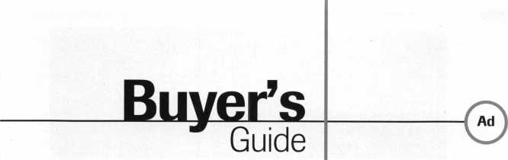

Alternative Tools

Here are new tools that address problems  
from an alternative point of view. When  
the “usual” methods can’t get it done, try  
an alternative tool. “The Tool” tension  
wrench is designed especially to allow more  
room for picks in SCI and KW1 keyways.  
“Lever Up” lifts vertical auto lock linkage  
without disconnect danger and without  
the tool entering the vehicle. “Paddle  
Pusher” operates paddles and crash bars  
like you were standing inside. $12.95

(+$4.95 S/H). Allow four to six weeks for delivery. Send order on  
back of business card with check or m/o to: Alternative Tools, Inc.;

162 Robin Dr.; Loveland, CO 80537.

Reader Service #19

Custom Key Tags

Every dollar counts, so let us help you  
keep your customers coming back. Key  
Tags are an inexpensive way to advertise  
and keep your customers coming back to  
you. Add a tag to a set of new keys or key  
chain and the next time your customer  
needs a new key cut, they’re sure to  
remember you. We customize key tags to  
hold your store’s name or logo on one side  
and telephone number on the other. Each  
key tag is made from buffed pewter and  
measures 3/8"x7/8" in size, and comes

with its own ring. Our minimum order is 250 @ $1.20 each =  
$300.00 including set-up charge. Simply send us your store name  
and telephone number and we’ll do the rest: Milman Manufacturing,  
at either Commercial Street, Box 113, Roxboro, Quebec H8Y 3E8,  
Canada; or Champlain Mall Rd. , P.O. Box l64l;Champlain, NY  
12919; USA. Phone (514) 425-5794 or fax (514) 425-5793.

Reader Service #20

Door Controls International

Door Controls International announces our new  
champion lever trim. UL certified ANSI/BHMA  
156.3—1994, grade 1. The 08L lever trim is to  
work in conjunction with our fire rated security  
alarmed rim exit device, Pannex. The vandal  
resistant lever is available for standard or narrow  
stile doors, and can also be supplied with electric  
release. Phone (313) 426-0400.

Reader Service #21

PRO-LOK

Pro-Lok has developed new machined aluminum padlock service  
tools for professional locksmiths. The green anodized LT605  
Diskbuster is a fixture that automatically lines up your drill bit  
to penetrate the shearline on disk-type padlocks, allowing safe,  
simple openings. The gold anodized LT612 Padlock Drill Jig  
lets you drill most rekeyable padlocks open while saving the lock  
body and cylinder. The black anodized LT612DG Drill Guide

is an optional attachment that centers the oval retaining nut on the bottom of many rekeyable padlocks, allowing you to drill it out, service the cylinder and reuse the padlock. For more information, contact PRO-LOK. Phone (714) 633-0681

Reader Service #22

PRO-LOK

The 1998 update from PRO-LOK will feature over 100 pages of car opening infor­mation. From the Audi A4 to the Volvo 960, you will find full color pictures and an easy to follow step-by-step guide to unlocking the ’98 cars. With each page as a self-contained lesson, both the beginner and the expert will be able to open those new ’98 cars. For more information, contact your distributor or PRO-LOK at (714) 633-0681.

Reader Service #23

NEW ILCO DISTRIBUTOR!!

Monday Security Corporation  
1**-**800**-**886-6721

Contact Laura for details  
on dealer discounts

We carry almost every make  
and model of new and  
used safe deposit locks,  
and safe parts, specializing  
in the antique parts.

Have you received our  
catalog?

Reader Service #3

March 1998Keynotes \ 53

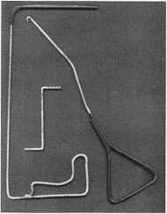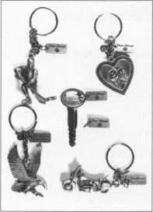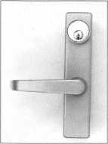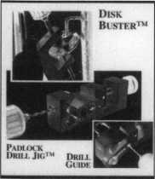

PRP

Most Frequently Asked Questions.

I’ve been getting calls lately about the catego­ry changes that have taken place in the past sev­eral years. If you have not participated in a sit­ting for some time, and are planning to do so again soon, you might want to review the fol­lowing when you are filling out your application.

1. The combining of C01 and C02 (Basic and Advanced Alarms) into the new category, L42 (Alarms).
2. If a candidate has passed either one, they will retain that credit and may take L42 for additional credit.
3. If a candidate has passed both, they may not sit for L42.
4. If a candidate has not taken or failed both, they may only sit for L42.
5. The splitting of C09 (Cylinder Servicing, Interchangeable Core) into the new categories of L38 (Interchangeable Core, Best Style) and L39 (Interchangeable Core, other than Best Style).

A. If a candidate has passed C09, they will retain that credit, and may take either or both L38 and L39 for additional credit for

Report

V

^avicTOwell,

Proficiency Registration Program

Available to locksmiths worldwide, ALOAs proficiency registration program (PRP) evaluates the educational and technical competence of dedicated individuals in 36 categories such as hardware installation, high security and safe/safe vault locks, master keying, alarms and access control devices. There are four levels of PRP certification:

CML, CMS

PRP/Education Manager I

Registered Locksmith (RL)

Certified Registered Locksmith (CRL) Certified Professional Locksmith (CPL) and Certified Master Locksmith (CML)

W

: for

B. If a candidate has

only take L38 and

1. The combining of C14

locks, basic) and Cl5 (Elen

advanced) into the new ca

mechanical Access Controf),

1. If a candidate has pi

will retain that cred

for an additional cr<

1. If a candidate has p;

not sit for L40.

1. If a candidate has n<

they may only sit

1. The combining of C35 C  
   C36 (Remote door, detent i<  
   gory L43 (Detention Lock ii
2. If a candidate has p;

will retain that credii  
for additional credit.

1. If a candidate has pi

not sit for L43.

1. If a candidate has n<

they may only sit

Also, you might want

cation period has been she u

to 15 days. I hope adding

fa: led C09, they may

139.

'Electro-mechanical

:tro-mechanical locks,  
egory, L40 (Electro-  
1).

>£ ssed either one, they

t and may take L40

•edit.

>< ssed both, they may

taken or failed both,  
L40.

Locks, detention) and

ion) into the new cate-

ng Systems).

>i ssed either one, they

t and may take L43

* ssed both, they may

t fer

: taken or failed both,

L43.

:o note that the appli-

•rtened from 30 days  
this flexibility in

New Certifications

New CRLs

Cable, Ted S./Lilburn, Ga.

Douden, David S./New Cumberland, Pa. Firestone, David A./Middleton, Pa. Keerans, Scott M./Richmond, Va.

Lee, Joe J./Philadelphia, Pa.

Murphey, Terry/Charlotte, N.C.

Pickell, Brian S./Mount Joy, Pa.

Stepp, Kenneth A./New Cumberland, Pa.

About the Manager: David Lowell,

CML, CMS, is ALOAs immediate past president  
and an ALOA Trustee. David has sewed on the  
ALOA board for 10 years. He owns and operates  
Phoenix Lock & Key in Arizona, and has been an  
ALOA member since 1981.



each one passed.

PRP Dates

March 8,1998

Ypsilanti, Mich.

IDN Hardware Sales John Kress (313) 591-1150 March 14,1998 Illinois Dept, of Pro Regulation Mary Jo Southward (217) 785-0523 March 21,1998 Atlanta, Ga.

Georgia Chapter Stephen L. Gebbia, CML (770) 455-6242 March 24,1998 Las Vegas, Nev.

ALOA Education Conference at ISC David M. Lowell,CML,CMS (800) 532-2562 March 28,1998 Hammond, La.

Lou-Miss Locksmith Association

Thomas L. Hunt, CPL, CPS (205) 833-3333

scheduling will help

March 28,1998

Somerset, NJ.

Master Locksmiths Association of New Jersey Charles Green, CRL (973) 267-8884 March 28,1998 Kenosha, Wis.

Greater Chicago Locksmith

Association

John J. Greenan

(773) 486-2030

April 5,1998

Poison, Mont.

Montana Chapter Rene Rasumssen (406) 883-8539 April 25, 1998 Anaheim, Calif.

American Security Distribution Debby Lussier (909) 371-2607 April 26, 1998 Eau Claire, Wis.

Indianhead Chapter John Dorsey, CPL (715) 832-4207

May 1,1998

Washington, D

Clark Security  
Terri Burges

(800) 854-208L

May 16,1998

Boston, Mass.  
North Bennett

Jack Hobin, CFfl  
(617) 227-015E

May 23,1998  
King of Prussic

Forge), Penn.  
SAFETECH

David M. Lowdll

(214) 827-723G

May 31, 1998

Chicago, III.

ALOA Educati<|>i

Conference at

David M. Lowdll,

(800) 532-2562

June 18-19,1

Nashville, Tenr

ALOA ’98 Seci ri  
David M. Lowe II,

(800) 532-2562

15-day appliestii

required

C.

Products

Street School

L

(Valley

n

ISC

,CML,CMS

998

ity Expo

,CML,CMS

on period

August 2,1998

St. Charles, III.

Clark Security Products Terri Burges (800) 854-2088 September 2,1998 New York, N.Y.

ALOA Education Conference at ISC David M. Lowell,CML,CMS (214) 827-1701 September 13,1998 Philadelphia, Penn.

Greater Philadelphia Locksmiths Association William L. Young, CML (610) 647-5950 September 20,1998 Burbank, Calif.

Clark Security Products Terri Burges (800) 854-2088 October 4,1998 Independence, Ohio POLA

Martha Eggler (216) 676-8464

October 18,1998

Omaha, Neb.

MINK Locksmith Convention Elmer Howard (402) 330-8701 October 23,1998 Portland, Ore. Tri-Regional Locksmith Convention John Kerr (503) 253-0424

March 1998

***Keynotes***

It pays

to have new faces  
in the crowd.



During 1998  
each ALOA member  
who sponsors  
a new applicant  
will receive $40 cash  
(upon clearance,  
and payment

of application fee and dues).

|  |  |
| --- | --- |
| , -1 . | Tips |
| Trade | ^^on^?amunno, CML, CPS  Trade Tips Editor |
|  |

Picking the ol’

Baldwin Images Lock

I found this tip while practicing picking  
a Baldwin images lock. Simply, insert your  
pick through the keyway underneath the  
bottom pins. Once a spring action is felt  
(with little resistance), turn the knob and  
the latch should release.

William Stone, Veits Lock Co.

Malibu Fun

With the General Motors recall of the  
’97 Malibu and other cars using the same  
ignition lock, I have found an easy way to  
remove the lock cylinder from the dash.

The recall gives details of disconnecting  
the battery, removing the fuse, disconnecting  
the restraint system, removing the  
instrument cluster removing the lock  
assemble, etc.

On the Malibu and other models with the  
lock mounted in the dash, you can remove  
the lock cylinder in minutes.

1. Remove the trim around the ignition  
   switch (it only snaps in place).
2. Remove the  
   trim around the  
   radio (this just  
   snaps on). With  
   the radio trim  
   removed, you  
   will see a small  
   square hole in  
   the dash that

will give you access to the lock housing.

1. Using a wire or hook pick, you can probe  
   the bottom of the local housing and release  
   the lock cylinder. An eighth-inch wire with  
   a one-half inch hook will work just fine.

With a working key, the time is under

five minutes.

If you have a defective lock cylinder, you  
can easily remove the chrome cap and drill a  
small home at the edge of the cylinder. Now,  
with a wire or pin, apply pressure to the side-  
bar. With a proper key inserted in the cylin-  
der, the side pressure should allow you to  
turn the cylinder to the “on” position. With  
no key, pick the lock while holding pressure  
on the side bar. With the lock cylinder

**/Row** To **Become A Trade Tipper**

Each month, the Associated Locksmiths of America (ALOA) holds a “Trade Tips” contest in Keynotes for ALOA members.

In addition to helping other locksmiths by sharing your knowledge, there are three levels of prizes to be awarded:

Authors of any Trade Tip published will receive $20.

Monthly Prize for the best Trade Tip is $100.

The Grand Prize for die best Trade Up of the Year is an expense-paid trip tothe ALOA’98 Security Expo

Each year, the ALOA Publications Committee selects one outstanding tip, the author of which receives a seven-day ALOA convention package that includes travel within the continental United States and accommodations.

Want to Participate?

Mail your best idea (including photos, illustrations or parts, if necessary) to:

Keynotes Trade Tips Editor 3003 Live Oak St Dallas, TX, 75204-6186.

All entries are sent to the Trade Tips editor with the author’s identify deleted.

The tips must be submitted exclusively to Keynotes and become the exclusive property of ALOA. Tips are judged on the basis of accuracy, professionalism, ethical standards, originality and usefulness.

*J*

removed, replace the existing tumblers with new ones available from a General Motors dealer.

Robert Wolthoff, Owner of Bob’s Lock Shop in Layton, Utah

Last month s winner was Steve El wood with “Button Pin Spring Action.”

March 1998Keynotes | 55

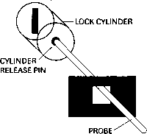

News.

arnum, CML

***Y ALOA chapter members can write to Dana Barnum at: CHAPTER NEWS; 3003 Live Oak Street; Dallas TX 75204; fax (214) 827-1810; [aloa@anet-dfw.com](mailto:aloa@anet-dfw.com)***

Word From the Board Meeting

Greetings, chapter members.

Since my report to you in the February issue I have heard from several members who are concerned about the recent changes being proposed by our ALOA board. Here are a few of the questions asked.

Question: I have heard that the ALOA hoard is trying to make changes in the way we vote and elect our officers. Is that true?

Answer: Yes. At the last ALOA membership meeting in July the number one request from the membership was “give us the right to vote even when we cannot attend the national convention.”

In response to that, one of the major projects that your board has been working toward is giving you, the member, more— and hopefully better—control of the persons who represent you and other members within your own region. In order to accomplish this the membership must approve changes to the Bylaws and the Articles of Incorporation. The changes that are suggested will:

1. Allow a method of electing regional officers by a mail-in ballot or a proxy vote.
2. Allow the ALOA members from each region of the country to nominate and elect their own representatives (up to three repre­sentatives per region, depending upon the number of members in that region).

Question: I have just paid my ALOA dues for 1998. I have always thought I have gotten a fair value for my dues hut, why are we getting a dues increase now?

Answer: As has been pointed out before, anything of value comes with a price. In the past our office in Dallas lacked several important people that were necessary to achieve some of the goals the membership have requested. Those goals I am referring to are:

1. Better educational classes.
2. More educational classes accessible to our chapters.
3. More and better trained instructors.
4. A better way to monitor state legislation.
5. Aid the locksmiths across the country in their fight for better legislation.

The way to accompli ;h

hire additional people  
would handle these an

Manager, and a full tim  
Manager. I am sure you

about these men in

Thanks for asking  
questions. Please feel

me with your concerns

address listed below.

eas-

i futi r<

these tasks was to

to fill positions which

i—an Education

i Legislative

will begin to read

•e articles in Keynotes.

important

to call or email

Dr questions to the

th sse

free

ch ipter

More From Japan

Last month, you r  
on the new Japanese

following is a first-

Korea/Japan ambassadc r

chapters debut meetin\

goings on:

-hanc

One Nov. 22, 1997

chapter was born in Tojc

After several years

members have gathered  
of members to establisl i

With some help frojn

the United States and

the Japanese chapter g )t

The eagerness and stro i

industry in Japan were

first chapter meeting b y

With their new group

Keiryu Tskuishiro, Ke z<

Makoto Yoshizawa, th;

chapter looks good

I also had an opport ui

Lock company’s head

was very impressive,

our industry was out:

in their showroom wei  
technology and produ

The MIWA compan;

60 percent of the Japa le:

observing the hardwaie

apparent that MIWA

manufacturer. It’s like  
Schlage on every othe]

there are just a few M^

the American market.

Another major evei it

was the Kaiga Co., LID.

trade show, held in Tc ky<

hotel. The show was held

21—23. There were several

remember a report

of ALOA. The

report from

Joe Lee on the

as well as other

a new international

:yo, Japan,

planning, the Japan

a sufficient amount  
a chapter,

members here in

i he Korean chapters,

off to a great start,

g urge to expand our

strongly felt at this

all the members,

of officers, led by

;o Takahashi and  
future of this new

nity to visit MIWA

c fifice in Tokyo, which

1 heir advancement in

:st anding. The products

advanced in

ed extremely well,

close to 45 to

se market. While

in Japan, it was  
a dominant

seeing Kwikset or

door. Currently,

WA products on

that same week  
. education and

ro at the Miyako

from November

manufacturers

Ly holds (

from the United States and one from Italy. The HPC, Inc. and the A.S.P., Inc. companies were the ones that had display booths from the United States. SILCA S.P.A. of Italy also had a display booth. Among the American products represented were items from PRO-LOK, Rytan, and Lockmasters. Some of the eye catchers included picks, tension tools, and high security cylinders from EWA. Attendees came from all over Japan as well as the Republic of Korea and Taiwan to attend this event.

Mr. Asano, the president of Kagiya Co., Ltd., went beyond the responsibility of being a sponsor but also acted as a close friend to all of the international members. Without him and the employees of his company, the inter­national ALOA members attending the show would have had a very hard time.

After my visit to the beautiful Japan, my journey took me across the channel to the republic of Korea where I also attended the Korean Chapter’s meeting. In both chapters, the interest in the PRP was high.

That wasn’t the only thing that had increased ... the value of the Korean Dollar doubled during my stay in Korea. That served as one of the main topics at the Korean Chapter’s meeting. Another was the membership dues in both international chapters.

Joe J. Lee, CRL

\About the author: Dana

Barnum, CML, #05444, operates South Penn  
Lock & Safe Co. in Media, Penn. He has been on  
the board of directors of the Greater Philadelphia  
Locksmiths Association (GPLA). Dana has also  
sponsored many new ALOA members. Dana can  
be reached at FAX (610) 565-9902 or email

him at [danabamum@aol.com](mailto:danabamum@aol.com)

March 1998

J Keynotes

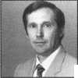

Chapter

Roster

Dept

Y The best way to learn about ALOA’s programs  
and to network with locksmiths in your area is by  
participating in local ALOA chapter activities. This  
is your opportunity to exchange management and  
technical information, build your professional image,  
and share trade tips with your fellow locksmiths.

If you want to start a chapter in your area, please  
call ALOA, (214) 827-1701.

|  |  |  |  |  |
| --- | --- | --- | --- | --- |
| Alabama | Georgia | Minnesota | North Dakota | Washington, DC |
| Alabama Locksmiths | Georgia Chapter | Minnesota Chapter | North Dakota Chapter | Washington, DC Area |
| Association | P.O. Box 48088 | 3M Center | Rte. 1 Box 67 | 2987 Thomas Rd. |
| 2980 Hartford Hwy, #2 | Atlanta, GA 30362-1088 | Bldg. 223-BE-04 | Devil’s Lake, ND | Bryan Road, MD 20616 |
| Dothan, AL 36305 | (404) 455-6244 | St. Paul, MN 55144-1000 | 58301-3907 | (301) 283-0145 |
| (334) 793-5060 | Michael D. Robinson, | (612)733-6674 | (701)662-5625 | * William Smith, Jr., CML— |
| *James Turner, CPL— | CRL—Chairman | *Douglas Rude, CRL | *James H. Strong, CRL | Chairman |
| Chairman | *M.W. Whitman, Jr. | Montana | Ohio | Wisconsin |
| Arizona | Hawaii | Montana Chapter | Ohio North Coast | Fox Valley Chapter |
| Grand Canyon Chapter | Hawaii Chapter | Mountain Locksmithing | Chapter | 1425 N. Richmond St. |
| 1905 E. Weber, Suite 108 | 4420 Lawehana St. | 210 N 7th | #2 Horseshoe Drive | Appleton, WI 54911 |
| Tempe, AZ 85281 | Unit 4 | Bozeman, MT 59715 | Monroeville, OH 44847 | (414) 731-5400 |
| (602) 921-0123 | Honolulu, HI 96818 | (406)586-5187 | (419) 465-4153 | e-mail [sageinc@athenet.net](mailto:sageinc@athenet.net) |
| *John Ilk, CRL—Chairman | (808) 623-5914 | *Jim Morrissey, CRL— | * Ronald Betschman, CML— | *John F. Engel, CRL |
|  | *Andreas Muenker, CML— | Chairman | Chairman | Chairman |
| California | Chairman | Carol Morrissey, CRL— |  | Matt Swoboda— |
| Los Angeles/ |  | Secretary | Ohio Valley Chapter | Vice Chairman |
| Orange Counties | Indiana |  | 144 Julep |  |
| Chapter | Central Indiana | Nebraska | Cincinnati, OH 45218 | Indianhead Chapter |
| P.O. Box 697 | 1237 Wabash Ave. | Nebraska Chapter | (513) 825-7528 | 201 N. Barstow St. |
| Alhambra, CA 91820-0697 | Terre Haute, IN 47807 | 343 W. 2nd St. | *James T. Brickler, | Eau Claire, WI 54703-3525 |
| (310) 869-2555 | (812)234-6249 | Hastings, NE 68901 | Chairman | (715)832-4207 |
| *John H. Cosby, CPL | *Herbert Dusenberry, | (402) 463-6661 |  | *John Dorsey, CPL |
|  | CML—Chairman | *Brad Boden | Pennsylvania | Chairman |
| San Diego Chapter |  |  | Keystone State Chapter |  |
| 1049 Island Ave. | Northern Indiana | Nevada | 3 W 4th St. | Wyoming |
| San Diego, CA 92101-7228 | 122 N Orchard St. | Sierra Nevada Chapter | Bridgeport, PA 19405 | Wyoming Chapter |
| (619) 234-4829 | Kendallville, IN 46755 | C/O Pamela Vankirk | (610) 272-9292 | 5920 E. Pershing |
| Burt Fieser—Chairman | (219) 347-1754 | P.O. Box 115 | *Barry Leas, CRL | Cheyenne, WY 82001 |
|  | *Earl Shanfelt—Chairman | Reno, NV 89504 |  | (307) 638-8752 |
| Colorado |  | (702) 328-9285 | South Dakota | *Betty Crenshaw, CML |
| Colorado Front Range | Southern Indiana | *Danniel F. Howard, | South Dakota Chapter |  |
| 2055 26th St. | P.O. Box 185 | CML—Chairman | 402 S. Minnesota Ave. | International |
| Boulder, CO 80302 | Bloomington, IN |  | Sioux Falls, SD 57102 | Chapters |
| (303)443-9740 | 47402-0185 | New Jersey | (605) 331-6026 | Korea Chapter |
| John I. Shandy, CML— | (812)334-3737 | Garden State Chapter | *Ronald Heidzig— | Suh Man Soo, President |
| Chairman | * Daniel W. Hill, CML— | 106 Ridgedale Ave. | Chairman | *Joe J. Lee |
| *John M. Thomas, CRL— | Chairman | Morristown, NJ 07960 |  | 5430 Howland St. |
| Vice Chairman |  | (201) 538-2737 | Tennessee | Phila., PA 19124 |
| (303) 666-8980 | Kentucky | *Steve Frei, Chairman | Smokey Mountain | Phone and fax: |
|  | Kyana Chapter |  | Chapter | (215)744-5254 |
| Connecticut | 510 E. Parrish Ave. | New Mexico | 2557 Middle Creek Rd. |  |
| Nutmeg Chapter | Owensboro, KY 42303- | New Mexico Chapter | Pigeon Forge, TN 37863 | * Denotes contact person |
| Phil’s Lock Shop | 3125 | 917 2nd St. NW | (615)453-8344 | for this chapter. |
| 360 E. Main | (502) 684-5093 | Albuquerque, NM 87102 | *Jessie Swan, RL | All questions regarding |
| Meriden, CT 06450-6022 | *Timothy Morrison, CML— | (505)242-1380 |  | chapter activities, |
| (203) 237-4602 | Secretary | *Evelyn Wersonick, CML | West Tennessee | meetings and events |
| Phillip Hobbs, CPL— |  | Marc McGrannahan, | 1261 Wellsville Rd. | should he directed to |
| Chairman | Maryland | Chairman | Memphis, TN 38117 | this individual. |
| Florida | Chesapeake Chapter |  | (901)685-1130 |  |
| 205 Cleveland Ave. | Sunbelt Chapter | *John Singleton |  |
| South Florida Chapter | Baltimore, MD 21222 | South Central Region |  |  |
| 1710 NE Miami Gardens | (410) 633-0111 | New Mexico State | Texas |  |
| Dr. | * Bob De Weese, CPL— | University | Sunbelt Chapter |  |
| Miami, FL 33179 | Chairman | Box 30001 Dept. 3545 | see New Mexico listing |  |
| (305) 944-0469 |  | Las Cruces, NM |  |  |
| *Jerri Moeller, CRL | Massachusetts | 88003-0001 |  |  |
| Secretary | Massachusetts Chapter | (505) 846-6292 |  |  |
| Paul Renderer, CML— | 200 Weir Street | *Don Brazil—Chairman |  |  |
| Chairman | Taunton, MA 02780 |  |  |  |

(508) 823-4649 *Stephen Ehrlich, CML— Treasurer

March 1998 Keynotes L_



ALOA

Extra

Dept

GM Key Code Blockade

Recently the executive director of ALOA,

Bill Gibson, contacted General Motors about their practice of no longer supplying key codes to locksmiths. GM has stated that the new policy is because repressors and other unscrupulous individuals have been obtaining codes for purposes other than legitimate, owner authorized car openings.

Gibson pointed out that locksmiths provide a valuable service to GM customers. He reminded the auto manufacturer that competent locksmiths, using key codes, can open cars and provide replacement keys quickly-without risking damage to the car. He further pointed out that often locksmith service is provided at times when dealerships are not usually open and at remote locations.

GM executives have been made aware that ALOA members subscribe to a professional code of ethics and professionalism—that they will know how to use the codes and will have the tools to make a proper key—that they are aware of ALOA’s “Positive ID” policy and will take precautions to ensure that they do not open a car for unauthorized persons.

ALOA has suggested a safe way to make locksmith services available to GM customers without undue risk. ALOA will provide the various GM divisions a list of members, or if they prefer, a list of members holding the ALOA fidelity bond. GM can then release codes to these members with little risk of the problem that has apparently caused this change in policy.

At press time, GM had not responded.

Out On a Ledger

There was recently an article in the Locksmith Ledger concerning “stings,” which some of you may have seen. Much of the author’s representation of the sting was very well done. As Mr. Lagasse stated, the television report is frequently interested in creating a sensational story, not in accurately reporting the facts. Mr. Lagasse did, however, make some statements concerning the Associated Locksmiths of America, Inc. (ALOA) to which the executive director felt he must respond. He contacted Editor Gale Johnson with the following clarification.

ALOA has been aware of “stings” for many years. ALOA compiled a videotape of

58 | Keynotes March 1998

l she1

taken i

pare i

; hav i

ALT

stings that has been

television stations. Thi:

ALOA chapters so that

see the risk of opening

without requiring propjei

copy of the tape was

convention and run in

booth in order to pre]

possibility of a sting

Articles were written

problem, various

Board of Directors

television stations to

information concerning

ALOA regularly publi:

Policy” in Keynotes.

anyone in the associate )i

respond to a locksmith5

with a sting.

There are many

local television station  
ALOA cannot possibly

and ask them not to

subject. In fact, making

complaint might caus i

a sting when they had T  
about it. The few time s

discovered, in advance,

preparing a report, att 5j  
to have the report done

few stations contact

many local locksmith:

airing the sting

It is unfortunate

who are not concernec l

who attempt to “create

continue to work to  
these reporters do.

wn on various

tape was sent to

the members could  
vehicles or doors

r identification. A

to an ALOA

he membership

members for the

oc rurring in their area,

for Keynotes about this

»ers on the ALOA  
appeared on local

p: ovide accurate

unlock ID policy.

;hes its “Positive ID

A is unaware of

»n ever failing to

s request for assistance

r tho is;

Web Update

If you haven’t been or

lately, you might war t

;ands of independent

in this country .  
contact all of them

rdport on this, or any,

such a general

some of them to mn  
’t previously thought

that ALOA has

that a station was

mpts have been made

fairly. Of course, very

OA, or any of the

associations prior to

; that

there are reporters

with accuracy and  
” news. ALOA will

nimize the damage

the ALOA web page

to check out a few

changes. Our new website server restructured the locksmith search section, the on-line membership applicat ion and the legislative page. We hope you v ill find these more

useful in their presen

weeks we plan to offer ALOA ’98 convention materials to downloa I (if you misplace your brochure), and will p robably replace the chat

room with a membei

tuned for further dev  
Quick tip—when

state. In the coming

bulletin board. Stay

dopments.

accessing the “Members

Only” section of the ALOA page, you will need to enter your first name exactly as you submitted it on your membership application. In other words, if your ALOA records say your first names is James, don’t try to use Jim. Also, if your member number is only five digits, you will need to enter a “0” at the beginning. Only six digit numbers work for access. This will be corrected soon.

Hint Word List

Following are the “hint” words for the crossword puzzle on page 60:

Awl

Bit

Can

Car

Clock

Clamp

Clip

Cord

Cut

Dealers

Displays

Drain

Drill

Drive

Drills

Educate

Education

Engrave

Hardware

Heel

Holesaw

Installation

Keys

Keyed Alike

Kwikset

Level

Lock

Local

Master

Nail

Pick

Pliers

Rap

Repin

Rulers

Saw

Schlage

Seminars

Shed

Shim

Sign

Tap

Unlock

Vise

Weiser

Weslock

Wrench

3 AT&T

2 All-Lock Company

6 ISC

100 Jet Hardware Mfg., Inc.

1. Locksmith Publishing Corp.
2. Monday Security Group

1 Timemaster

IBC _ BC _42 _ 53 _ 25

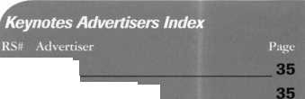

ALOA ’98 International Convention & Security Expo

*Nashville has always been referred to as Music City USA, so get ready for the hits! An ad in* Keynotes, ALOA ’98 Daily *and the on-site program wil make a hit of your booth! Don't delay. Make the most of the following discounts* when you advertise in all three convention publications.*

June/July Issue 15%

Convention Daily 20%

Convention Program 25%

*\*Discounts do not include color process or production charges*. *Ads for all three publications must be purchased in order to receive the above discount.*

Standard Convention Publication Rates

June/July Daily

Convention Issue Newsletter

$4,050 $2,000 _

_ 4,050 1,500 _

_ N/A N/A _

ALOA ’98 Program

_ $1,400 675

BC/Gatefold Spread**

IBC/IFC**

Tab Page

Full Page

2/3 Page

1/2 Page (Horizontal)

1/3 Page

1/4 Page (Vertical)

1/6 Page

’"Includes Color Charges

Nashville Convention Center

Nashville, Tennessee

Space reservations are

*Associated Locksmiths of America*

*214.827.1701*

*800.532.2562*

*214.827.1810 fax*

*e-mail [convtion@anet-dfw.com](mailto:convtion@anet-dfw.com)*

due by April 26,1998

Contact ANELIA

or D’ANNA for

specific pricing,

|  |  |  |  |  |  |
| --- | --- | --- | --- | --- | --- |
| masattKtk | |  |  | |  |
| f |  |  | WM |  | \ |
|  | | | I 41M1MLLB l cm | | |
| VJMVI  r  . il  i y panni  1 • - | | | V. • -» | I  ■v a | | |

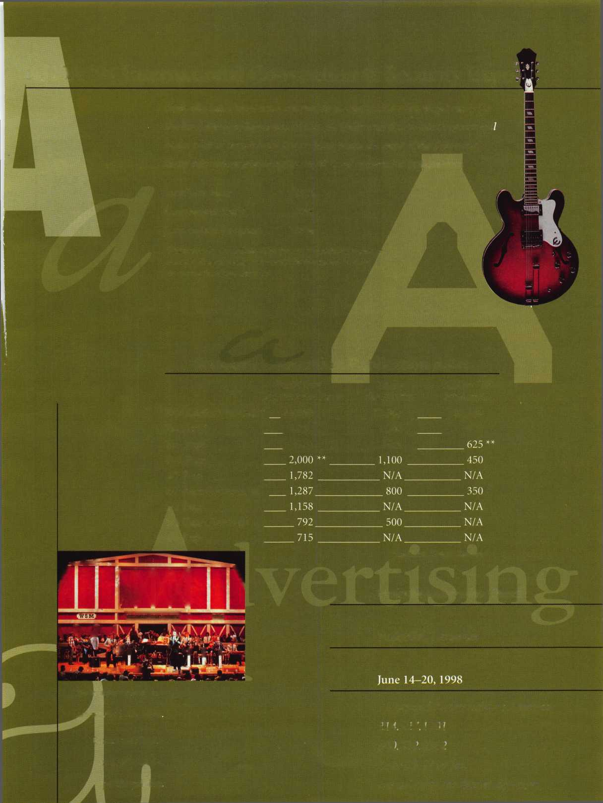

Across Clues:

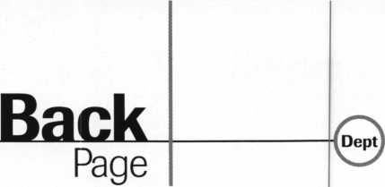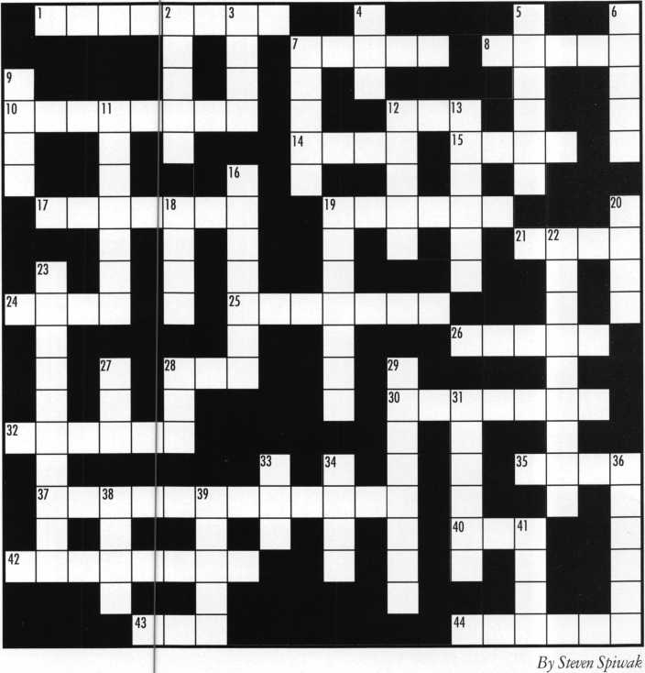

1. Another word for “gondolas”
2. Where the water goes down
3. Some are variable speed
4. The theme of this puzzle  
   12. A method of opening a cylinder
5. A device used to hold an object
6. A device used to secure a door
7. A special type of drill bit
8. A well-known brand of lock
9. and toe
10. What we sue ILCO machines to cut
11. A well-known brand of lock
12. A timely device

28. What must be done to a key before it can be used

1. The purpose of instructional videos is to .
2. A well-known brand of padlock
3. An electrical extension
4. What must be done to a lock when it is affixed  
   to a door
5. The container that paint is packaged in
6. A method for etching metal objects
7. A piercing tool
8. Give some people inches and they think  
   they are

Down Clues:

1. Not far away, but
2. A well-known brand of lock
3. and die set
4. An end or a box
5. A device used for holding objects
6. A 3/4" or 1/2"set
7. A small shelter for keeping tools
8. A name for people in Las Vegas, or who carry hardware
9. The act of changing tumblers in a cylinder
10. A common gripping tool
11. A well-known brand of lock
12. A metal object used to compensate the differences between door and jamb
13. A device to hold papers
14. The purpose of seminars
15. The common term for two locks that use the same key
16. A drill
17. Not an automobile, but a
18. Another word used for “open”
19. A common cutting tool
20. A device used to open lock cylinders
21. Devices used to put holes in wood or metal
22. These can be hand-painted on neon or metal
23. A hammer and

Answers to last month’s puzzle:

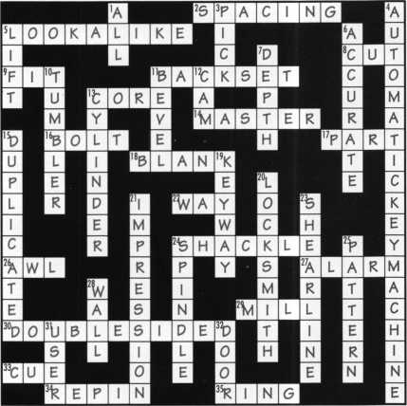

Hints on page 58.

Keynotes

March 1998

**^ v ALOA Conference Program at International Security Confere**

**osition**

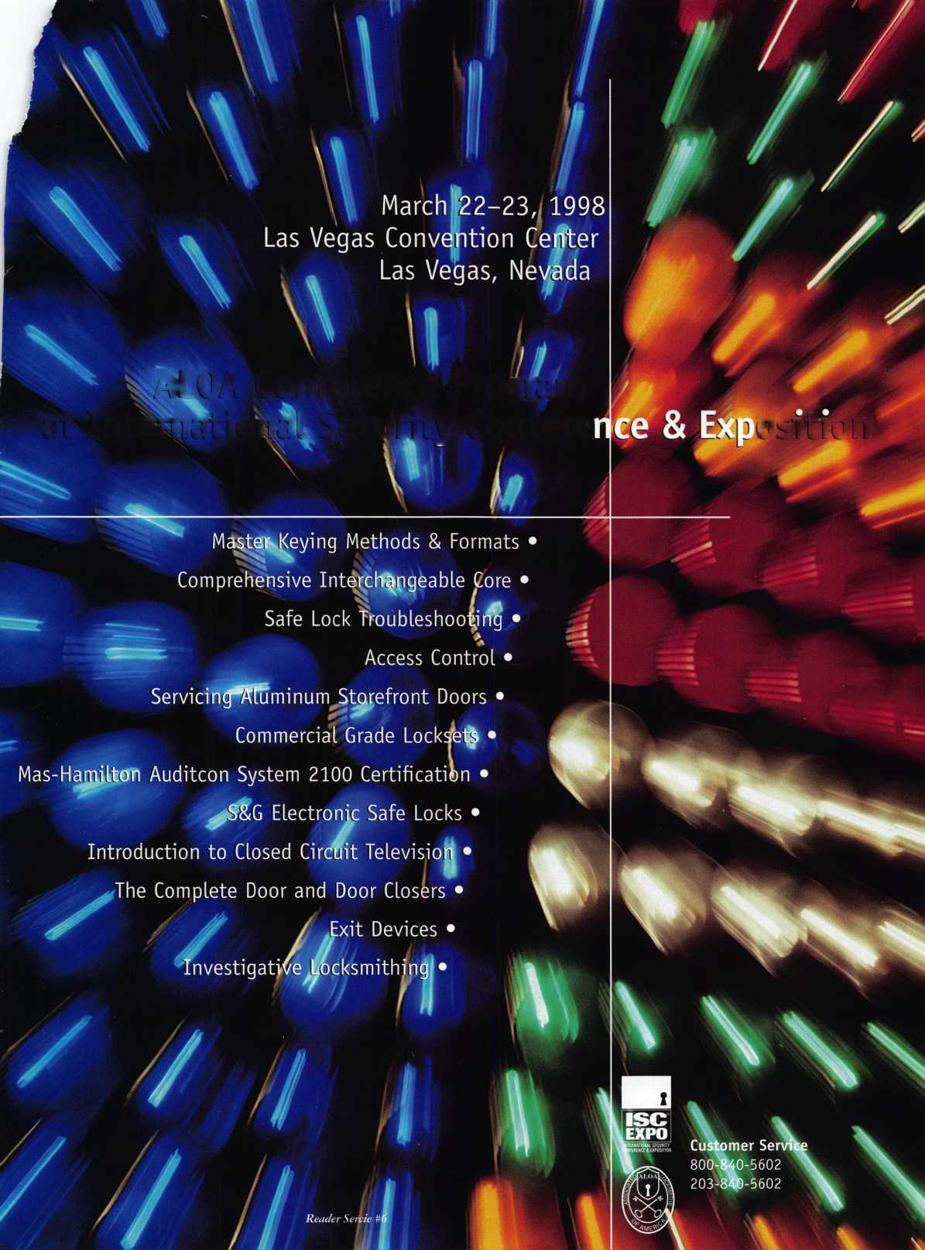

**Jet Soars to a new level of Quality**

**In two short years since its initial introduction by jet, the silver line has become a  
symbol of quality and a monument to precision in the key manufacturing indus-  
try. The silver line keys are coined, embossed and designed to look exactly like  
the originals. Plus the jet pledge guarantees superiority over the originals as  
well.**

**jet’s silver line offers regular and sectional keys from...**

**ARROW BEST CORBIN RUSSWIN**

**£■■■* DIEBOLD FALCON HHM**

**K#IKSET LeFEBURE MEDECO**

**MOSLER SARGENT SARGENT & GREENLEAF**

**SCHLAGE YALE YORK**

**New key blanks are constantly added to the silver line to serve Master Keying  
and Duplication needs. Recent additions include Corbin Russwin D2-6-NS and**

**77-6-NS ''“**

**Another jet symbol of Quality.**

JET HARDWARE MANUFACTURING CORP 800 Hinsdale Street, Brooklyn NY 11207

**i v , •' • , * ' •< ' *' ! ’v ! • >. • . /•>** *' **\*t**

Free Information - R4adf^r\Sovvinp Card iiion

